

2015-2019 Report

San Luis Valley Field Office

Brandi Wheeler

03/2020

Contents

1. List of Abbreviations 4

1.1 List of Species Codes 5

2. Introduction 6

3. Training 6

4. Sample Design 6

4.1. Site Selection and Point Generation 6

4.1.1. Ecological strata 6

4.2 Sample Point Rejection 7

4.2.1. Office-based Rejection 7

4.2.2. Field-based Rejection 8

5. Methods 8

5.1 Plot Establishment 9

5.2 Assessment, Inventory, and Monitoring Protocol 9

5.2.1 Soil Stability Test 10

5.2.2 Line-Point Intercept and Vegetation Height 11

5.2.3 Canopy Gap Intercept 12

5.2.4 Species Inventory 12

6. Results 12

6.1. Stratified Plots 2015-2018 13

6.1.1 Summary 13

6.1.2 Basalt Hills 18

6.1.3 Limy Bench 22

6.1.4 Loamy 26

6.1.5 Mountain Outwash 30

6.1.6 Other 34

6.1.7 Rocky Foothills 38

6.1.8 Salty 42

6.1.9 Sandy 46

6.1.10 Forest 50

6.2 Intensification Plots 54

6.2.1 Summary of PV Intensification plots 54

6.2.2 Summary of GUSG Intensification plots 59

6.2.3 GUSGO 61

6.2.4 GUSGP 66

6.2.5 GUSGW 70

6.3 Plots Found within Sage Grouse Habitat 74

7. References 75

8. Appendix 76

**Appendix of Tables** 93

**Appendix of Figures** 95

# List of Abbreviations

|  |  |
| --- | --- |
| AIM | Assessment, Inventory and Monitoring |
| ARS | Agricultural Research Service |
| BH | Basalt Hills |
| BLM | Bureau of Land Management |
| CDA | Colorado Department of Agriculture |
| CPW | Colorado Parks and Wildlife |
| DBH | Diameter at Breast Height |
| DIMA | Database for Inventory, Monitoring and Assessment |
| ES | Ecological Site |
| ESD | Ecological Site Description |
| FORE | Forest |
| GPS | Global Positioning System |
| GRTS | Generalized Random-Tessellation Stratified |
| GUSG | Gunnison Sage-Grouse |
| HAF | Habitat Assessment Framework |
| LB | Limy Bench |
| LHA | Land Health Assessment |
| LO | Loamy |
| LPI | Line Point Intercept |
| MLRA | Major Land Resource Area |
| MMS | Mixed Mountain Shrub |
| MO | Mountain Outwash |
| NOC | National Operations Center |
| NRCS | National Resources Conservation Services |
| OSD | Official Series Description |
| OTH | Other |
| QA/QC | Quality Control and Quality Assurance |
| ROF | Rocky Foothills |
| SAL | Salty |
| SAN | Sandy |
| SLVFO | San Luis Valley Field Office |
| SLVFSG | San Luis Valley Field Office Sage-Grouse Habitat |
| USDA | United States Department of Agriculture |
| USFS | United States Forest Service |

# List of Species Codes

|  |  |
| --- | --- |
| **Species Code** | **Species Name** |
| ACHY | Achnatherum hymenoides |
| ACSC11 | Achnatherum scribneri |
| AGCR | Agropyron cristatum |
| ARFR4 | Artemesia frigida |
| ARTRV | Artemesia tridentate ssp. vaseyana |
| BOGR2 | Bouteloua gracilis |
| CADO2 | Carex douglasii |
| CHGR6 | Chrysothamnus greenei |
| DISP | Distichlis spicata |
| ELEL5 | Elymus elymoides |
| ERCE2 | Eriogonum cernuum |
| ERNA10 | Ericameria nauseosa |
| FEAR2 | Festuca arizonica |
| HECO26 | Hesperostipa comata |
| JUMO | Juniperus monosperma |
| JUSC2 | Juniperus scopulorum |
| KOMA | Koeleria macrantha |
| KRLA2 | Krascheninnikovia lanata |
| MUMO | Muhlenbergia montana |
| MUTO2 | Muhlenbergia torreyi |
| OPPO | Opuntia polycantha |
| PASM | Pascopyrum smithii |
| PIED | Pinus Edulis |
| PIFL2 | Pinus flexilis |
| PIMI | Piptatheropsis micrantha |
| PIPO | Pinus Ponderosa |
| POFE | Poa fendleriana |
| POSE | Poa secunda |
| PSME | Pseudotsuga menziesii |
| QUGA | Quercus gambelii |
| SATR12 | Salsola tragus |
| SAVE4 | Sarcobatus vermiculatus |
| SPCR | Sporobolus cryptandrus |

# Introduction

The Bureau of Land Management (BLM) manages public lands totaling 245 million acres across the United States. The BLM aims to sustain the health, diversity and productivity of public lands for current and future generations’ use and enjoyment. To better manage public land resources, field offices have begun using standardized protocols including the Assessment, Inventory, and Monitoring (AIM) Strategy (Toevs 2011).

AIM assessment utilizes standardized indicators and methods to allow for consistent monitoring across the agency. In order to span programs and boundaries, this strategy incorporates a statistically valid sample design which eliminates bias and employs remote sensing. The methods involved in the AIM strategy address four attributes of ecosystem sustainability including: biotic integrity, soil/site stability, hydrologic function and landscape integrity. These methods provide quantitative assessment using indicators including vegetation cover and composition, bare ground, vegetation height, the proportion of the site with large inter-canopy gaps and soil stability. Data collected with these methods provide information to understand the condition of the ecosystem and allows the agency to adapt their management as necessary.

In 2015, the BLM San Luis Valley Field Office (SLVFO) began AIM sampling efforts to improve effectiveness of monitoring and management, increase understanding of ecosystem functions and to implement adaptive management to achieve resource management goals. The San Luis Valley Field Office (SLVFO) manages nearly 500,000 acres of public land in between the San Juan and Sangre de Cristo ranges in Southern Colorado (BLM San Luis Valley Field Office). The office also contains approximately 11,000 acres of Gunnison Sage-Grouse (GUSG) critical endangerment habitat (determined using 2010 CPW GUSG Habitat Range layers). At the landscape scale, data was collected across 9 (8 in 2015 and 13 in 2018) ecological strata to learn more about conditions of land throughout the field office, guide rangeland management decisions, gain a better knowledge of the ecological sites present, and build a background for the development of ecological sites (ESs). At a smaller scale, plots were completed within sage-grouse habitat and across 70 grazing allotments. Data within the allotments will support in grazing permit renewal and ongoing vegetative treatments. Together, data from all plots will be utilized in informed decision making and evaluating management efficacy across the field office.

# Training

The AIM crews attend training on the core AIM methodologies each field season prior to sampling. Training takes 40 hours to complete and utilizes BLM and NOC agencies to instruct and lead the trainings. Wilderness First AID (WFA) training was also completed by all crew members. WFA training takes 16 hours to complete.

# 4. Sample Design

## 4.1. Site Selection and Point Generation

The BLM and Jornada institute created strata for each field office and produced a master sample of two million possible sample points using the Generalized Random- Tessellation Stratified (Stevens 2004), or GRTS, approach. Master sample points are located within the BLM, across 13 contiguous western states. Smaller scale projects requiring increased sample point density use the Shiny tool to generate sample points using the GRTS approach. Therefore, all geospatial scales use the same sample point draw methods.

### 4.1.1. Ecological strata

Stratification utilized United States Department of Agriculture (USDA) mapped soil layers and ecological range site values compiled by National Resources Conservation Service (NRCS). These values were categorized into groups (strata) based off soil and site potential similarities using geographical information systems (GIS). Therefore, each stratum has multiple soil and site potentials assigned (Appendix, Table 49 and Table 50). Strata were given the names Basalt Hills, Limy Bench, Forest, Loamy, Mountain Outwash, Rocky Foothills, Salty, Sandy, and Other. Forest stratum was not developed until 2016, when it was determined to have a different amount of timber cover than other sites. Amount of timber in future sites was determined by analyzing and comparing 2015 data with SSURGO map units, reviewing range site descriptions and SLVFO vegetation map products. In 2018 GUSGO, GUSGP and GUSGW strata were created based on the GUSG habitat and season (production, occupied or winter). Also in 2018, a stratum was created to monitor the Ponchavilla (PV) allotment.

The resulting stratified layers were then provided to the NOC AIM team to assign weight to each stratum based on the strata’s proportion to the entire field office. It was expected to complete 60 regular plots at a minimum of 3 plots per defined stratum. The number of points to be drawn in each stratum was determined by multiplying the proportional area by the total plot count but still ensuring the minimum plot count per stratum is met. Base points drawn per stratum for the AIM master sample project were as follows: 10 BH, 11 LB, 8 LO, 5 MO, 6 OT, 6 RF, 4 SAL, 5 SAN and 5 FO (see Table 1). Additionally, each of the strata were assigned 5 overdraw points to replace points that may be rejected later, either in the field or in the office. After points were generated in the Master Sample, they were assigned several attributes including soil map units, slope, aspect, elevation, precipitation, and grazing allotment names to streamline the field-sampling process.

Table 1. Master sample point generation based on proportional area of ecological strata.

|  |  |  |  |
| --- | --- | --- | --- |
| **Stratum** | **Acres** | **Proportion** | **Points/year** |
| Basalt Hills | 112,532 | 0.23 | 10 |
| Limy Bench | 120,190 | 0.24 | 11 |
| Loamy | 82,887 | 0.17 | 8 |
| Mountain Outwash | 28,174 | 0.06 | 5 |
| Other | 43,886 | 0.09 | 6 |
| Rocky Foothills | 39,403 | 0.08 | 6 |
| Salty | 8,327 | 0.02 | 4 |
| Sandy | 37,332 | 0.08 | 5 |
| Forest | 26,048 | 0.05 | 5 |
| *Total* | 497,779 |  | 60 |

## 4.2 Sample Point Rejection

To eliminate dangers and increase the efficiency of sampling throughout the field season, points can be removed from the sample either before sampling begins or when necessary in the field.

### 4.2.1. Office-based Rejection

Before field sampling began, randomly generated points/plots are viewed using GIS and potentially rejected based on the AIM office-based point/plot rejection criteria (Table 2).

Table 2. AIM office-based point/plot rejection criteria completed prior to field sampling.

|  |  |
| --- | --- |
| **Domain** | **Criteria** |
| Unsafe to sample | Points unsafe to sample for various known reasons |
| Distance from Road | Plot greater than 3 miles walking distance from nearest road |
| Land Status | Plot not on BLM land |
| Slope | Any area within the plot has a slope greater than 50% |
| Access | Roads unsafe to travel, access through private land denied |
| Boundaries | Transect crosses fences of ownership boundaries |

### 4.2.2. Field-based Rejection

Few plots are rejected in the field due to GIS and office rejection. Rarely plots warrant movement or rejection upon sampling in the field due to the following:

* Point was unsafe to sample
* Slope was greater than 50%
* Access was denied (locked gate, unsafe roads, private land, etc.)
* Any part or transect of the plot intersected water features
* Transect crosses a boundary between management units
* Transect crosses a road
* Any portion of the plot intersected two or more ecological sites or strata

Plots meeting any of the above criteria are moved 50 meters in a cardinal direction to attempt possible sampling. The plot is first moved North followed by East, South then West. If plot center is moved in all four cardinal directions, and still meets any rejection criteria, the plot is permanently rejected and an overdraw point is sampled in its place.

# 5. Methods

For all plots the core indicators are assessed in accordance with Assessment Inventory and Monitoring protocol (J.J. Herrick 2015).

In the field, much of the data is entered directly into the Database for Inventory, Monitoring and Assessment (DIMA) using a Motion tablet prior to 2019. Data can also be collected on standardized paper data sheets and entered into the DIMA in the office. DIMA is a Microsoft Access database designed and maintained by the United States Department of Agriculture-Agricultural Research Service (USDA-ARS) Jornada Experimental Range. The use of this database increases the crew’s efficiency by decreasing amount of time entering data in the office, decreasing errors made during data entry, and increasing consistency of the data. DIMA decreases errors during data entry by displaying error messages that assist with quality assurance during entry. DIMA is a standardized database and was used by all AIM crews across the US prior to 2019, allowing data from multiple project sites to be easily combined for larger scale analyses. Currently, beginning in 2019, the Survey 123 and Collector APP are used to record data on tablets. Survey 123 has all the necessary data forms, performs similar QA functions and allows for the use of a standardized species list across all field offices. Collector manages the data forms, sorting by plot location on a map. DIMA data can still be easily combined with data using the current technology, Survey 123.

During and after the field season, the data goes through a Quality Assurance/Quality Control (QA/QC) process to ensure all data is consistent and complete. QA/QC prior to 2019 involved reviewing the DIMA for mistakes as well as fixing mistakes using the DIMA tool which would produce a report of any mistakes found within the forms present in the DIMA. The DIMA containing all the data was sent to the National Operations Center (NOC) to be housed in the BLM’s Terrestrial AIM Database (TerrADat) with all other AIM data across BLM lands. Post 2018, forms are reviewed using ArcGIS online to ensure forms for all sites are present. Forms containing unknown plants are reviewed and any unknown numbers are checked to have an unknown plant form completed with the associated number. Additional QA/QC is performed by AIM staff for any missing details or repeated forms which is then reported to field offices for correction. Following QA/QC the data is uploaded to the central database (TerrADat). This centralized storage of data allows land managers to easily pull data from any BLM land to make landscape scale management decisions.

# 5.1 Plot Establishment

After navigating to each plot using a Trimble Juno 3b handheld GPS unit or Collector, plot center is established with a 10-inch piece of rebar. The 0.7-acre plot is set up by establishing three 25-meter transects beginning 5 meters from plot center at 0°, 120°, and 240° magnetic. When pulling the line, the crew member remains on the right side of the line to avoid altering the condition of the left side where sampling will take place. Plot ID and establishment/visit date are recorded. When using the DIMA or paper data sheets and the GPS unit, GPS coordinates are recorded in the decimal degrees coordinate system and the NAD83 Datum for plot center and the start and end of each transect. Using the same coordinate system, Survey 123 uses the tablet to record this information. From plot center, photos are taken looking out at each transect (0°, 120°, and 240° magnetic). Photo points are useful for qualitatively verifying and interpreting the quantitative data collected by the four core methods. Then, the soils are characterized and verified by digging a soil pit to a depth of 70 centimeters at each plot and a photo is taken of the soil profile. Soil characterization involves determining presence of carbonates, percent clay, percent rock fragments, color, texture, horizons, modifiers and structure. Soils are texturally and visually compared to the Natural Resource Conservation Service’s (NRCS) official series descriptions (OSD) and map unit components to determine the soil series and component present at the plot. Additional plot characterizations are observed and recorded including slope, aspect, elevation, landscape unit and position, and vertical and horizontal slope shape. Slope and aspect are determined by facing down slope and using a clinometer and compass. Elevation is determined using the GPS or tablet device. Finally, specific plot observations are made including weather, signs of erosion, management history, wildlife and livestock use and off-site influences.

# 5.2 Assessment, Inventory, and Monitoring Protocol

AIM data is collected to assess the six recommended core indicators for BLM quantitative vegetation and soil monitoring (Table 3). These core indicators can be assessed by implementing the four core AIM methods: line-point intercept with plot-level species inventory, vegetation height, gap intercept, and soil stability. A detailed summary of each method is provided, but for specific instructions and rules for the methods, refer to the *Monitoring Manual for Grassland, Shrubland and Savanna Ecosystems, Second Edition* (J. J. Herrick 2015).

Table 3. Core indicators and methods of the AIM protocol.

|  |  |
| --- | --- |
| **Indicator** | **Method** |
| Amount of bare ground | Line-Point intercept with plot-level species |
| Vegetation composition | inventory |
| Non-native invasive plant species |  |
| Plant species of management concern |  |
| Vegetation height | Height at selected line-point intercept points |
| Proportion of soil surface in large intercanopy gaps | Canopy gap intercept |
| Soil aggregate stability | Soil stability |

### 5.2.1 Soil Stability Test

Soil Stability is used to estimate the degree of soil structural development and erosion resistance. The test reflects the soils biotic integrity. Small samples (2- 3 mm thick and 6-8 mm in diameter) of the soil surface (soil surface only, no litter) are collected along each transect at the 4, 8, 12, 16, 20, and 24-meter marks. Samples are taken one box length from the transect line. Cover type (root mat, no cover, perennial cover, grass, forb, shrub, or tree) at the sampling point are recorded. If the sample point could not be collected due to rock or embedded woody litter, the sample point is moved one box length to the right. If still unable to sample, unable to sample is recorded. If shrub or vegetation is present at the sample point, the sample is collected at the base of the vegetation. Roots and crusts are included if at the sample point. When samples fall apart during collection the soil surface is misted with deionized water and collection of another sample is attempted. The sample is placed in a dry sieve. If soil is not dry when collected, the soil stability box containing the sieves is left open to allow samples to air dry. An empty soil stability box is filled with deionized water (approximately the same temperature as the soil), the water reaching the top of each compartment. Each sieve containing the samples are lowered into the respective water-filled compartment-upper left corner of the box to lower right corner of the box. Each sieve dipping time takes one second to reach the bottom of the box, starting when the first sieve touches the water. Another sample is dipped every 15 seconds. Observation begins as soon as the first sample hits the water and samples are assigned a class based on Table 6. The process is repeated at five minutes (starting with the upper left corner sample), but this time each sample is dipped 5 times.

Table 4. Stability class ratings for the AIM soil stability test.

|  |  |
| --- | --- |
| **Stability Class** | **Criteria for assignment to stability class** |
| 1 | 50% of structural integrity lost (melts) within 5 seconds of immersion in water and less than 10% remains after 5 dipping cycles or soil too unstable to sample. |
| 2 | 50% of structural integrity lost (melts) 5-30 seconds after immersion and less than 10% remains after five dipping cycles. |
| 3 | 50% of structural integrity lost (melts) 30-300 seconds after immersion and less than 10% remaining after 5 dipping cycles. |
| 4 | 10-25% of soil remains on the sieve after five dipping cycles. |
| 5 | 25-75% of soil remains on the sieve after five dipping cycles. |
| 6 | 75-100% of soil remains on the sieve after five dipping cycles. |

### 5.2.2 Line-Point Intercept and Vegetation Height

Line-Point Intercept (LPI) allows for accurately quantifying cover (vegetation, litter, rocks and biological crusts) at a rapid rate. LPI data assists in understanding wind and water erosion, water infiltration and the sites ability to recover from disturbance. On each transect, a 90 cm pin flag is dropped a few cm off the ground with a controlled drop method beside the tape. This starts at 50 cm and happens every half meter. Any vegetation hit is recorded, uppermost vegetation is recorded as the top layer and all additional species are recorded in the order they hit the pin. Plants are recorded using their alpha- numeric symbol from the USDA PLANTS database. Unknown plants are assigned a four-digit code based on growth form followed by a number. Growth forms include annual forb (AF), perennial forb (PF), annual graminoid (AG), perennial graminoid (PG), shrub (SH) or tree (TR). This code is predetermined during species inventory and additional steps for this process are discussed in the species inventory methods. Each plant species is only recorded once per pin drop. Foliage can be recorded as live or dead. When recording with DIMA or Survey 123, a box is checked if the foliage is dead. When recording on paper, the plant species is circled if the foliage is dead. If both live and dead foliage are hit for the same species, the live is recorded. If no vegetation is hit the top layer was recorded as N. Herbaceous litter (L), woody litter (WL) or lichen (VL) is also recorded when hit but is not recorded as the top layer. Soil surface type is also recorded (see Table 5). In conjunction with LPI, the tallest part of vegetation for herbaceous and woody plants within a 30 cm radius of the transect line is recorded in centimeters every five pin drops (2.5 m) with the plant species code.

Table 5. Permitted options for soil surface type when using the AIM LPI method.

|  |  |
| --- | --- |
| **Soil surface type** | **Soil surface code** |
| Gravel (5-76mm) | GR |
| Cobble (>76-250mm) | CB |
| Stone (>250-600mm) | ST |
| Boulder(>600mm) | BY |
| Bedrock | BR |
| Duff | D |
| Moss | M |
| Visible lichen on soil crust | LC |
| Water | W |
| Soil (visibly unprotected by anything above) | S |

Each plant species is attributed with a growth habit and duration based on the USDA Plants database classification and classified as noxious or nonnoxious based on Colorado Department of Agriculture (CDA) noxious species list A, B, C and watch. These attributes are used in assessment of the vegetative indicators. Abiotic indicators (bare ground, rock fragments, litter) help describe the sites. The following cover types are summarized for each stratum: forbs/herbs, bare soil, invasive plants, perennial grasses, rock fragment cover, succulents, total litter and trees. Definitions for each indicator are listed in Table 6.

Table 6. Definition of the cover types measured with the LPI method.

|  |  |
| --- | --- |
| **Indicator** | **Definition** |
| Forbs/Herbs | Non-woody plants categorized as a forb |
| Bare soil | No plant cover over bare soil |
| Noxious plants | Plants listed in CDA lists as noxious |
| Grasses | Non-woody perennial and annual graminoids |
| Rock fragments | Rock fragments on soil surface |
| Shrub/Subshrub | Woody plants categorized as shrubs or subshrubs |
| Succulents | Agavaceae, Cactaceae or Crassulaceae species |
| Total litter | No longer attached dead plant material |
| Trees | Perennial woody plants categorized as trees |

### 5.2.3 Canopy Gap Intercept

Gap intercept reveals what is considered large (greater than 20 cm) gaps and are important indicators of wind and water erosion, potential weed invasion and wildlife habitat (hiding cover and thermal environment). The Canopy Gap intercept method is completed for each transect. Starting at 0, the observer looks straight down over the transect line. Gaps greater than 20 cm between canopies (canopies include dead or live annual and perennial plants) are recorded. Gaps are broken when vegetation covers 50% or more of a 3 cm segment of the transect line, with a minimum distance between gaps of 2 cm. Gap is recorded with the start and end of the gap.

### 5.2.4 Species Inventory

Species inventory allows for rapid record of species richness. Every plant species present within the 30 m radius of plot center is documented in the species inventory method. The entire area of the plot is walked by a single observer in a systematic manner to search for all species present. At least 50% of the plant base must be within the plot boundary to be recorded. Unknown plants are marked with a pin flag and would be addressed following completion of species inventory. Species inventory is allotted 15 minutes with successive 2-minute increments if needed. After completing species inventory, unknown plants are assigned a unique code with a previously mentioned growth form and a sequential number (ex. PF01). If there are more than 10 plants of the unknown species and the plant is not considered rare, the unknown plant is collected and placed in a plant press. Photos of the unknown plant are taken, and the plant code is recorded on an unknown plant tracking sheet. In the office, the plant is identified using a dichotomous key. Colorado uses Jennifer Ackerfield’s “Flora of Colorado” to identify plants. Once the plant is identified the unknown code was replaced in DIMA with the plant code. In Survey 123, the unknown plant form is updated with the identified species code and scientific name. During QA/QC the NOC updates these species codes in all forms.

# 6. Results

SLVFO has completed 303 plots during the 2015-2019 field seasons. Only 2015-2018 was analyzed due to 2019 data being unavailable due to the QA/QC process. Plots spanned across 11 master sample strata, 4 intensification strata and 70 grazing allotments (see Appendix, Table 51). Data was analyzed in R version 3.6.2.

# 6.1. Stratified Plots 2015-2018

### 6.1.1 Summary

Site characteristics include ES, range site, elevation, slope, landscape type, soil and vegetation. ES was determined using Web Soil Survey. Initial criteria for ES assignment to a stratum was not available and therefore current data could not be compared to the study design. The plot’s soil profile was compared to the ES typical profile (available in Web Soil Survey) using the TerrADat Plots and Soil Horizons records. Variation between the two were recorded and added to the stratum descriptions. Elevation, slope, annual precipitation and landscape type were determined using TerrADat Plots records. Soil characteristics were determined using the TerrADat Soil Horizons records, and vegetation was determined using the TerrADat Species Richness Detail. Vegetation listed in the stratum description will not be a comprehensive list of all species present. Instead, vegetation will be common species unless otherwise noted. Common species is defined as species being present on at least 20% of plots within the stratum in accordance with dominant species. Site characteristics were highly variable across strata and will be described in detail in each stratum description.

#### 6.1.1.1 Soil Stability

Soil stability samples were calculated using the soil stability results in the Query Results in TerrADat for all strata. FORE had the highest average soil stability (4.57) and SAN had the lowest (2.08). Soil stability will also be separated by categories cover and no cover in each stratum description.

#### 6.1.1.2 Vegetation and Surface Cover

Vegetation and surface cover data, dominant species and invasive species were determined using the TerrADat LPI detail records. Percent of cover types were determined using the TerrADat project Query Results. Grass, forb, shrub, succulent and tree included noxious and nonnoxious species percent any hit. Shrub included shrub and subshrub noxious and nonnoxious percent any hit. For litter, TerrADat Total Percent Litter First Hit was used which includes woody and herbaceous litter. Foliar cover analysis was completed using Foliar Cover Percent Any Hit in the TerrADat project Query Results. Foliar Cover Percent Any Hit was determined using the LPI results and was defined as all vegetation cover. Dominant species calculations were developed based on the commonly used definition of dominant species being the most abundant species. Abundance was determined by occurrence due to the relationship between the two (Gaston et al. 2000). Studies have used the most frequent occurrence (Kompala-Baba et al. 2019) or a set percentage of occurrence such as more than 10% or a mean of 20% (Dzwonko and Loster 1989, Garcia-Palacios et al 2010) or a combination of both (Frieswyk et al. 2007). Due to the variety of sites within a single stratum, if occurring on 20% of plots for the stratum and if it had the highest percent cover, it was considered abundant. A specific criterion for percent cover was not selected due to high variation in ecosite types. Dominant species were determined by **1**. Calculating percent any hit of each species for each plot. **2.** Selecting species located on 20% or more of the sites for each stratum. **3.** Calculating the average for the species from step 2, averages include plots with a value of 0. **4.** Selecting the 2-4 species that had the highest average from step 3 and categorizing by growth habit (forb, graminoid, sedge, shrub, subshrub, succulent or tree).

Strata were compared to determine the stratum with the highest average percent cover by cover type (Table 7, Figure 1). Dominant species were specific to stratum and will be addressed in each stratum description.

Table 7. Strata with the highest value of each covertype. Values are all percent

except for soil stability and are the average value for all plots within the stratum.

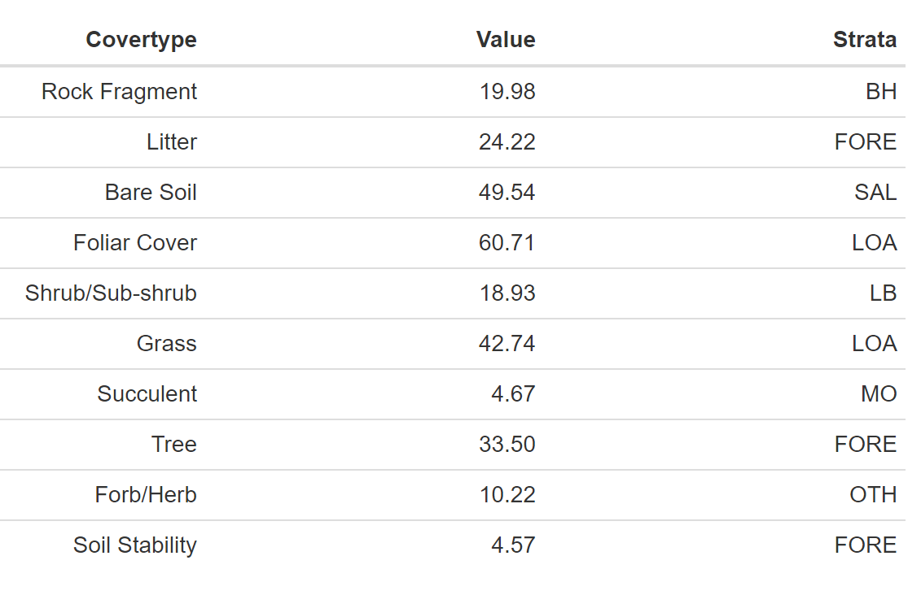

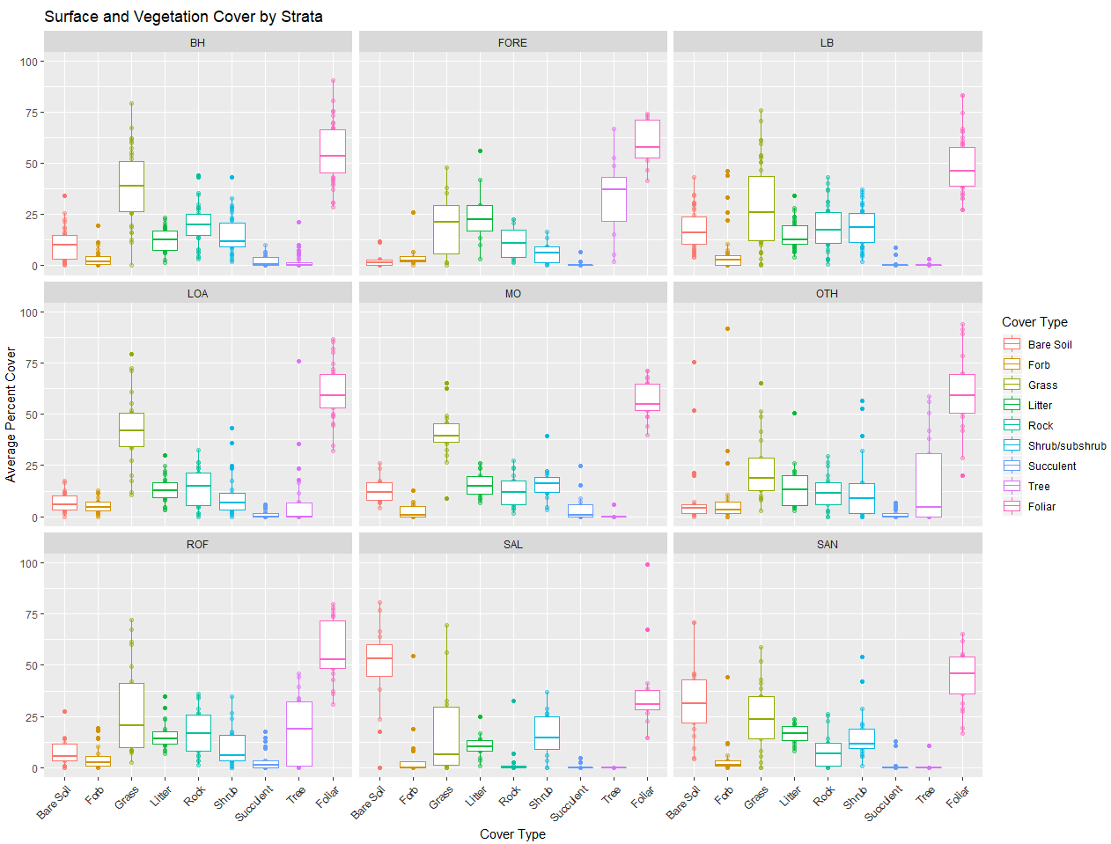

Figure 1. Surface and vegetation cover for all master sample stratum based on LPI results.

Foliar cover was further divided into noxious and nonnoxious categories. The nonnoxious category was calculated using all Nonnoxious Plant Species Percent Any Hit in Query Results. The noxious category was calculated using all Noxious Plant Species Percent Any Hit in Query Results.

For all strata in SLVFO percent nonnoxious species is greater than percent noxious species (Figure 2). Average noxious species per plot was greatest in the SAL stratum (1.71%) followed by the OTH stratum (0.03%). Average percent nonnoxious species per plot was greatest in the LOA stratum (60.71%) followed by the OTH stratum (60.29%). Average percent nonnoxious species per plot was lowest in the SAL stratum (36.21%).

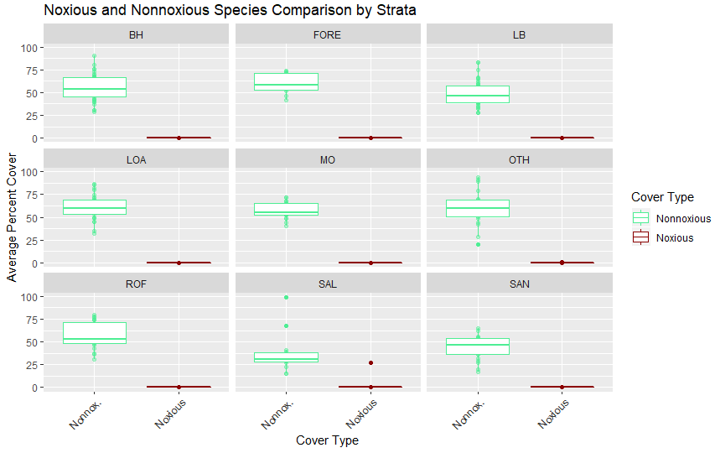

Figure 2. Percent nonnoxious and noxious species for the master sample categorized by stratum based on LPI results.

Annual and perennial grass covers were determined by using TerrADat Query Results, Annual Grass Percent Any Hit and Perennial Grass Percent Any Hit based on LPI results. For strata with grass cover, perennial grass was greater than annual grass for all strata. SAL and SAN have annual grass present on one plot (Figure 3).

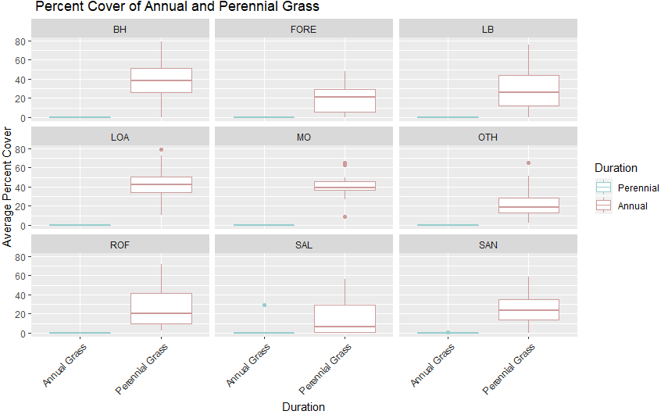

Figure 3. Percent perennial and annual grass hit during LPI for the master sample categorized by stratum.

#### 6.1.3.1 Canopy Gap

TerrADat Gap Detail (based on gap intercept results) was used to determine gap values. For all strata canopy gaps were placed into four groups based on size. The groups included gaps sized 25-50 cm, 51-100 cm, 101-200 cm and 200+ cm.

Average canopy gap per plot was highest in the SAL stratum (66.29%) and lowest in the LOA stratum (31.71%). Canopy gaps separated into the 4 groups described above will be analyzed in each stratum description.

Stratum description will include a final summary table including categories surface indicators, dominant species, gap, height and species richness. Herbaceous heights were calculated using Average Herbaceous Height in TerrADat which is based of heights observed during LPI. Shrub/subshrub and tree heights were calculated from LPI detail in TerrADat. The average heights of shrub/subshrub and tree did not include none (0) values. The TerrADat Species Richness Detail records (based on observations during species richness) were used to calculate species richness.

#### 6.1.4.1 Plots within Stratum Varying from the mean

TerrADat Query Results were used to calculate the mean and standard deviation of each indicator. Indicators included bare soil, soil stability, rock, litter, gap, succulent, tree, shrub, grass, forb, forb height, grass height, noxious species, nonnoxious species and preferred forb number. The Empirical Rule states approximately 95% of the population would be within two standard deviations of the mean. Therefore, the benchmark for each indicator was set to the mean +/- two standard deviations. Bins were created for meeting (value of 1) or not meeting the indicator benchmark (value of 0) and meeting (1) or not meeting (0) all benchmarks. For each plot, the average percent of indicator benchmarks met was calculated using these bins. For the stratum, the number of plots meeting all indicator benchmarks was calculated using the meeting/not meeting all benchmark bins. NAs were not included in the calculation. Plots within allotments with the lowest percent of indicators meeting benchmarks were recorded. If there was more than one plot in the allotment and one of the plots did not reach benchmark, it was noted. Number of plots meeting benchmark within each allotment was calculated using master sample and intensification results. Table 8 displays these results for allotments with at least 3 plots and does not include allotments with all plots meeting the benchmarks. For a comprehensive list of all plots within allotments see Appendix Table 53.

29/69 allotments had plots that did not meet all the stratum indicator benchmarks; 21 of which had ≤ 50% of the plots within the allotment meeting benchmark (Table 8). Flat Top, McIntyre Gulch and Dry Lakes allotments did not have any plots meet the stratum benchmarks (Table 8).

Table 8. Number of plots meeting all stratum indicator benchmarks. Displays allotments with at least 3 plots and at least one plot not meeting all benchmarks.

|  |  |  |  |
| --- | --- | --- | --- |
| **Allotment** | **Plots Meeting Benchmark (#)** | **Plots in Allotment (#)** | **Plots Meeting Benchmark (%)** |
| Flat Top | 0 | 3 | 0 |
| McIntyre Gulch | 0 | 3 | 0 |
| Dry Lakes | 0 | 3 | 0 |
| North Tracy | 1 | 4 | 25 |
| Llano | 1 | 4 | 25 |
| East Bend | 1 | 4 | 25 |
| Foothills | 1 | 4 | 25 |
| Poncha Pass East | 5 | 15 | 33.33 |
| Poncha Pass-West | 1 | 3 | 33.33 |
| Noland Gulch | 1 | 3 | 33.33 |
| Pinon | 2 | 6 | 33.33 |
| Pinon Hills | 2 | 6 | 33.33 |
| None | 14 | 31 | 45.16 |
| Tracy Common | 5 | 11 | 45.45 |
| Trickle Mountain | 7 | 15 | 46.67 |
| McMahon/Greenie | 5 | 10 | 50 |
| Rajadero Canyon | 2 | 4 | 50 |
| Bishop Rock | 3 | 6 | 50 |
| Twin Lakes | 2 | 4 | 50 |
| Lakes | 2 | 4 | 50 |
| Poison Gulch | 3 | 5 | 60 |
| Little Mogotes | 3 | 5 | 60 |
| Valley View Hot Spng | 3 | 5 | 60 |
| River | 2 | 3 | 66.67 |
| Hat Springs | 2 | 3 | 66.67 |
| Capulin | 2 | 3 | 66.67 |
| Cross Creek | 2 | 3 | 66.67 |
| Blanca WHA | 2 | 3 | 66.67 |
| East Carnero Creek | 3 | 4 | 75 |
| Pup Peak | 4 | 5 | 80 |

### 6.1.2 Basalt Hills

The Basalt Hills stratum occupies approximately 112,532 acres of land within the SLVFO, and from 2015-2018, 39 plots within the strata had been sampled. BH ESs include Basalt Hill 7-12" and Basalt Hills (Appendix 52). Site characteristics vary from their ESs typical profile in percent clay (15 plots), percent slope (4 plots), percent rock fragment (18 plots), soil texture (4 plots), landscape type (16 plots), elevation (1 plot), rock fragment type (3 plots) and depth to bedrock (2 plots). Annual precipitation ranges from 7-30.3 inches with a mean of 11.23 inches. Slope ranges from 1.19-58% with a mean of 16.27%. Elevation ranges from 2,285-2,769 meters with a mean of 2,501 meters. Landscape type is predominantly Hills/Mountains (27 plots) followed by Fan Piedmont (10 plots) and Terraces (2 plots). The most common soil textures include loam (36 horizons), sandy loam (24 horizons) and clay loam (14 horizons). Rock fragments range from 0-90% with a mean of 29.45%. Effervescence ranges from non-effervescent to violently effervescent, violently being most common. Percent clay ranges from 1-60% with a mean of 17.76%. BOGR2, HECO26, KRLA2, PIED, ELEL5 and CHGR6 are common species for the BH stratum.

#### 6.1.2.1 Soil Stability

Soil stability has an average of 3.36 for all samples with a difference of more than 1 between samples under and not under cover (Table 9).

Table 9. Summary of soil stability test results in the BH stratum. ME is the margin of error calculated using an 80% confidence interval.

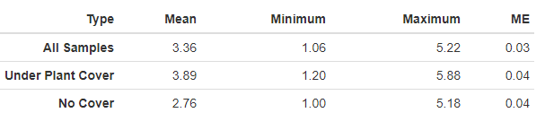

#### 6.1.2.2 Vegetation and Surface Cover

Grass and rock are the most dominant cover type in the BH stratum (Figure 4). Graminoid species BOGR2 dominated the stratum (Figure 5 and Table 10). The BH stratum does not have any noxious or annual grass species currently reported (Figure 2, Figure 3).

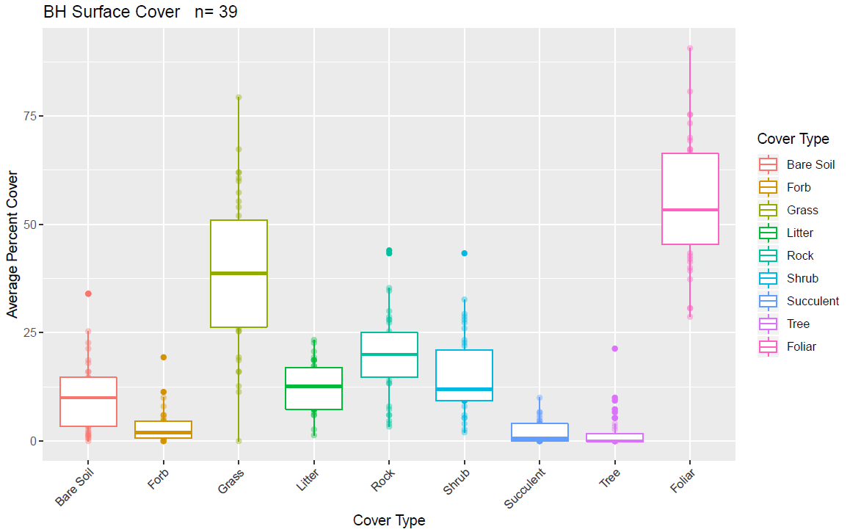

Figure 4. Surface and vegetation cover using line-point intercept results for the BH stratum. n=population size.

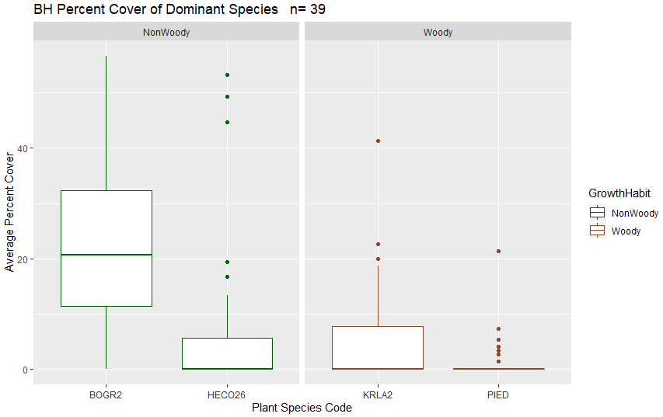

Figure 5. Dominant species categorized by growth habit (woody or nonwoody) in the BH stratum based on LPI results. n=population size.

#### 6.1.2.3 Canopy Gap

Percent canopy gap ranges from 13.12-31.93% of the plot. Percent canopy cover ranges from 29.03-86.88% of the plot. The average percent of canopy gaps per plot is 41.48% and the average canopy cover is 58.52% (Figure 6).

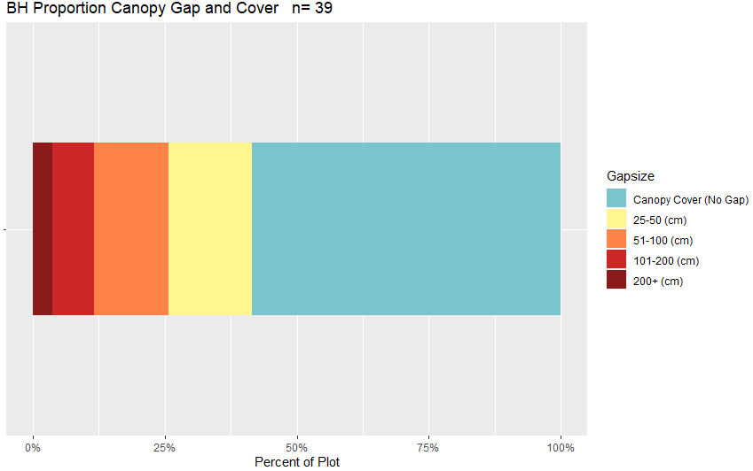

Figure 6. Bar chart of average canopy cover and canopy gaps per plot for the BH stratum based on Gap Intercept results. Canopy cover was determined by subtracting the percent canopy gaps from 100. n=population size.

Table 10. Surface indicators, vegetation cover, canopy gap and cover, and species richness values determined using LPI for the BH stratum. Percent values are the average percent hit. ME is the margin of error calculated using an 80% confidence interval.

|  |  |  |  |  |  |
| --- | --- | --- | --- | --- | --- |
| **Indicator** | **Mean** | **Minimum** | **Maximum** | **St.Dev.** | **ME** |
| **Surface Indicator (%)** | | |  |  |  |
| Rock Fragment | 19.98 | 3.33 | 44 | 9.89 | 0.32 |
| Litter | 12.53 | 1.33 | 23.33 | 5.54 | 0.18 |
| Bare Soil | 10.56 | 0 | 34 | 8.67 | 0.28 |
| **Foliar Cover (%)** | |  |  |  |  |
| Shrub/Sub-shrub | 15.09 | 2 | 43.33 | 9.25 | 0.3 |
| Grass | 38.48 | 0 | 79.33 | 17.57 | 0.58 |
| Succulent | 2.03 | 0 | 10 | 2.5 | 0.08 |
| Tree | 1.95 | 0 | 21.33 | 4.24 | 0.14 |
| Noxious Forb/Herb | 0 | 0 | 0 | 0 | 0 |
| Nonnoxious Forb/Herb | 3.23 | 0 | 20.67 | 3.97 | 0.13 |
| **Vegetation Height (cm)** | | |  |  |  |
| Grass | 26.86 | 6 | 48.07 | 9.94 | 0.33 |
| Forb/Herb | 21.89 | 2 | 44.25 | 11.79 | 0.39 |
| Tree | 224.93 | 25 | 610 | 127.91 | 4.2 |
| Shrub | 26.48 | 2 | 482 | 28.32 | 0.93 |
| **Dominant Grass Cover (%)** | | |  |  |  |
| BOGR2 | 22.29 | 0 | 56.67 | 14.87 | 0.49 |
| HECO26 | 7.49 | 0 | 53.33 | 15.4 | 0.51 |
| **Dominant Herb. Cover (%)** | | |  |  | 0 |
| NA | NA | NA | NA | NA | NA |
| **Dominant Woody Cover (%)** | | |  |  |  |
| KRLA2 | 5.11 | 0 | 41.33 | 8.85 | 0.29 |
| PIED | 1.28 | 0 | 21.33 | 3.71 | 0.12 |
| **Canopy Gaps (%)** | |  |  |  |  |
| Gaps 25-50 cm | 15.81 | 1.39 | 25.39 | 5.24 | 0.17 |
| Gaps 51-100 cm | 14.07 | 3.13 | 27.16 | 6.57 | 0.22 |
| Gaps 101-200 cm | 7.94 | 0 | 22.28 | 6.01 | 0.2 |
| Gaps >200 cm | 3.66 | 0 | 42.95 | 7.45 | 0.24 |
| **Canopy Cover (%)** | |  |  |  |  |
| Total Canopy Cover | 58.52 | 29.03 | 86.88 | 14.47 | 0.48 |
| **Species Richness** | |  |  |  |  |
| No. Species per Plot | 25 | 2 | 53 | 10.83 | 0.36 |

#### 6.1.2.4 Plots Meeting Benchmark

20 plots (51.28%) met all indicator benchmarks in the BH stratum (Figure 7, Table 11). Within the allotments, 2/4 McMahon/Greenie, ½ Pup Peak and 3/5 Poncha Pass East plots did not meet all indicator benchmarks (Appendix 54). Plots with the lowest percent of indicator benchmarks met included HILL-051(16) within the Pup Peak allotment and HILL-019 within the Llano allotment (Appendix 54). Grass height and cover, and forb height were the most common indicator benchmarks not met (Table 11).

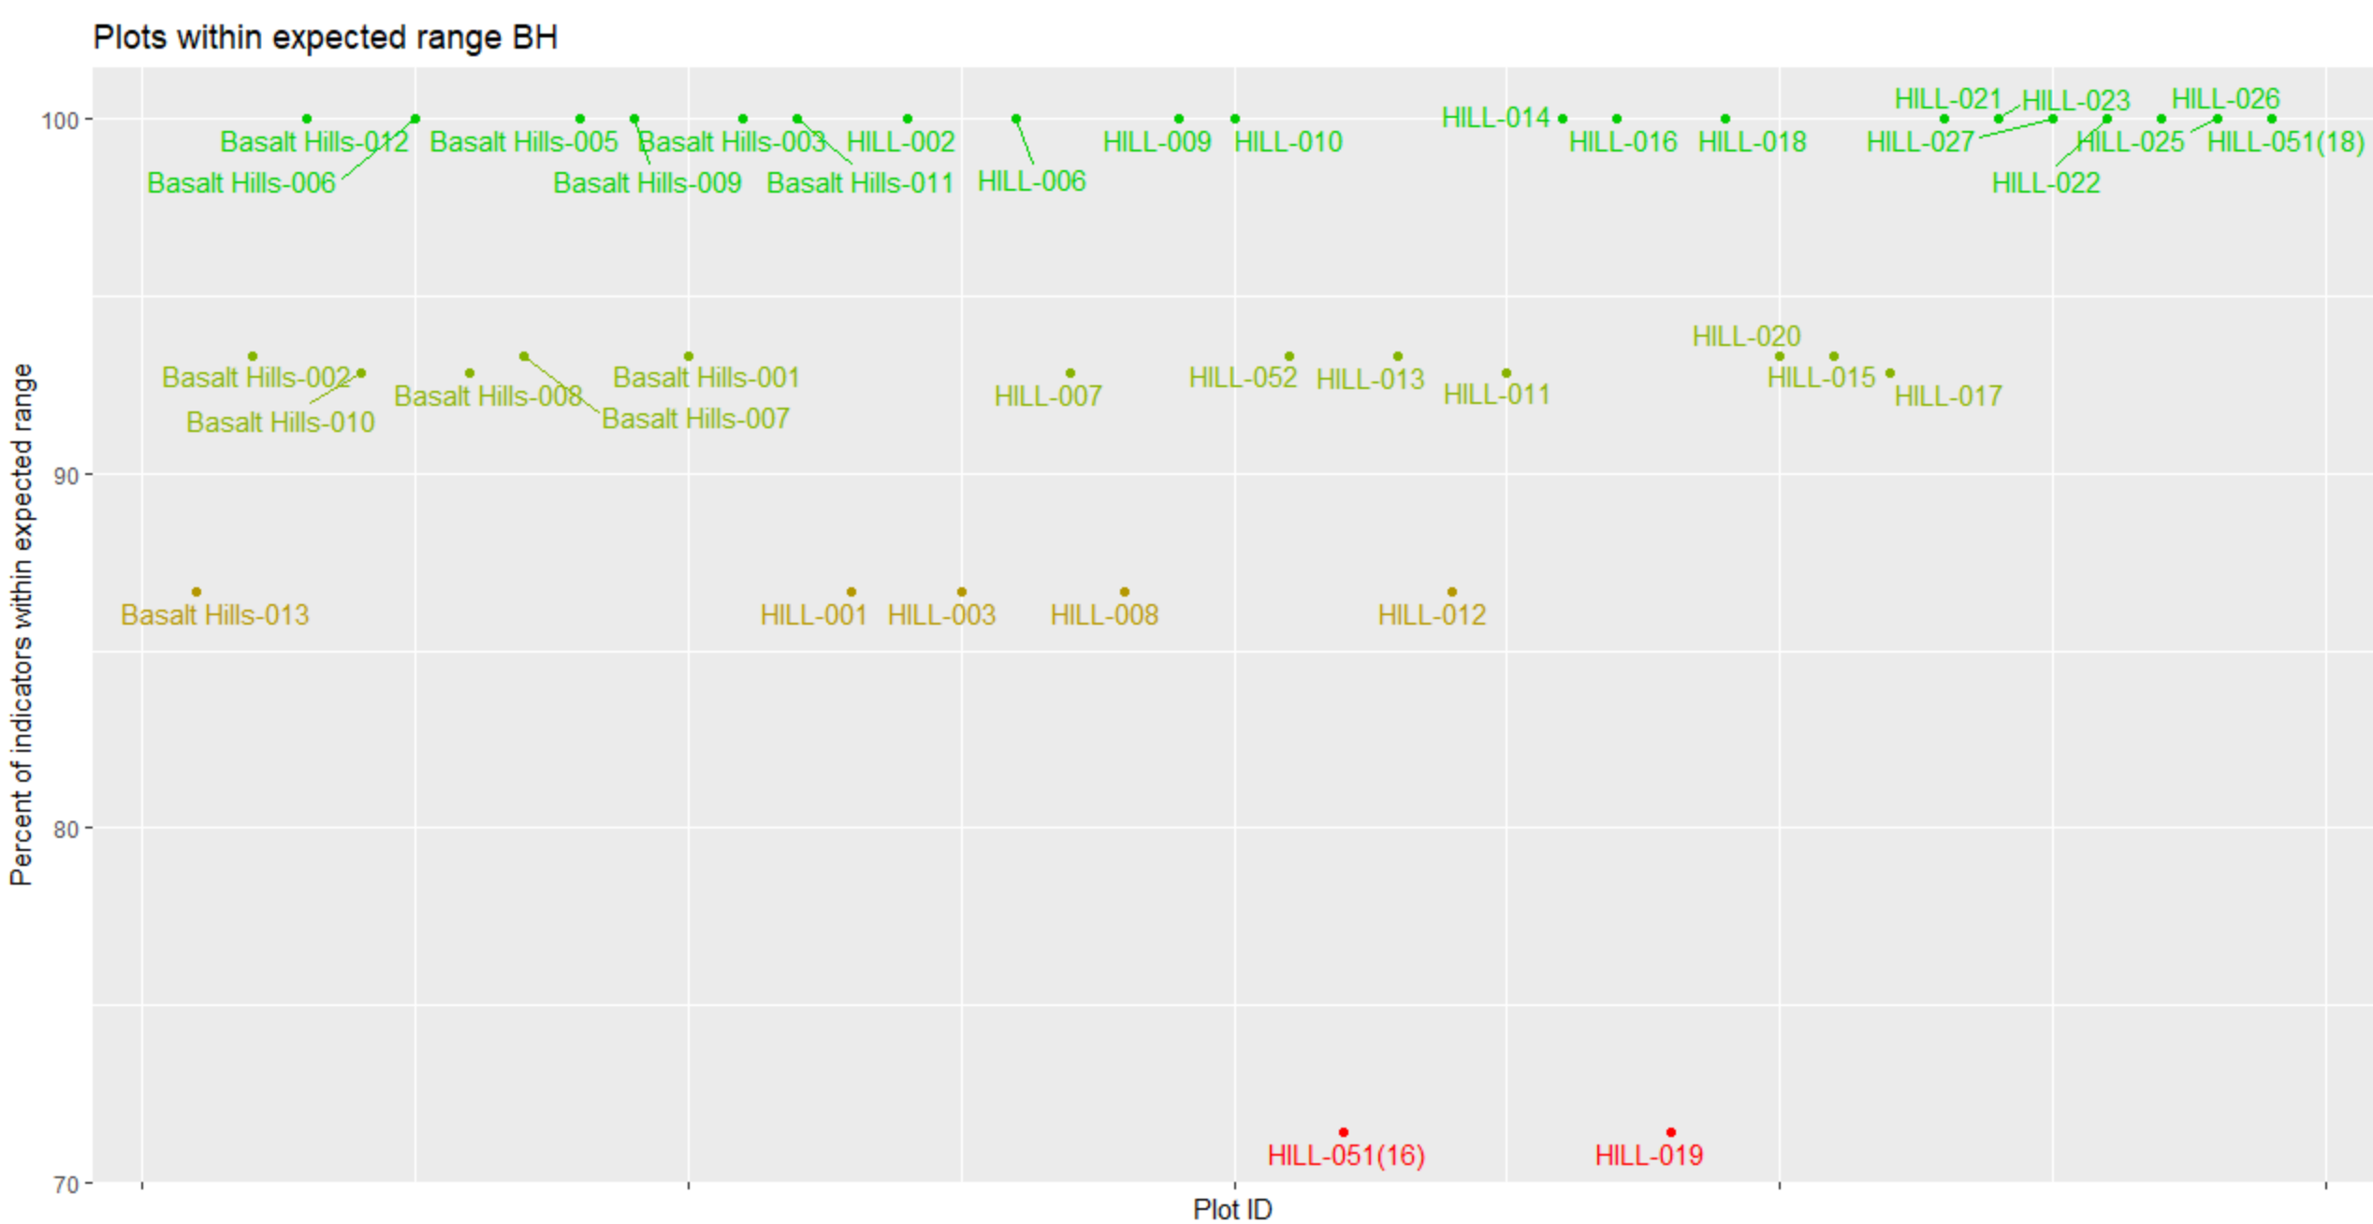

Figure 7. Percent of indicators meeting their expected benchmark range for each plot in the BH stratum.

Table 11. Percent of plots in the BH stratum that met each indicator.

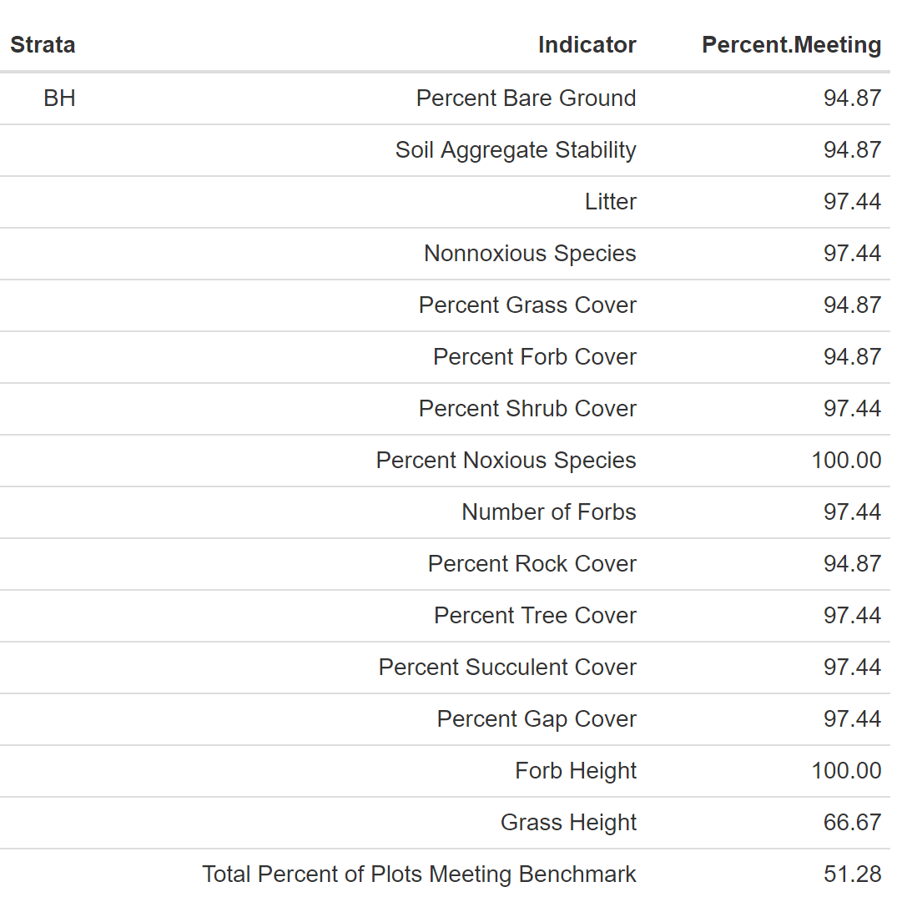

### 6.1.3 Limy Bench

The Limy Bench stratum occupies approximately 17,868 acres in the SLVFO, and from 2015-2018, 43 plots within the strata had been sampled. The LB ESs includes Limy Bench or only has the ESD listed (Appendix 52). Multiple characteristics vary from the typical profile including landscape type (12 plots), percent rock fragment (14 plots), percent clay (13 plots), texture (18 plots), percent slope (9 plots), elevation (4 plots), annual precipitation (4 plots), rock fragment type (4 plots) and depth to bedrock (1 plot). 9 plots did not have percent rock fragment recorded. Variation in texture is predominantly due to presence of sand in gravelly soils. Annual precipitation ranges from 7-120 in with a mean of 12.8 in. Slope ranges from 0.001 to 22.96% with a mean of 4.315%. Elevation ranges from 2,294-2,572 meters with a mean of 2,412 meters. Landscape type is predominantly Fan/Piedmont (21 plots) followed by Terrace (14 plots), Hills/Mountains (3 plots), Flat Plain (3 plots), Flood Plain/Basin (1 plot) and Other (1 plot). Soil textures are predominantly loam (50 horizons), sandy loam (31 horizons) and clay loam (15 horizons). Rock fragments range from 0-90% with a mean of 24.3%. Effervescence ranges from non-effervescent to violently effervescent, violently being the most common. Clay ranged from 3-52% with a mean of 15.08%. BOGR2, KRLA2, PASM, SATR12, CHGR6 AND ELEL5 are common species.

#### 6.1.3.1 Soil Stability

Soil stability has an average of 2.91 for all samples with a difference of 0.95 between samples under and not under cover (Table 12).

Table 12. Summary of soil stability test results in the LB stratum. ME is the margin of error calculated using an 80% confidence interval.

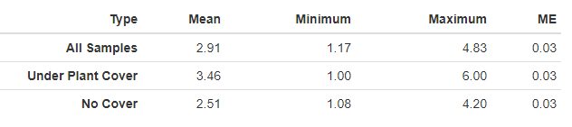

#### 6.1.3.2 Vegetation and Surface Cover

Grass, shrub and rock are the most dominant cover type in the LB stratum (Figure 8). Grass species BOGR2 and woody species KRLA2 dominate the stratum (Figure 9 and Table 13). The LB stratum does not have any noxious or annual grass species currently reported (Figure 2, Figure 3).

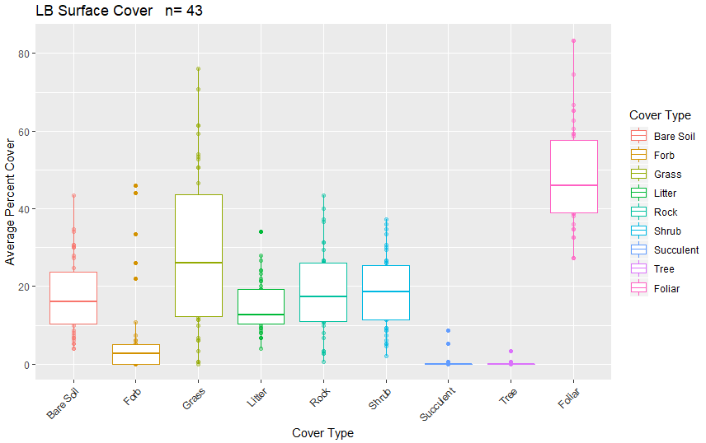

Figure 8. Surface and vegetation cover using line-point intercept results for the LB stratum. n=population size.

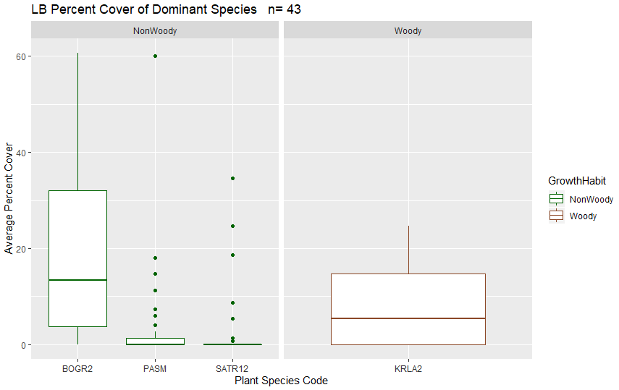

Figure 9. Dominant species categorized by growth habit (woody or nonwoody) in the LB stratum based on LPI results. n=population size.

#### 6.1.3.3 Canopy Gap

Canopy gap ranges from 11.73-79.35% of the plot. Canopy cover ranges from 20.65-88.27% of the plot. The average percent of canopy gaps per plot is 47.54% and the average percent canopy cover is 52.46% (Figure 10).

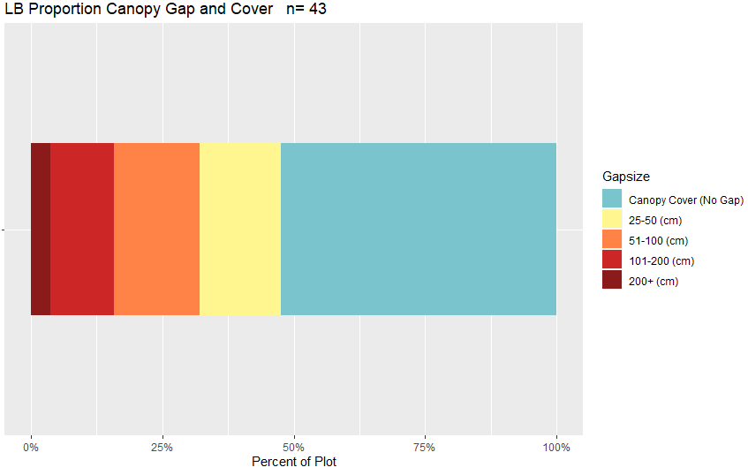

Figure 10. Bar chart of canopy cover and canopy gaps average per plot for the LB stratum based on Gap Intercept results. Canopy cover was determined by subtracting the percent canopy gaps from 100. n=population size.

Table 13. Surface indicators, vegetation cover, canopy gap and cover, and species richness values determined using LPI for the LB stratum. Percent values are the average percent hit. ME is the margin of error calculated using an 80% confidence interval.

|  |  |  |  |  |  |
| --- | --- | --- | --- | --- | --- |
| **Indicator** | **Mean** | **Minimum** | **Maximum** | **St.Dev.** | **ME** |
| **Surface Indicator (%)** | | |  |  |  |
| Rock Fragment | 18.05 | 0.67 | 43.33 | 10.5 | 0.31 |
| Litter | 14.95 | 4 | 34 | 6.69 | 0.2 |
| Bare Soil | 17.32 | 4 | 43.33 | 9.69 | 0.29 |
| **Foliar Cover (%)** | |  |  |  |  |
| Shrub/Sub-shrub | 18.93 | 2 | 37.33 | 9.38 | 0.28 |
| Grass | 28.99 | 0 | 76 | 20.56 | 0.61 |
| Succulent | 0.42 | 0 | 8.67 | 1.53 | 0.05 |
| Tree | 0.09 | 0 | 3.33 | 0.52 | 0.02 |
| Noxious Forb/Herb | 0 | 0 | 0 | 0 | 0 |
| Nonnoxious Forb/Herb | 6.17 | 0 | 46 | 11.27 | 0.34 |
| **Vegetation Height (cm)** | | |  |  |  |
| Grass | 22.28 | 11.43 | 40 | 8.04 | 0.24 |
| Forb/Herb | 17.2 | 2 | 40 | 9.28 | 0.28 |
| Tree | 127.5 | 120 | 135 | 10.61 | 0.32 |
| Shrub | 22.2 | 1 | 97 | 11.53 | 0.34 |
| **Dominant Grass Cover (%)** | | |  |  |  |
| BOGR2 | 19.18 | 0 | 60.67 | 18.81 | 0.56 |
| PASM | 3.12 | 0 | 60 | 9.75 | 0.29 |
| **Dominant Herb. Cover (%)** | | |  |  |  |
| SATR12 | 2.23 | 0 | 34.67 | 6.99 | 0.21 |
| **Dominant Woody Cover (%)** | | |  |  |  |
| KRLA2 | 7.46 | 0 | 24.67 | 7.77 | 0.21 |
| **Canopy Gaps (%)** | |  |  |  |  |
| Gaps 25-50 cm | 15.39 | 7.19 | 26.99 | 4.75 | 0.14 |
| Gaps 51-100 cm | 16.3 | 2.52 | 26.48 | 5.85 | 0.17 |
| Gaps 101-200 cm | 12.25 | 0 | 34.51 | 10.2 | 0.3 |
| Gaps >200 cm | 3.6 | 0 | 22.19 | 5.2 | 0.16 |
| **Canopy Cover (%)** | |  |  |  |  |
| Total Canopy Cover | 52.46 | 20.65 | 88.27 | 15.18 | 0.45 |
| **Species Richness** | |  |  |  |  |
| No. Species per Plot | 17.14 | 6 | 43 | 7.18 | 0.21 |

#### 6.1.3.4 Plots Meeting Benchmark

17 plots (39.53%) met all indicator benchmarks (Figure 11). Within the allotments, 2/3 Bishop Rock, 1/3 Capulin, ½ Findley Gulch, ½ Llano, 2/2 McIntyre Gulch, ½ McMahon/Greenie, 2/3 Pinon, 2/2 San Antonion and ½ Twin Lakes plots did not meet all indicator benchmarks (Appendix 55). Grass and forb height and gaps were the indicator benchmarks most commonly not met (Table 14). Plots with the lowest percent of indicator benchmarks met include LIMY-076 in the Piney Creek allotment, Limy Bench-050 in the Tracy Common allotment and Limy-071 in the Twin Lakes allotment (Appendix 55).

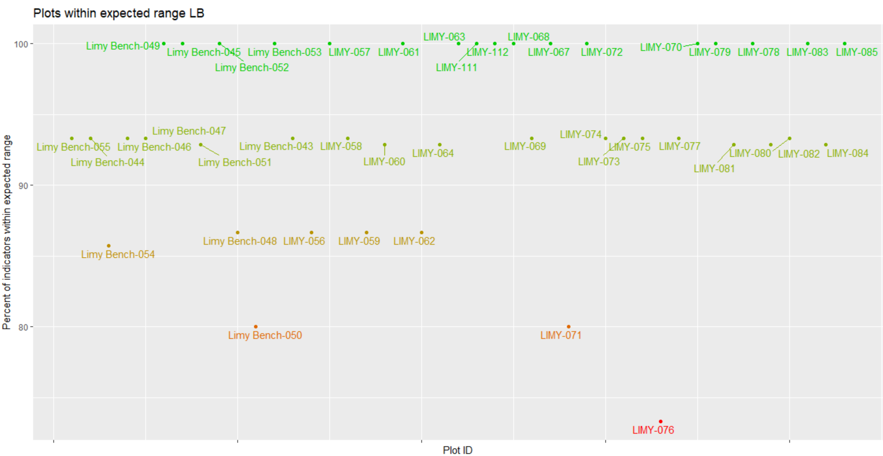

Figure 11. Percent of indicators meeting their expected benchmark range for each plot in the LB stratum.

Table 14. Percent of plots in the LB stratum that met each indicator.

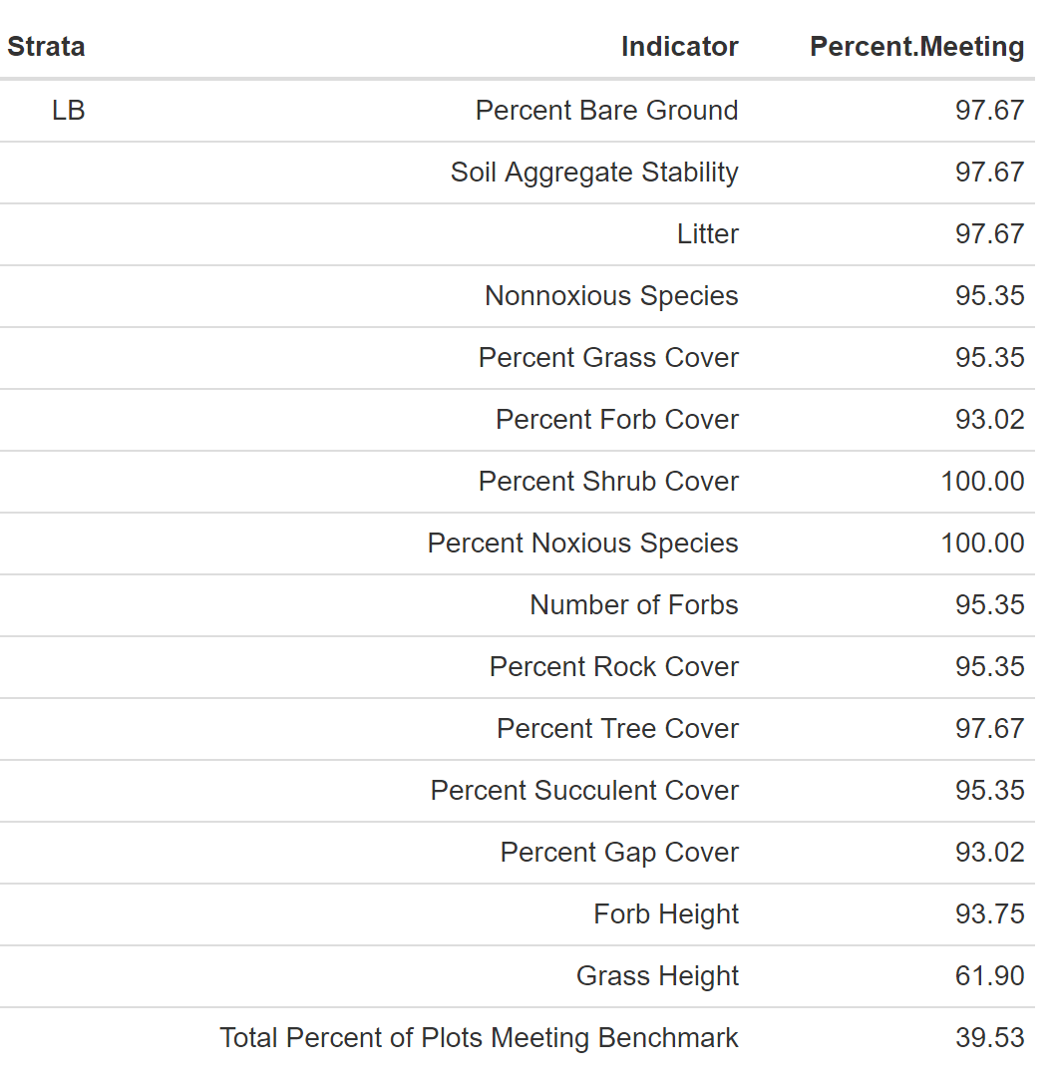

### 6.1.4 Loamy

The Loamy stratum occupies approximately 82,887 acres in the SLVFO, and from 2015-2018, 29 plots had been sampled. ESs include Mountain Loam 10-14" P.Z., Shallow Loam, Foothill Loam and Limy Bench (Appendix 52). Multiple variations from ES typical profile characteristics include texture (3 plots), percent clay (8 plots), landscape type (5 plots), percent rock fragment (10 plots), rock fragment type (1 plot), effervescence (1 plot), texture (9 plots), percent slope (3 plots) and elevation (2 plots). Percent rock fragment was not recorded for 8 plots. Variation in texture is predominantly due to sand in soils that were gravelly and/or contained unweathered bedrock. Annual precipitation ranges from 9.68-21.91 inches with a mean of 15.95 inches. Slope ranges from 2.5-43.97% with a mean of 17.21%. Elevation ranges from 2,399-2,983 meters with a mean of 2,723 meters. Landscape type is predominantly Hills/Mountains (24 plots) followed by Fan Piedmont (5 plots). Soil texture is predominantly loam (24 horizons), sandy loam (19 horizons) and clay loam (13 horizons). Rock fragments range from 0-93% with a mean of 29.84%. Effervescence ranges from non-effervescent to violently, violently being the most common. Percent clay ranges from 2-35% with a mean of 17%. BOGR2, MUMO, MUTO2 and PIED are common species.

#### 6.1.4.1 Soil Stability

The average soil stability for all samples was 3.98 with a difference of 1.07 between samples under and not under cover (Table 15).

Table 15. Summary of soil stability test results in the LOA stratum. ME is the margin of error calculated using an 80% confidence interval.

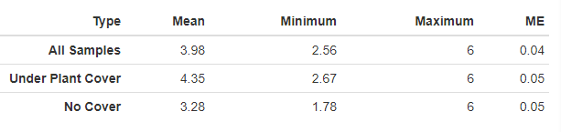

#### 6.1.4.2 Vegetation and Surface Cover

Grass, rock and litter are the most dominant cover type in the LOA stratum (see Figure 12). Grass species BOGR2 dominates the stratum (Figure 13 and Table 16). The LOA stratum does not have any noxious or annual grass species currently reported (Figure 2, Figure 3).

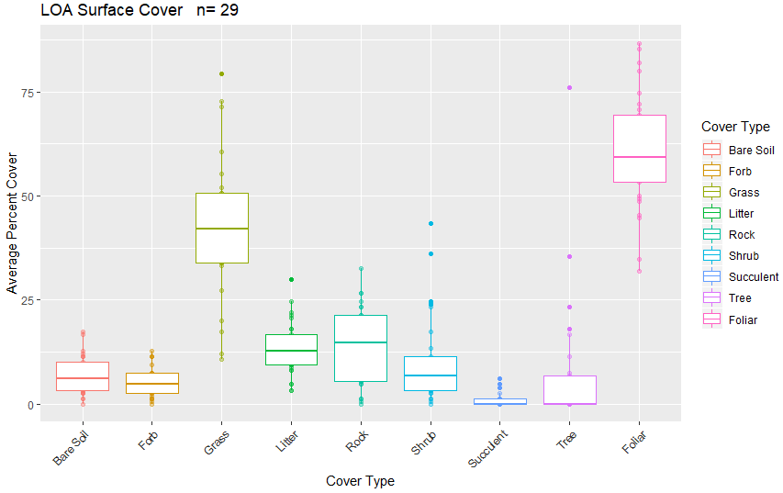

Figure 12. Surface and vegetation cover using line-point intercept results for the LOA stratum. n=population size.

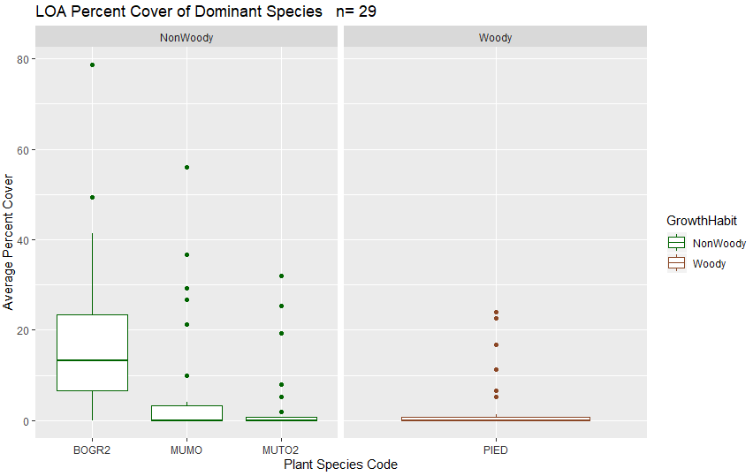

Figure 13. Dominant species categorized by growth habit (woody or nonwoody) in the LOA stratum based on LPI results. n=population size.

#### 6.1.4.3 Canopy Gap

Canopy gap ranges from 5.69-56.91% of the plot. Canopy cover ranges from 43.09-94.31% of the plot. The average percent of canopy gaps per plot is 31.71% and the average percent canopy cover is 68.29% (Figure 14).

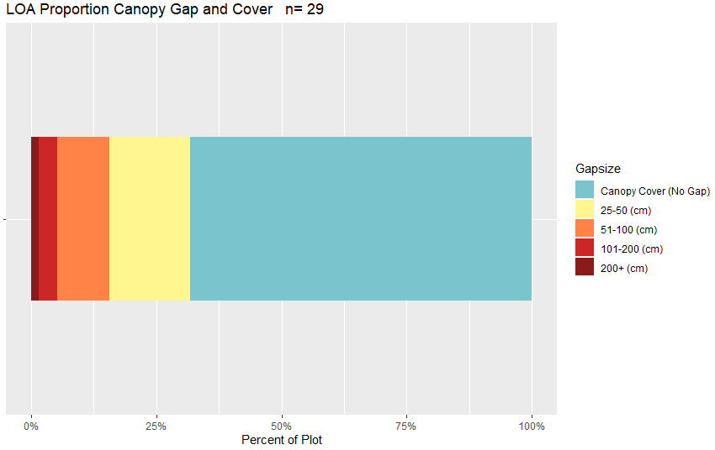

Figure 14. Bar chart of canopy cover and canopy gaps average per plot for the LOA stratum based on Gap Intercept results. Canopy cover was determined by subtracting the percent canopy gaps from 100. n=population size.

Table 16. Surface indicators, vegetation cover, canopy gap and cover, and species richness values determined using LPI for the LOA stratum. Percent values are the average percent hit. ME is the margin of error calculated using an 80% confidence interval.

|  |  |  |  |  |  |
| --- | --- | --- | --- | --- | --- |
| **Indicator** | **Mean** | **Minimum** | **Maximum** | **St.Dev.** | **ME** |
| **Surface Indicator (%)** | | |  |  |  |
| Rock Fragment | 14 | 0 | 32.67 | 9.17 | 0.41 |
| Litter | 13.4 | 3.33 | 30 | 6.44 | 0.28 |
| Bare Soil | 7.06 | 0 | 17.33 | 4.54 | 0.2 |
| **Foliar Cover (%)** | |  |  |  |  |
| Shrub/Sub-shrub | 10.34 | 0 | 43.33 | 10.6 | 0.47 |
| Grass | 42.74 | 10.67 | 79.33 | 16.43 | 0.73 |
| Succulent | 1.24 | 0 | 6 | 1.92 | 0.08 |
| Tree | 7.33 | 0 | 76 | 15.7 | 0.69 |
| Noxious Forb/Herb | 0 | 0 | 0 | 0 | 0 |
| Nonnoxious Forb/Herb | 5.33 | 0 | 12.67 | 3.43 | 0.15 |
| **Vegetation Height (cm)** | | |  |  |  |
| Grass | 29.15 | 11.85 | 56.87 | 10.89 | 0.48 |
| Forb/Herb | 25.71 | 5 | 51.6 | 13.52 | 0.6 |
| Tree | 653.43 | 20 | 1750 | 606.77 | 26.82 |
| Shrub | 36.07 | 5 | 195 | 29.57 | 1.31 |
| **Dominant Grass Cover (%)** | | |  |  |  |
| BOGR2 | 18.83 | 0 | 78.67 | 17.59 | 0.78 |
| **Dominant Herb. Cover (%)** | | |  |  |  |
| MUMO | 6.62 | 0 | 56 | 13.85 | 0.61 |
| MUTO2 | 3.22 | 0 | 32 | 8.1 | 0.36 |
| **Dominant Woody Cover (%)** | | |  |  |  |
| PIED | 3.06 | 0 | 24 | 6.81 | 0.3 |
| **Canopy Gaps (%)** | |  |  |  |  |
| Gaps 25-50 cm | 16.03 | 2.09 | 28.24 | 6.14 | 0.27 |
| Gaps 51-100 cm | 10.41 | 0.92 | 20.87 | 6.37 | 0.28 |
| Gaps 101-200 cm | 3.84 | 0 | 18.4 | 5 | 0.22 |
| Gaps >200 cm | 1.43 | 0 | 15.55 | 3.67 | 0.16 |
| **Canopy Cover (%)** | |  |  |  |  |
| Total Canopy Cover | 68.29 | 43.09 | 94.31 | 14.23 | 0.63 |
| **Species Richness** | |  |  |  |  |
| No. Species per Plot | 32.1 | 15 | 64 | 12.62 | 0.56 |

#### 6.1.4.4 Percent Meeting Benchmark

13 plots (44.83%) met all indicator benchmarks (Figure 15, Table 17). Within the allotments, ½ Bishop Rock, ½ East Carnero Creek, ½ Hat Springs, 2/2 Kerber Creek and 6/11 Trickle Mountain plots did not meet all indicator benchmarks (Appendix 56). Plots with the lowest percent of indicator benchmarks met include Loamy-092 within the Kerber Creek allotment, LOAM-126, Loamy-086 and Loamy-085 within the Trickle Mountain allotment, Loamy-088 within the Poncha Pass East allotment, LOAM-123 within the Pinon Hills allotment and LOAM-127 within the Bishop Rock Allotment (Appendix 56). Forb height and grass height are the indicators most commonly not met (Table 17).

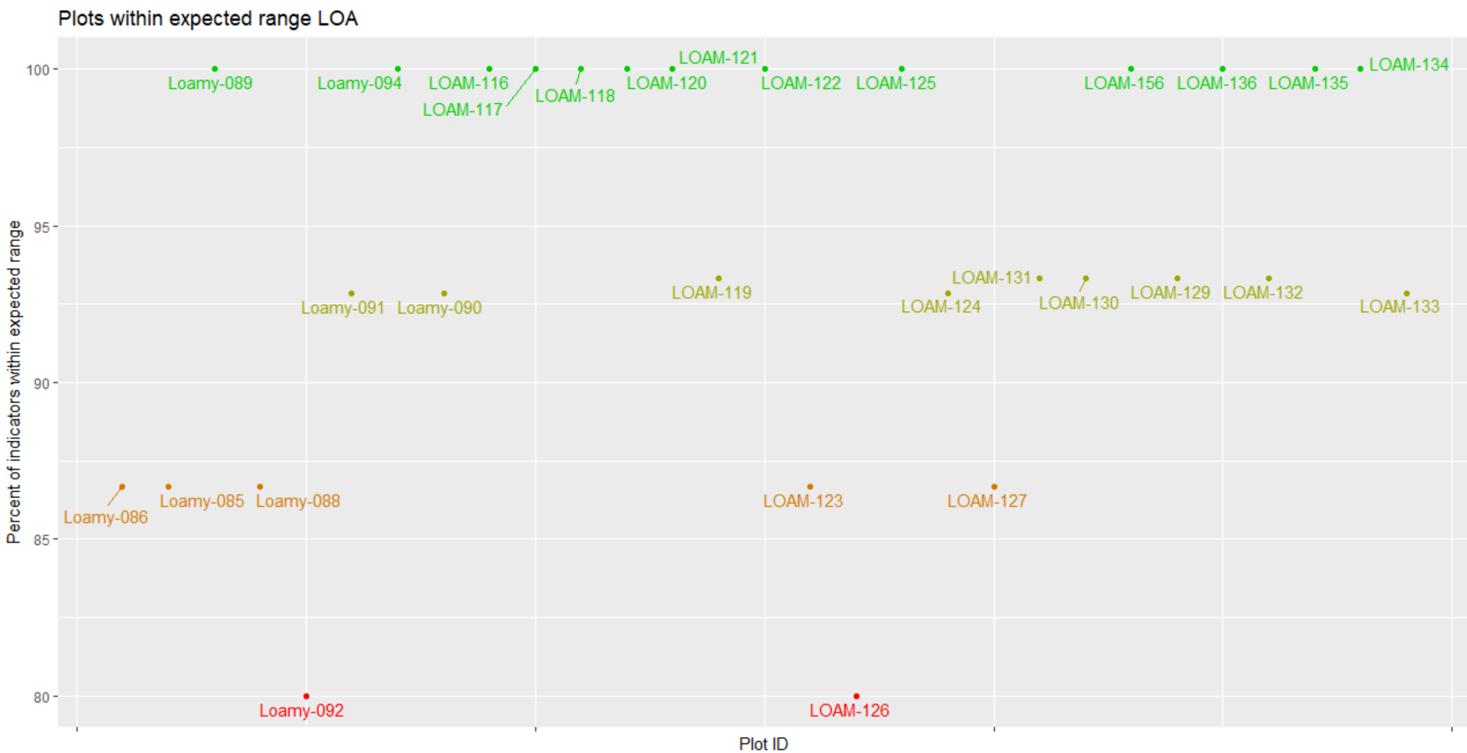

Figure 15. Percent of indicators meeting their expected benchmark range for each plot in the LOA stratum.

Table 17. Percent of plots in the LOA stratum that met each indicator.

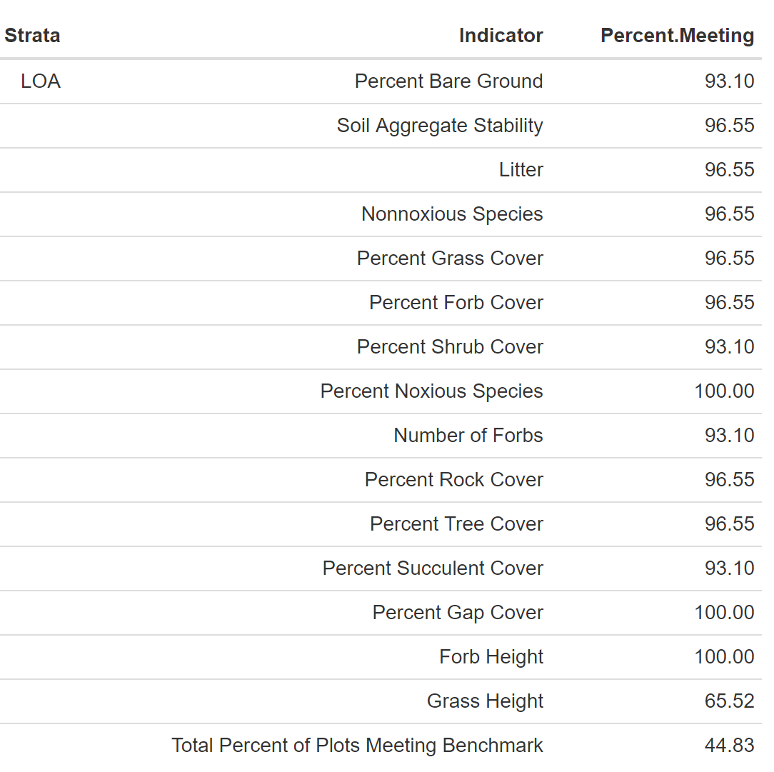

### 6.1.5 Mountain Outwash

The Mountain Outwash stratum occupies approximately 59,671 acres of land within the SLVFO, and from 2015-2018, 20 plots had been sampled within this stratum. ESs include Mountain Outwash, Salt Meadow, Limy Bench and Mountain Loam 10-14" P.Z. (Appendix 52). Multiple variations from the ES typical profile occur including characteristics landscape type (4 plots), elevation (5 plots), texture (9 plots), percent clay (11 plots), slope (9 plots), percent rock fragment (9 plots), rock fragment type (2 plots), annual precipitation (1 plot), slope (1 plot), and depth to bedrock (1 plot). Percent rock fragment was not recorded for 4 plots. Variation in texture is typically due to sand textures in gravelly soils. Annual precipitation ranges from 7-18.77 inches with a mean of 10.47 inches. Slope ranged from 1.07-9.7% with a mean of 3.94%. Elevation ranges from 2,270-2,679 meters with a mean of 2,427 meters. Landscape type is predominantly Fan Piedmont (14 plots) followed by Terrace (2 plots), Flat Plain (2 plots), Hills/Mountains (1 plot) and Other (1 plot). Soil texture is predominantly sandy loam (20 horizons), loam (17 horizons) and sandy clay loam (8 horizons). Rock fragments range from 0-90% with a mean of 28.24%. Effervescence ranges from non-effervescent to violently, with non-effervescent being the most common. Clay ranges from 3-35% with a mean of 17.56%. BOGR2, HECO26, PASM, CHGR6, ELEL5, ERNA10 and OPPO are common species.

#### 6.1.5.1 Soil Stability

The average soil stability for all samples is 3 with a difference of 0.95 between samples under and not under cover (Table 18).

Table 18. Summary of soil stability test results in the MO stratum. ME is the margin of error calculated using an 80% confidence interval.

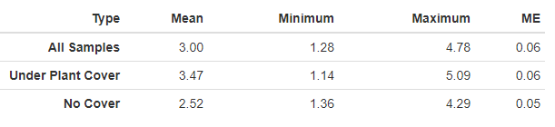

#### 6.1.5.2 Vegetation and Surface Cover

Grass, shrub and litter are the dominant cover types for the LOA stratum (Figure 16). Grass species BOGR2 and shrub species CHGR6 dominate the strata (Figure 17, Table 19). No noxious or annual grass species have been reported (Figure 2 and Figure 3).

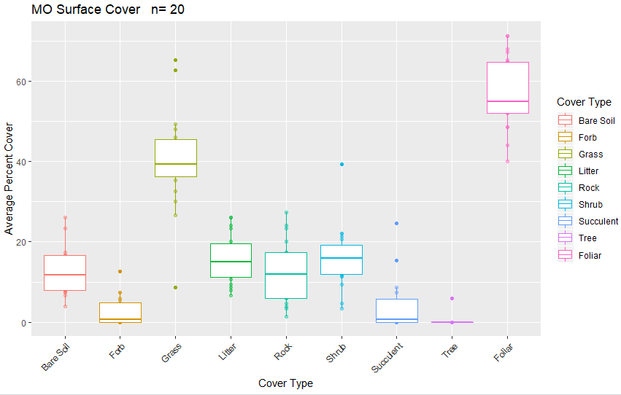

Figure 16. Surface and vegetation cover using line-point intercept results for the MO stratum. n=population size.

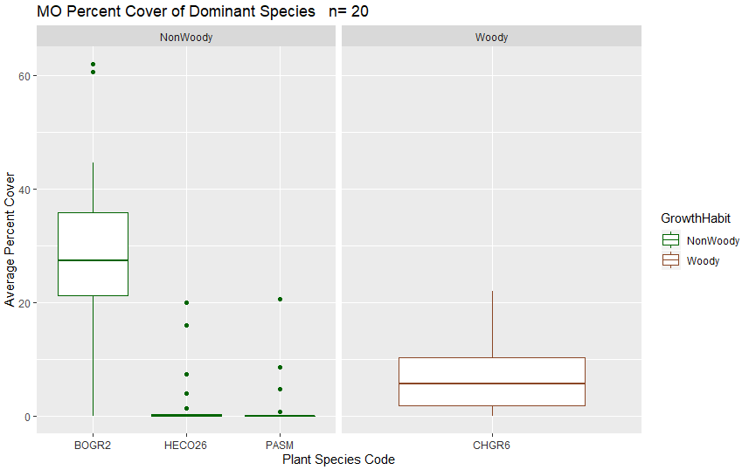

Figure 17. Dominant species categorized by growth habit (woody or nonwoody) in the MO stratum based on LPI results. n=population size.

#### 6.1.5.3 Canopy Gap

Canopy gap ranges from 16.29-66.91% of the plot. Canopy cover ranges from 33.09-83.71% of the plot. The average percent canopy gap per plot is 39.39% and the average percent canopy cover is 60.61% (Figure 18).

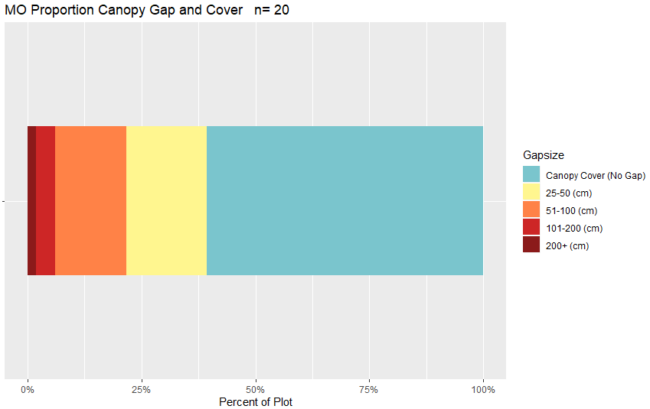

Figure 18. Bar chart of canopy cover and canopy gaps average per plot for the MO stratum based on Gap Intercept results. Canopy cover was determined by subtracting the percent canopy gaps from 100. n=population size.

Table 19. Surface indicators, vegetation cover, canopy gap and cover, and species richness values determined using LPI for the MO stratum. Percent values are the average percent hit. ME is the margin of error calculated using an 80% confidence interval.

|  |  |  |  |  |  |
| --- | --- | --- | --- | --- | --- |
| **Indicator** | **Mean** | **Minimum** | **Maximum** | **St.Dev.** | **ME** |
| **Surface Indicator (%)** | | |  |  |  |
| Rock Fragment | 12.43 | 1.33 | 27.33 | 7.61 | 0.49 |
| Litter | 15.63 | 6.67 | 26 | 5.95 | 0.38 |
| Bare Soil | 12.57 | 4 | 26 | 5.68 | 0.36 |
| **Foliar Cover (%)** | |  |  |  |  |
| Shrub/Sub-shrub | 16.17 | 3.33 | 39.33 | 7.59 | 0.49 |
| Grass | 40.33 | 8.67 | 65.33 | 12.05 | 0.77 |
| Succulent | 4.67 | 0 | 24.67 | 6.78 | 0.43 |
| Tree | 0.3 | 0 | 6 | 1.34 | 0.09 |
| Noxious Forb/Herb | 0 | 0 | 0 | 0 | 0 |
| Nonnoxious Forb/Herb | 2.6 | 0 | 12.67 | 3.52 | 0.23 |
| **Vegetation Height (cm)** | | |  |  |  |
| Grass | 27.15 | 14.1 | 45.55 | 8.37 | 0.54 |
| Forb/Herb | 38.3 | 17.33 | 70 | 18.47 | 1.18 |
| Tree | 121 | 83 | 150 | 34.39 | 2.2 |
| Shrub | 25.89 | 2 | 92 | 11.71 | 0.75 |
| **Dominant Grass Cover (%)** | | |  |  |  |
| BOGR2 | 28.63 | 0 | 62 | 16.35 | 1.05 |
| HECO26 | 2.43 | 0 | 20 | 5.66 | 0.36 |
| PASM | 1.73 | 0 | 20.67 | 4.94 | 0.32 |
| **Dominant Herb. Cover (%)** | | |  |  |  |
| NA | NA | NA | NA | NA | NA |
| **Dominant Woody Cover (%)** | | |  |  |  |
| CHGR6 | 6.67 | 0 | 22 | 6.08 | 0.39 |
| **Canopy Gaps (%)** | |  |  |  |  |
| Gaps 25-50 cm | 17.68 | 11.16 | 23.67 | 3.22 | 0.21 |
| Gaps 51-100 cm | 15.68 | 4.67 | 28.05 | 6.57 | 0.42 |
| Gaps 101-200 cm | 4.23 | 0 | 21.67 | 5.48 | 0.35 |
| Gaps >200 cm | 1.8 | 0 | 9.08 | 2.93 | 0.19 |
| **Canopy Cover (%)** | |  |  |  |  |
| Total Canopy Cover | 60.61 | 33.09 | 83.71 | 11.52 | 0.74 |
| **Species Richness** | |  |  |  |  |
| No. Species per Plot | 19.6 | 7 | 42 | 10.27 | 0.66 |

#### 6.1.5.4 Percent Meeting Benchmark

7 plots (35%) met all indicator benchmarks (Figure 19, Table 20). Within the allotments, ½ Valley View plots met all benchmarks. All other allotments only had one plot (Appendix 57). The plots with the lowest percent of indicators meeting benchmark include MTN-168 within the Nye allotment, Mountain Outwash-121 (not within an allotment) and Mountain Outwash-120 within the Tracy Common allotment (Appendix 57). Forb height and Grass height were the most common indicators not met (Table 20).

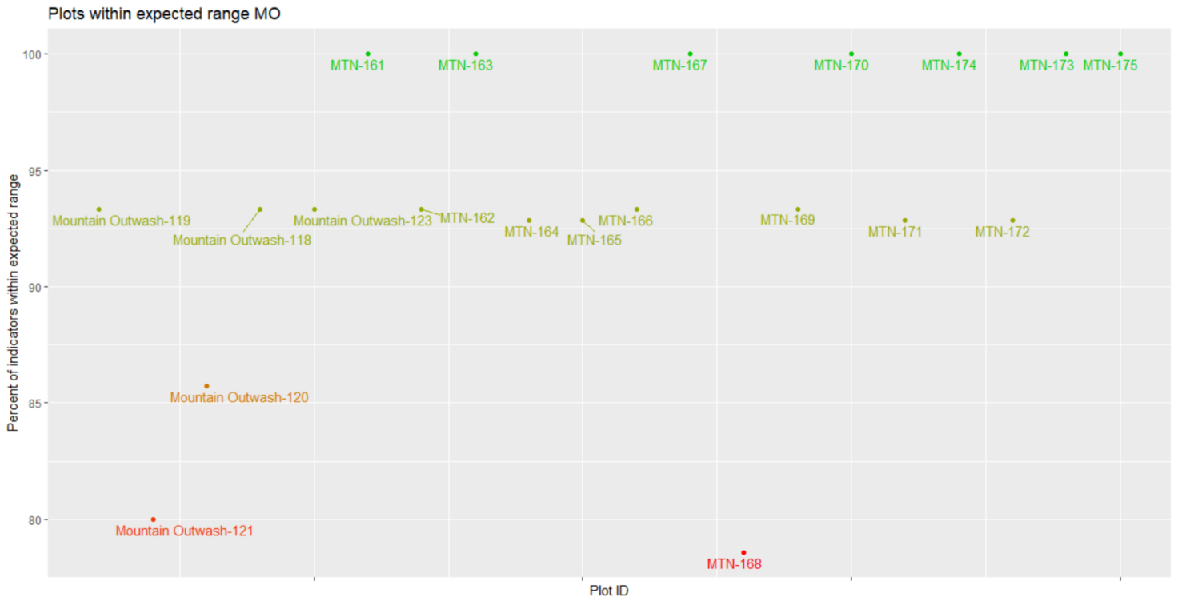

Figure 19. Percent of indicators meeting their expected benchmark range for each plot in the MO stratum.

Table 20. Percent of plots in the MO stratum that met each indicator.

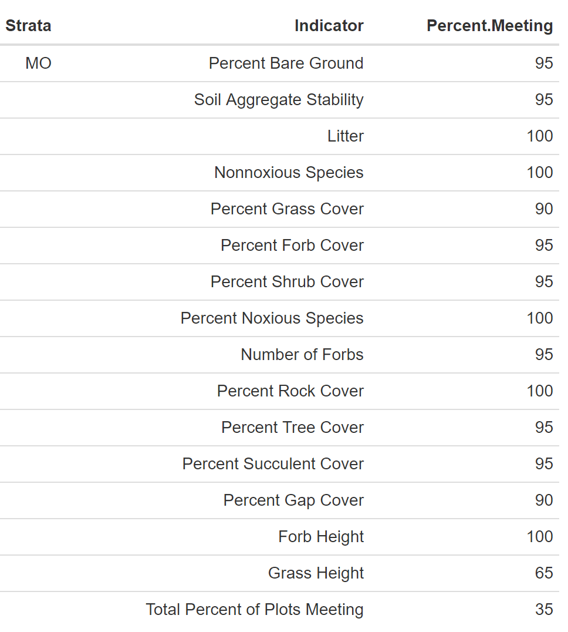

### 6.1.6 Other

The Other stratum occupies 43,886 acres of land within the SLVFO, and from 2015-2018, 21 plots had been sampled within this stratum. ESs include Chico Land, Pinyon-Juniper, Shallow Loam, Basalt Hill 7-12", Mountain Outwash, Valley Bench 10-12" and Wet Meadow 6-10" (Appendix 52). Multiple variations from the ES typical profile occur including characteristics elevation (14 plots), texture (14 plots), percent clay (13 plots), percent rock fragment (8 plots), percent slope (8 plots), landscape type (6 plots), depth to bedrock (2 plots), rock fragment type (4 plots) and effervescence (1 plot). Two plots did not have rock fragment type recorded. Most plots with varying soil texture are due to the presence of sand. Annual precipitation ranges from 7-20.07 inches with a mean of 14.44 inches. Slope ranges from 0.075-47.5% with a mean of 18.64%. Elevation ranges from 2,272-2,820 meters with a mean of 2,604 meters. Landscape type is predominantly Hills/Mountains (13 plots) followed by Fan Piedmont (3 plots), Dunes (2 plots), Flood plain/basin (1 plot), Terrace (1 plot) and Other (1 plot). Soil texture is predominantly clay loam (12 horizons), loam (12 horizons) and sandy loam (9 horizons). Percent rock fragments range from 0-94% with a mean of 30.85%. Effervescence ranges from non-effervescent to violently effervescent, non-effervescent being the most common. Clay ranges from 4-78% with a mean of 20.81%. PIED, HECO26, PIMI, MUMO, JUSC2, BOGR2, PASM and KOMA are common species.

#### 6.1.6.1 Soil Stability

The average soil stability for all samples is 4.46 with a difference of 1.33 between samples under and not under cover (Table 21).

Table 21. Summary of soil stability test results in the OTH stratum. ME is the margin of error calculated using an 80% confidence interval.

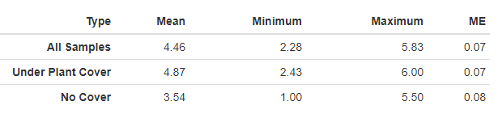

#### 6.1.6.2 Vegetation and Surface Cover

Grass, litter and rock are the most dominant cover type in the OTH stratum (Figure 20). Grass species BOGR2 and herbaceous species MUMO dominate the stratum (Figure 21 and Table 22). The OTH stratum currently has one plot with noxious species present and has no annual grass species reported (Figure 2, Figure 3). Plot OTH-191 has noxious species LELA2 at 0.67% cover.

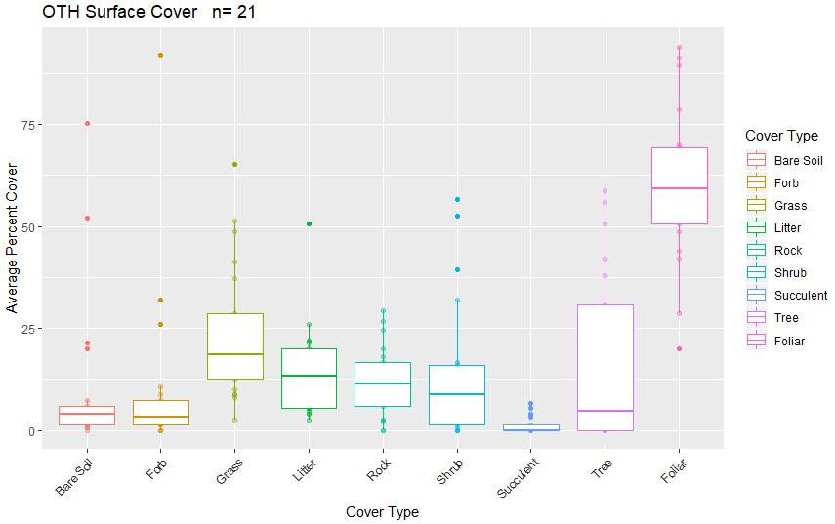

Figure 20. Surface and vegetation cover using line-point intercept results for the OTH stratum. n=population size.

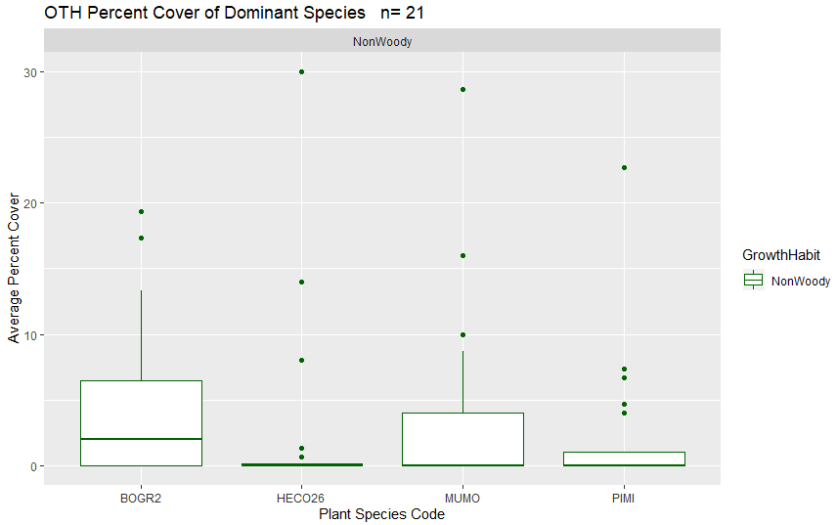

Figure 21. Dominant species categorized by growth habit (woody or nonwoody) in the OTH stratum based on LPI results. n=population size.

#### 6.1.6.3 Canopy Gap

Canopy gap ranges from 1.307-88.64% of the plot. Canopy cover ranges from 11.36-98.69% of the plot. The average percent of canopy gaps per plot is 40.17% and the average percent canopy cover is 59.83% (Figure 22).

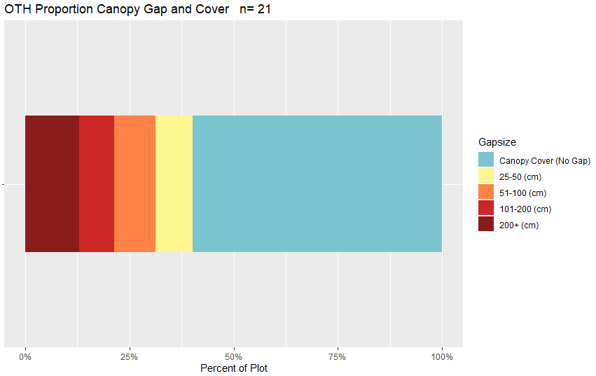

Figure 22. Bar chart of canopy cover and canopy gaps average per plot for the OTH stratum based on Gap Intercept results. Canopy cover was determined by subtracting the percent canopy gaps from 100. n=population size.

Table 22. Surface indicators, vegetation cover, canopy gap and cover, and species richness values determined using LPI for the OTH stratum. Percent values are the average percent hit. ME is the margin of error calculated using an 80% confidence interval.

|  |  |  |  |  |  |
| --- | --- | --- | --- | --- | --- |
| **Indicator** | **Mean** | **Minimum** | **Maximum** | **St.Dev.** | **ME** |
| **Surface Indicator (%)** | | |  |  |  |
| Rock Fragment | 11.81 | 0 | 29.33 | 8.69 | 0.53 |
| Litter | 14.44 | 2.67 | 50.67 | 11.17 | 0.68 |
| Bare Soil | 10.6 | 0 | 75.33 | 18.87 | 1.15 |
| **Foliar Cover (%)** | |  |  |  |  |
| Shrub/Sub-shrub | 13.97 | 0 | 56.67 | 17.21 | 1.05 |
| Grass | 23.24 | 2.67 | 65.33 | 16.56 | 1.01 |
| Succulent | 1.17 | 0 | 6.67 | 1.95 | 0.12 |
| Tree | 18.41 | 0 | 58.67 | 21.24 | 1.3 |
| Noxious Forb/Herb | 0.03 | 0 | 0.67 | 0.15 | 0.01 |
| Nonnoxious Forb/Herb | 10.25 | 0 | 92.67 | 20.6 | 1.26 |
| **Vegetation Height (cm)** | | |  |  |  |
| Grass | 28.3 | 13.93 | 47 | 10.08 | 0.62 |
| Forb/Herb | 23.53 | 3 | 64.6 | 16.13 | 0.98 |
| Tree | 364.23 | 11 | 1100 | 212.37 | 12.96 |
| Shrub | 88.33 | 9 | 400 | 78.27 | 4.78 |
| **Dominant Grass Cover (%)** | | |  |  |  |
| HECO26 | 2.7 | 0 | 30 | 7.31 | 0.45 |
| PIMI | 2.27 | 0 | 22.67 | 5.37 | 0.33 |
| **Dominant Herb. Cover (%)** | | |  |  |  |
| MUMO | 3.93 | 0 | 28.67 | 7.28 | 0.44 |
| **Dominant Woody Cover (%)** | | |  |  |  |
| PIED | 14.03 | 0 | 58.67 | 19.25 | 1.18 |
| **Canopy Gaps (%)** | |  |  |  |  |
| Gaps 25-50 cm | 8.91 | 1.31 | 21.25 | 5.65 | 0.34 |
| Gaps 51-100 cm | 9.97 | 0 | 20.31 | 6.46 | 0.39 |
| Gaps 101-200 cm | 8.27 | 0 | 24.01 | 8.05 | 0.49 |
| Gaps >200 cm | 13.01 | 0 | 52.84 | 15.96 | 0.97 |
| **Canopy Cover (%)** | |  |  |  |  |
| Total Canopy Cover | 59.83 | 11.36 | 98.69 | 22.43 | 1.37 |
| **Species Richness** | |  |  |  |  |
| No. Species per Plot | 28.33 | 0 | 46 | 12.35 | 0.75 |

#### 6.1.6.4 Percent Meeting Benchmark

8 plots (38.10%) met all indicator benchmarks (Figure 23, Table 23). Within the allotments, ½ Poncha Pass East and ½ Trickle Mountain plots did not meet all of the indicator benchmarks (Appendix 58). The plots with the lowest percent of indicators meeting benchmark include Other-136 within the Lakes allotment, OTH-222 within the Steel Canyon allotment, OTH-202 within the Poncha Pass East allotment and OTH-204 within the Mirage allotment (Appendix 58). Forb and grass height were the most common indicator benchmarks not met (Table 23).

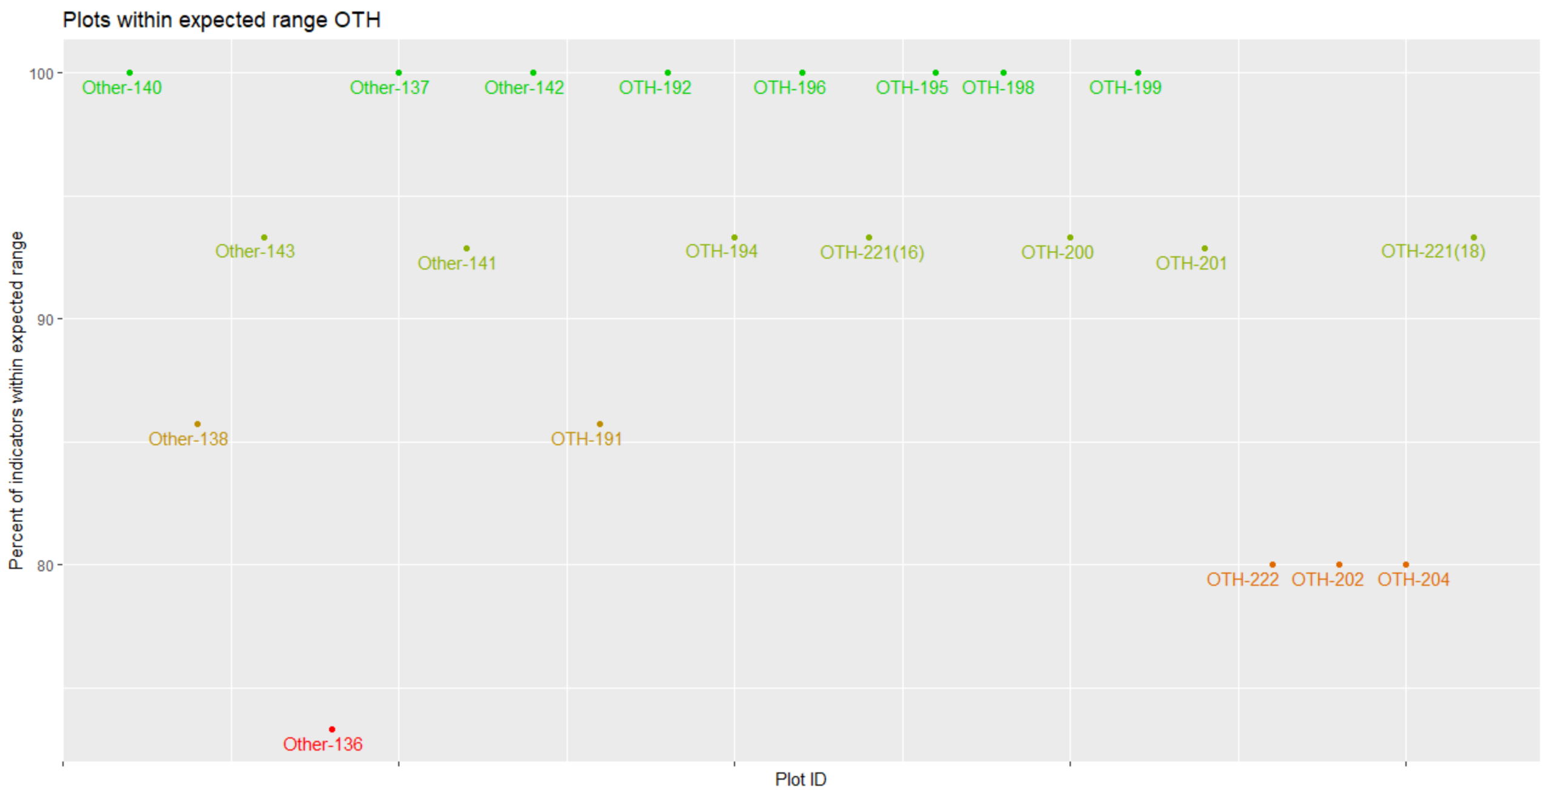

Figure 23. Percent of indicators meeting their expected benchmark range for each plot in the OTH stratum.

Table 23. Percent of plots in the OTH stratum that met each indicator.

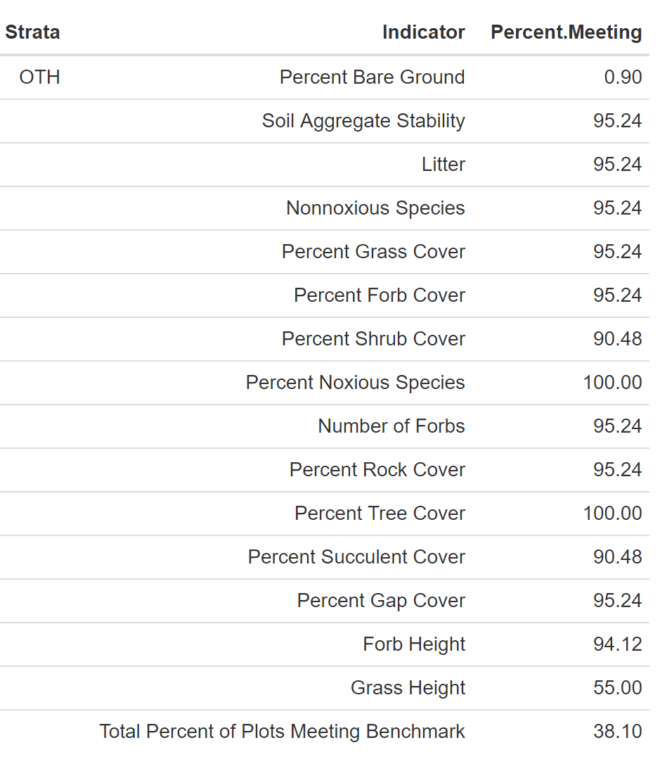

### 6.1.7 Rocky Foothills

The Rocky Foothills stratum occupies approximately 39,403 acres in the SLVFO, and from 2015-2018, 23 plots had been sampled within this stratum. ESs include Rocky Foothills, Mountain Outwash and Rocky Foothill (Appendix 52). Multiple variations from the typical profile occur including characteristics elevation (3 plots), texture (13 plots), percent clay (12 plots), percent rock fragment (11 plots), landscape type (10 plots), percent slope (7 plots), depth to bedrock (7 plots) and rock fragment type (3 plots). Two plots did not have percent rock fragment recorded and one plot did not have any soil characteristics recorded. Annual precipitation ranges from 7-20.62 inches with a mean of 14.67 inches. Slope ranges from 1-45.02% with a mean of 19.09%. Elevation ranges from 2,501-3,022 meters with a mean of 2,626 meters. Landscape type is predominantly Hills/Mountains (17 plots), followed by Fan Piedmont (4 plots), Flood Plain/Basin (1 plot) and Terrace (1 plot). Soil texture is predominantly loam, silt clay loam and sandy loam (12 horizons). Rock fragments range from 0-88% with a mean of 30.24%. Effervescence ranges from non-effervescent to violently, being predominantly non-effervescent (40/54 horizons). Clay ranges from 2-46% with a mean of 16.08%. HECO26, PIED, BOGR2, JUMO, ERNA10 and ELEL5 are common species.

#### 6.1.7.1 Soil Stability

The average soil stability for all samples is 4.05 with a difference of 1.06 between samples under and not under cover (Table 24).

Table 24. Summary of soil stability test results in the ROF stratum. ME is the margin of error calculated using an 80% confidence interval.

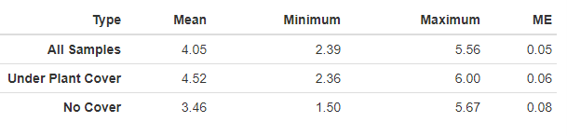

#### 6.1.7.2 Vegetation and Surface Cover

Grass, rock and litter are the dominate cover type for the ROF stratum (Figure 24). Tree species PIED and grass species BOGR2 dominate the stratum (Figure 25, Table 25). OTH does not have any noxious or annual grass species currently reported (Figure 2, Figure 3).

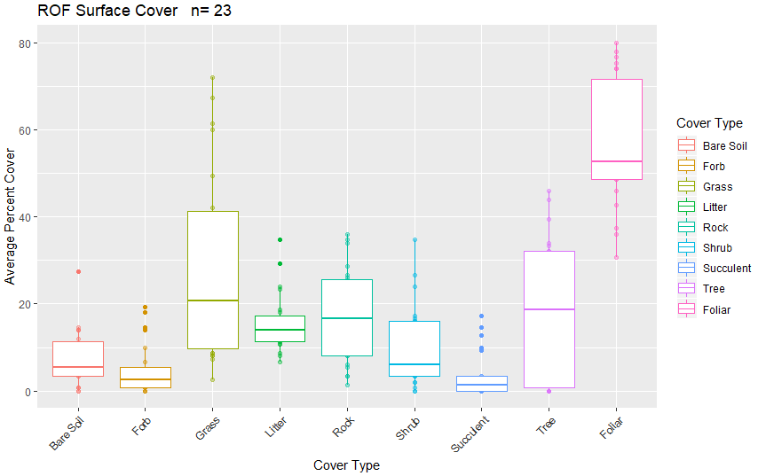

Figure 24. Surface and vegetation cover using line-point intercept results for the ROF stratum. n=population size.

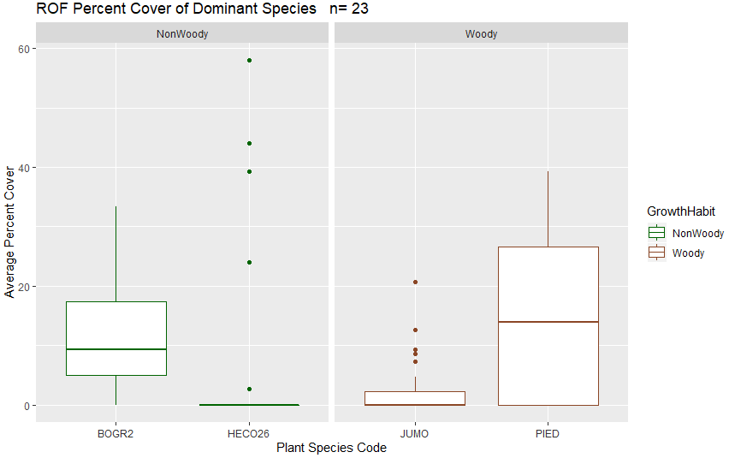

Figure 25. Dominant species categorized by growth habit (woody or nonwoody) in the ROF stratum based on LPI results. n=population size.

#### 6.1.7.3 Canopy Gap

Percent canopy gap ranges from 13.65-70.36% with an average percent canopy gap of 43.36% per plot. Percent canopy cover ranges from 29.64-86.35% with an average of 56.64% per plot (Figure 26).

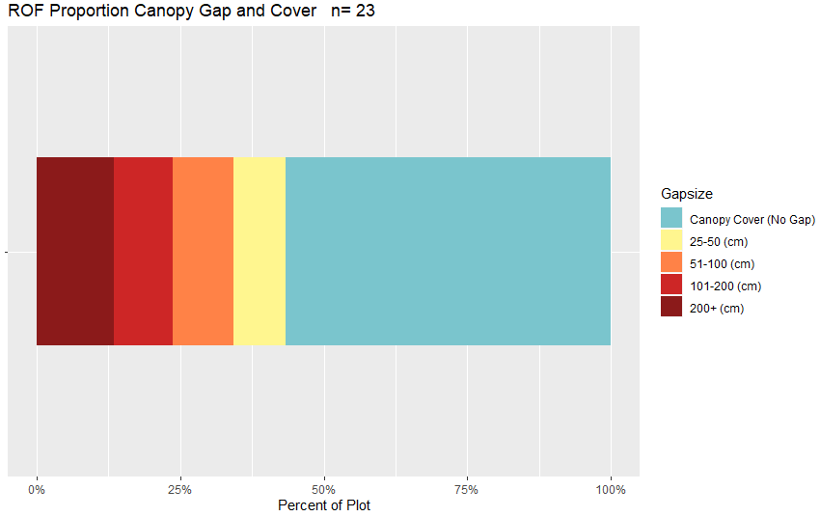

Figure 26. Bar chart of canopy cover and canopy gaps average per plot for the ROF stratum based on the Gap Intercept results. Canopy cover was determined by subtracting the percent canopy gaps from 100. n=population size.

Table 25. Surface indicators, vegetation cover, canopy gap and cover, and species richness values determined using LPI for the ROF stratum. Percent values are the average percent hit. ME is the margin of error calculated using an 80% confidence interval.

|  |  |  |  |  |  |
| --- | --- | --- | --- | --- | --- |
| **Indicator** | **Mean** | **Minimum** | **Maximum** | **St.Dev.** | **ME** |
| **Surface Indicator (%)** | | |  |  |  |
| Rock Fragment | 17.3 | 1.33 | 36 | 10.46 | 0.58 |
| Litter | 15.54 | 6.67 | 34.67 | 6.78 | 0.38 |
| Bare Soil | 7.39 | 0 | 27.33 | 6.49 | 0.36 |
| **Foliar Cover (%)** | |  |  |  |  |
| Shrub/Sub-shrub | 9.91 | 0 | 34.67 | 9.35 | 0.52 |
| Grass | 28.23 | 2.67 | 72 | 21.96 | 1.22 |
| Succulent | 3.57 | 0 | 17.33 | 5.28 | 0.29 |
| Tree | 19.3 | 0 | 46 | 15.88 | 0.88 |
| Noxious Forb/Herb | 0 | 0 | 0 | 0 | 0 |
| Nonnoxious Forb/Herb | 4.96 | 0 | 19.33 | 5.95 | 0.33 |
| **Vegetation Height (cm)** | | |  |  |  |
| Grass | 27.2 | 10.5 | 61.27 | 13.35 | 0.74 |
| Forb/Herb | 20.08 | 6 | 36 | 8.9 | 0.5 |
| Tree | 271.78 | 29 | 1300 | 178.51 | 9.95 |
| Shrub | 40.14 | 4 | 150 | 31.27 | 1.74 |
| **Dominant Grass Cover (%)** | | |  |  |  |
| HECO26 | 7.3 | 0 | 58 | 16.79 | 0.94 |
| BOGR2 | 12.46 | 0 | 33.33 | 9.65 | 0.54 |
| **Dominant Herb. Cover (%)** | | |  |  |  |
| NA | NA | NA | NA | NA | NA |
| **Dominant Woody Cover (%)** | | |  |  |  |
| PIED | 14.78 | 0 | 39.33 | 13.97 | 0.78 |
| JUMO | 2.75 | 0 | 20.67 | 2.75 | 0.3 |
| **Canopy Gaps (%)** | |  |  |  |  |
| Gaps 25-50 cm | 9.11 | 1.95 | 19.83 | 4.57 | 0.25 |
| Gaps 51-100 cm | 10.53 | 3.65 | 23.87 | 5.7 | 0.32 |
| Gaps 101-200 cm | 10.22 | 0 | 23.31 | 7.45 | 0.42 |
| Gaps >200 cm | 13.51 | 0 | 41.56 | 13.8 | 0.77 |
| **Canopy Cover (%)** | |  |  |  |  |
| Total Canopy Cover | 56.64 | 29.64 | 86.35 | 17.61 | 0.98 |
| **Species Richness** | |  |  |  |  |
| No. Species per Plot | 30.52 | 11 | 55 | 12.33 | 0.69 |

#### 6.1.7.4 Percent Meeting Benchmark

12 plots (52.17%) met all indicator benchmarks (Figure 27, Table 26). Within the allotments, ½ Bighorn Creek, ¼ Rajedero, 2/6 Tracy Common and 1/3 Valley View Hot Springs plots did not meet all of the indicator benchmarks (Appendix 59). The plots with the lowest percent of indicators meeting benchmark include Rocky Foothills-170 within the Steel Canyon allotment, Rocky Foothills-171 within the Bighorn Creek allotment, Rocky Foothills-166 within the Poncha Pass East allotment and ROCK-226 within the McIntyre Gulch allotment (Appendix 59). Grass height is the most common benchmark indicator not met (Table 26).

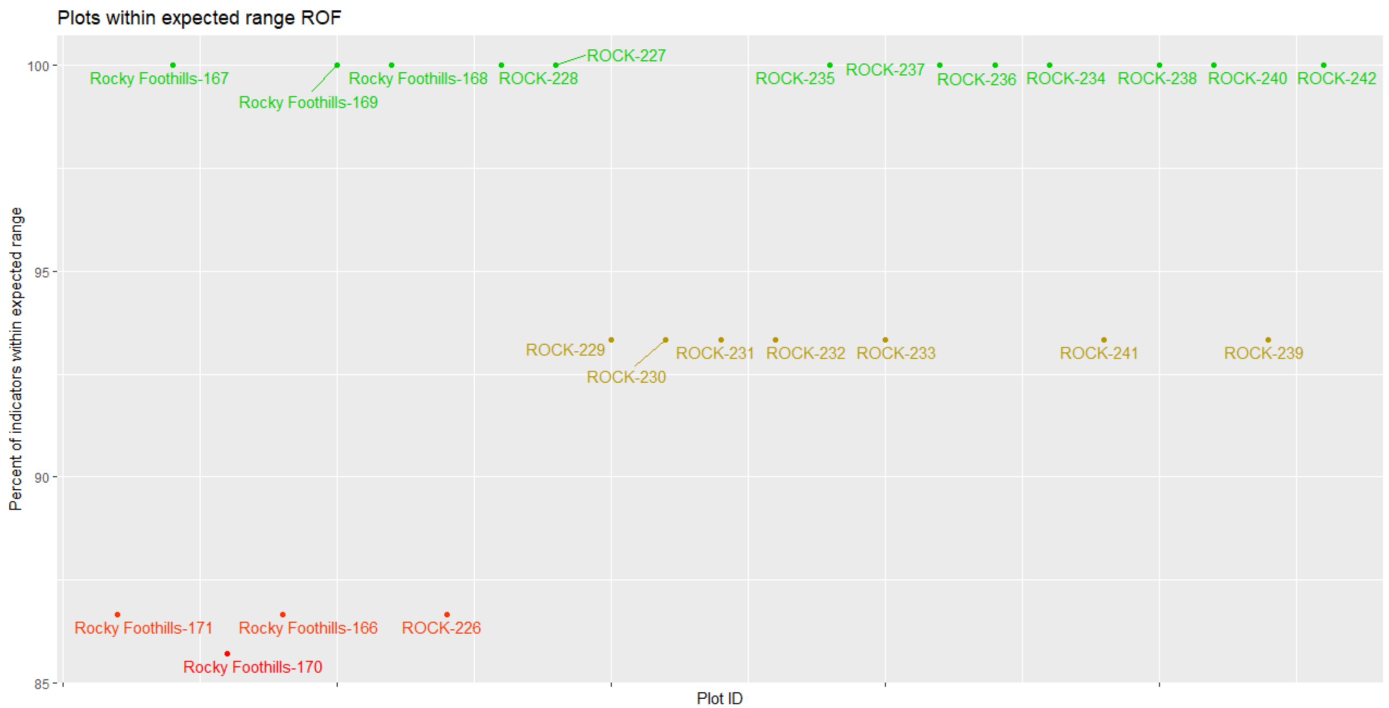

Figure 27. Percent of indicators meeting their expected benchmark range for each plot in the ROF stratum.

Table 26. Percent of plots in the ROF stratum that met each indicator.

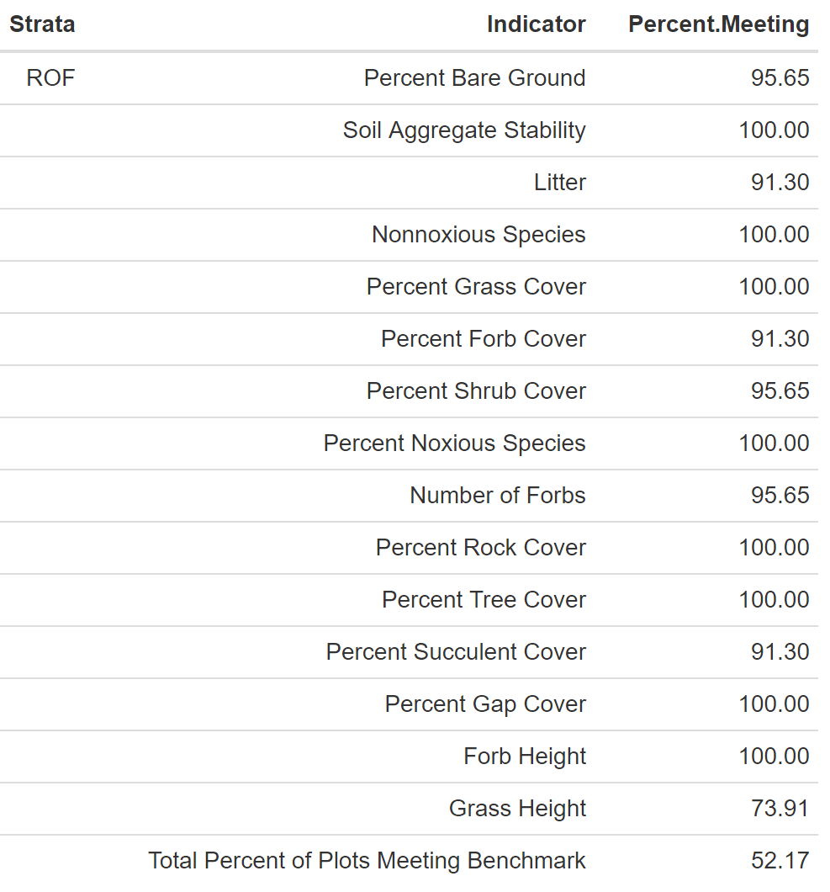

### 6.1.8 Salty

The Salty stratum occupies approximately 8,327 acres in the SLVFO, and from 2015-2018, 16 plots had been sampled within this stratum. ESs include Alkali Overflow, Salt Flats and Sand Hummocks (Appendix 52). Multiple variations from the typical ES profile occur including characteristics landscape type (8 plots), annual precipitation (6 plots), percent clay (5 plots), texture (14 plots), slope (2 plots), elevation (3 plots) and depth to bedrock (2 plots). Annual precipitation ranges from 7-8.44 inches with a mean of 7.82 inches. Slope ranges from 0-3.1% with a mean of 0.34%. Elevation ranges from 2,275-2,336 meters with a mean of 2,297 meters. Landscape type is predominantly Flat Plain (6 plots), followed by Dunes (4 plots), Flood Plain/Basin (2 plots), Other (2 plots), Fan Piedmont (1 plot) and Terrace (1 plot). Soil texture is predominantly loamy sand (10 horizons), sand (9 horizons) and sandy clay loam (7 horizons). Rock fragments range from 0-13% with a mean of 1.33%. Effervescence ranges from non-effervescent to violently, strongly being most common. Clay ranges from 2-55% with a mean of 16.62%. DISP, SAVE4 and ERCE2 are the only species present on at least 20% of plots. ERCE2 only occurred at 4.83% cover per plot.

#### 6.1.8.1 Soil Stability

The average soil stability for all samples is 2.47. No samples were classified as having no cover (Table 27).

Table 27. Summary of soil stability test results in the SAL stratum. ME is the margin of error calculated using an 80% confidence interval.

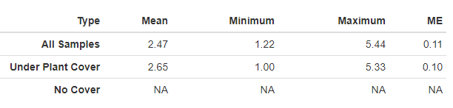

#### 6.1.8.2 Vegetation and Surface Cover

Bare soil and shrub covers are the most dominant cover type in the SAL stratum (Figure 28). Shrub species SAVE4 and grass species DISP dominate the stratum (Figure 29 and Table 28). Noxious and annual species are present (Figure 2, Figure 3). SALT-282 with has noxious species LELA2 and CIAR4 at 27.33% cover. SALT-282 has 29.33% cover of annual grass.

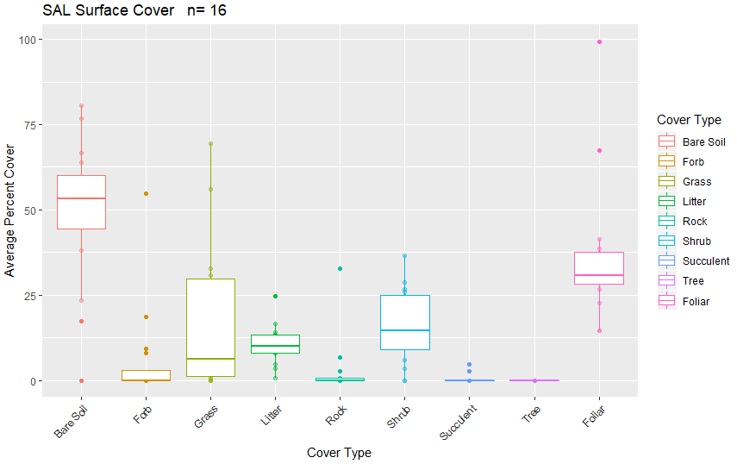

Figure 28. Surface and vegetation cover using line-point intercept results for the SAL stratum. n=population size.

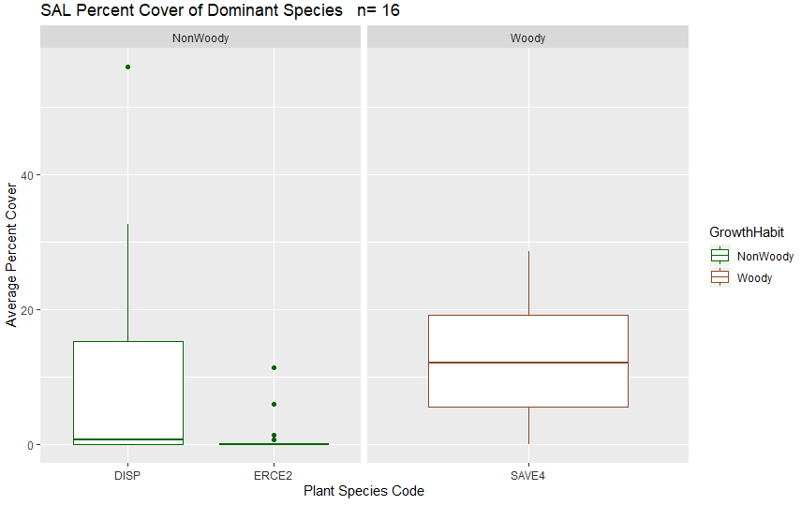

Figure 29. Dominant species categorized by growth habit (woody or nonwoody) in the SAL stratum based on LPI results. n=population size.

#### 6.1.8.3 Canopy Gap

Canopy gap ranges from 0.35-97.17% with an average of 66.29% per plot. Canopy cover ranges from 2.85-99.65% with an average of 33.71% per plot (Figure 30).

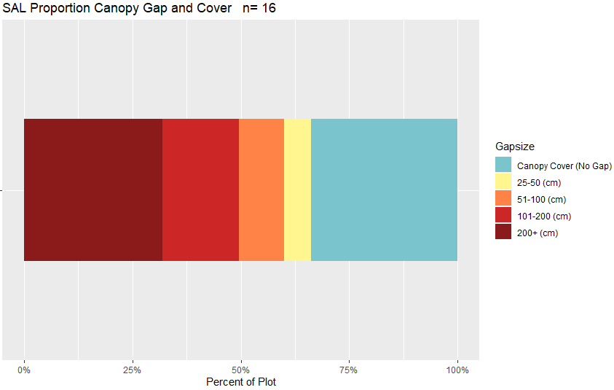

Figure 30. Bar chart of canopy cover and canopy gaps average per plot for the SAL stratum based on Gap Intercept results. Canopy cover was determined by subtracting the percent canopy gaps from 100. n=population size.

Table 28. Surface indicators, vegetation cover, canopy gap and cover, and species richness values determined using LPI for the SAL stratum. Percent values are the average percent hit. ME is the margin of error calculated using an 80% confidence interval.

|  |  |  |  |  |  |
| --- | --- | --- | --- | --- | --- |
| **Indicator** | **Mean** | **Minimum** | **Maximum** | **St.Dev.** | **ME** |
| **Surface Indicator (%)** | | |  |  |  |
| Rock Fragment | 2.71 | 0 | 32.67 | 8.17 | 0.65 |
| Litter | 10.54 | 0.67 | 24.67 | 5.61 | 0.45 |
| Bare Soil | 49.54 | 0 | 80.67 | 21.2 | 1.7 |
| **Foliar Cover (%)** | |  |  |  |  |
| Shrub/Sub-shrub | 15.46 | 0 | 36.67 | 10.77 | 0.86 |
| Grass | 17.96 | 0 | 69.33 | 21.5 | 1.72 |
| Succulent | 0.46 | 0 | 4.67 | 1.3 | 0.1 |
| Tree | 0 | 0 | 0 | 0 | 0 |
| Noxious Forb/Herb | 1.71 | 0 | 27.33 | 6.83 | 0.55 |
| Nonnoxious Forb/Herb | 5.29 | 0 | 46.67 | 12.2 | 0.98 |
| **Vegetation Height (cm)** | | |  |  |  |
| Grass | 20.4 | 9.55 | 68.8 | 15.76 | 1.26 |
| Forb/Herb | 23.27 | 6 | 92.88 | 24.45 | 1.96 |
| Tree | NA | NA | NA | NA | NA |
| Shrub | 43.29 | 2 | 114 | 22.49 | 1.8 |
| **Dominant Grass Cover (%)** | | |  |  |  |
| DISP | 10.63 | 0 | 56 | 17.03 | 1.36 |
| **Dominant Herb. Cover (%)** | | |  |  |  |
| ERCE2 | 1.21 | 0 | 11.33 | 3.09 | 0.25 |
| **Dominant Woody Cover (%)** | | |  |  |  |
| SAVE4 | 13.08 | 0 | 28.67 | 9.53 | 0.76 |
| **Canopy Gaps (%)** | |  |  |  |  |
| Gaps 25-50 cm | 6.32 | 0 | 21.32 | 6.17 | 0.49 |
| Gaps 51-100 cm | 10.43 | 0 | 25.67 | 6.33 | 0.51 |
| Gaps 101-200 cm | 17.66 | 0 | 33.07 | 8.97 | 0.72 |
| Gaps >200 cm | 31.88 | 0 | 78.2 | 25.28 | 2.03 |
| **Canopy Cover (%)** | |  |  |  |  |
| Total Canopy Cover | 33.71 | 2.85 | 99.65 | 23.22 | 1.86 |
| **Species Richness** | |  |  |  |  |
| No. Species per Plot | 10.88 | 2 | 33 | 7.92 | 0.63 |

#### 6.1.8.4 Percent Meeting Benchmark

12 plots (68.75%) met all indicator benchmarks (Figure 31, Table 29). Within the allotments, 2/2 Lakes plots did not meet all of the indicator benchmarks (Appendix 60). The plots with the lowest percent of indicators meeting benchmark include SALT-282 (not within an allotment) (Appendix 60). Forb and grass height are the two indicator benchmarks most commonly not met (Table 29).

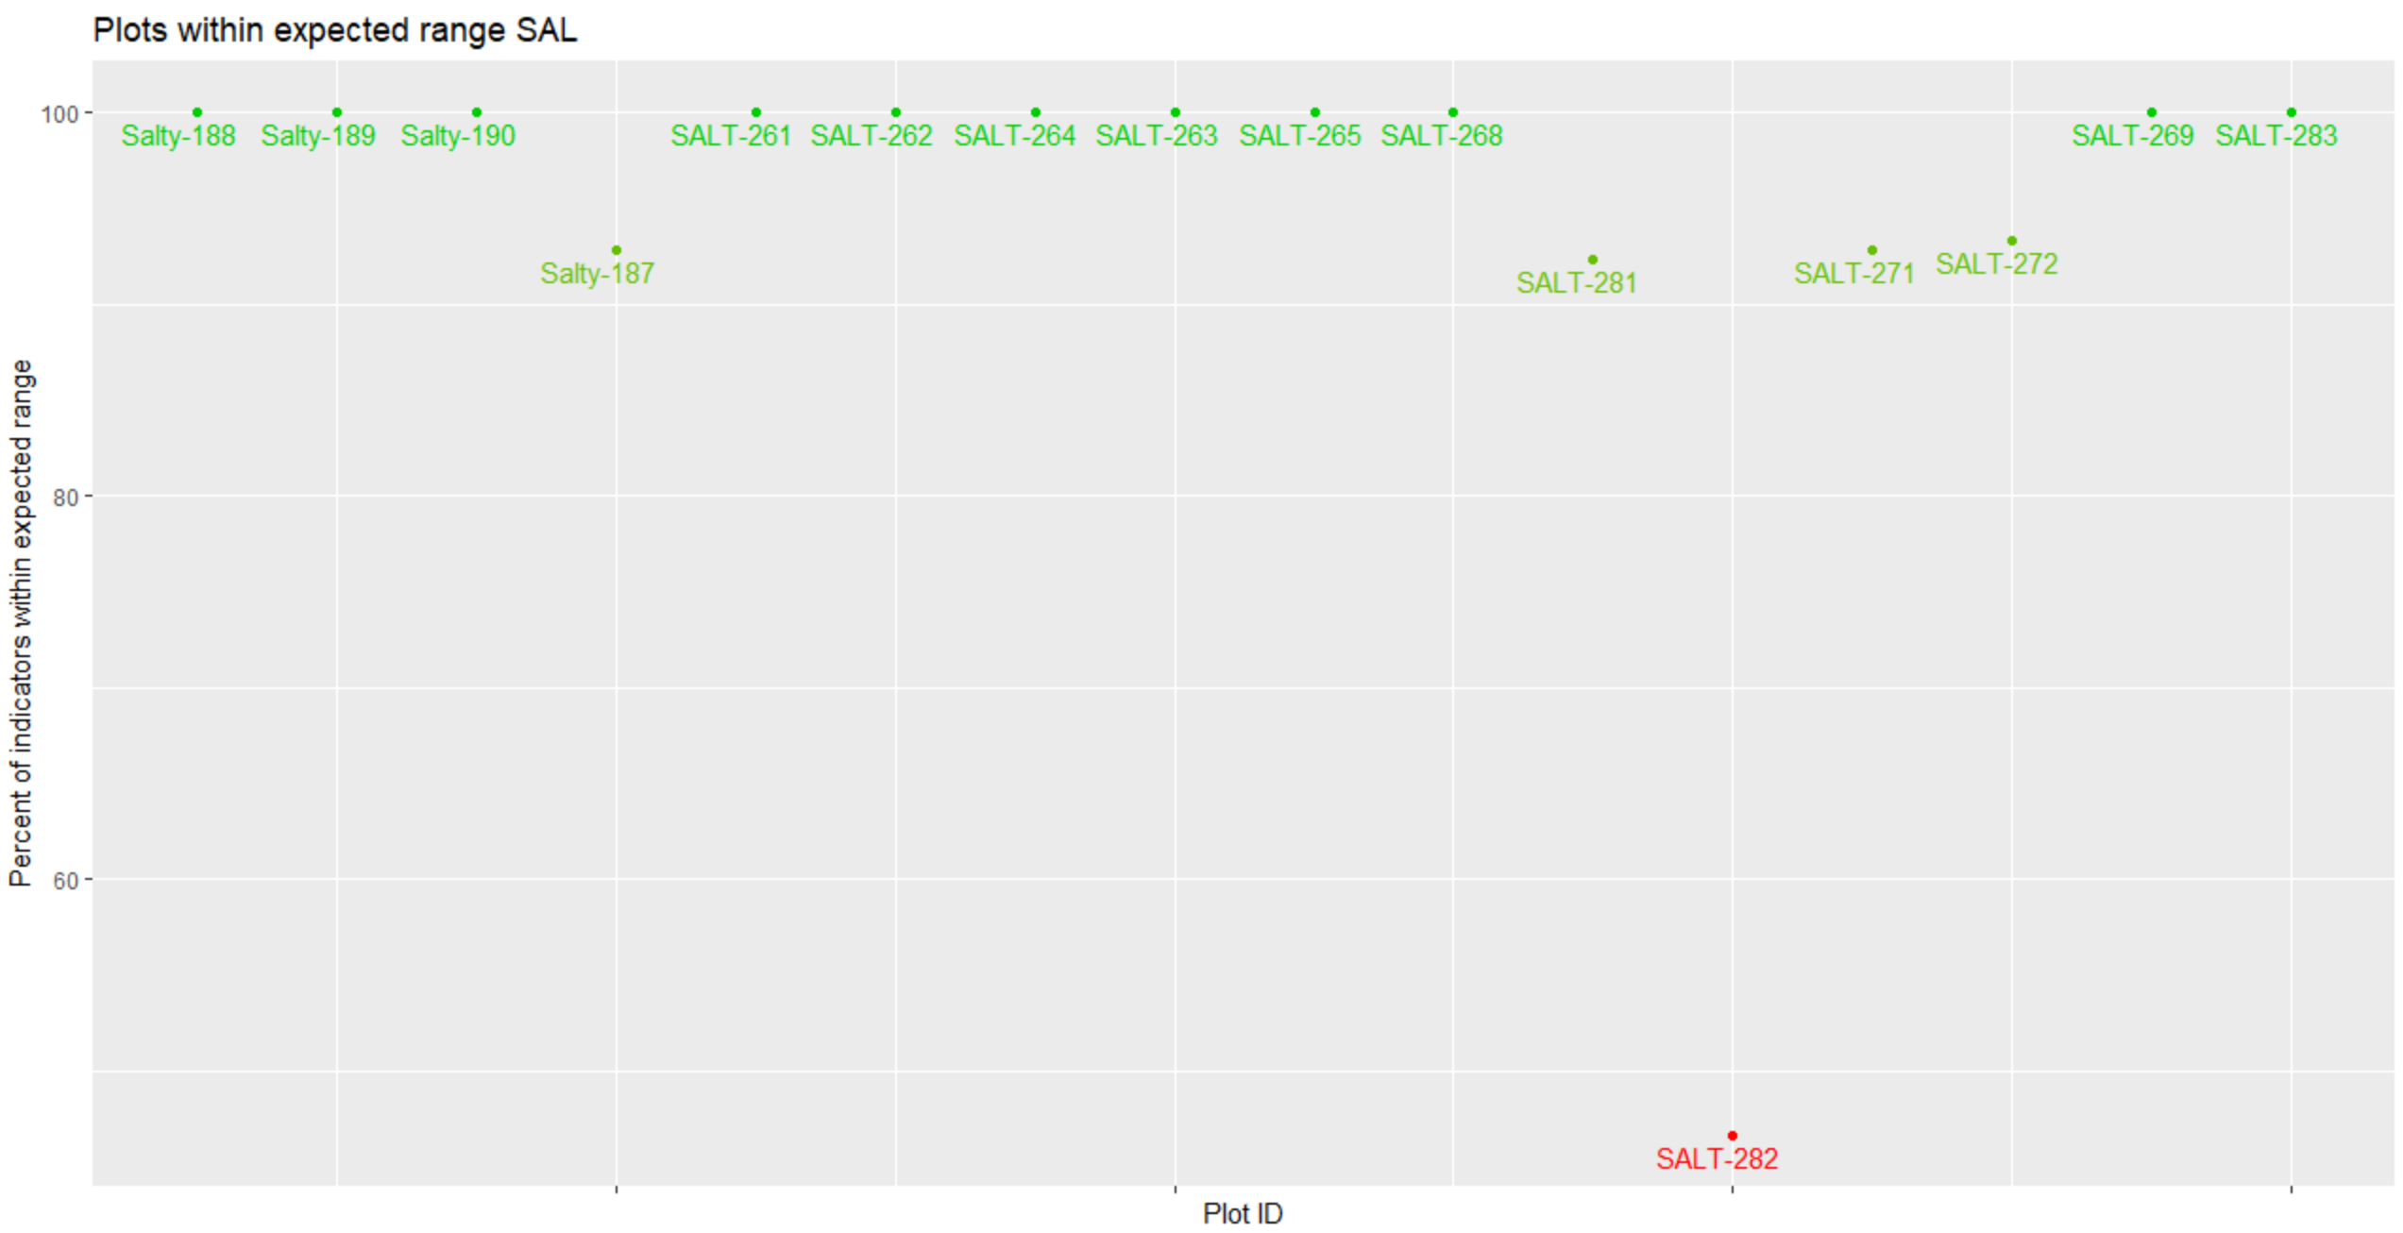

Figure 31. Percent of indicators meeting their expected benchmark range for each plot in the SAL stratum.

Table 29. Percent of plots in the SAL stratum that met each indicator.

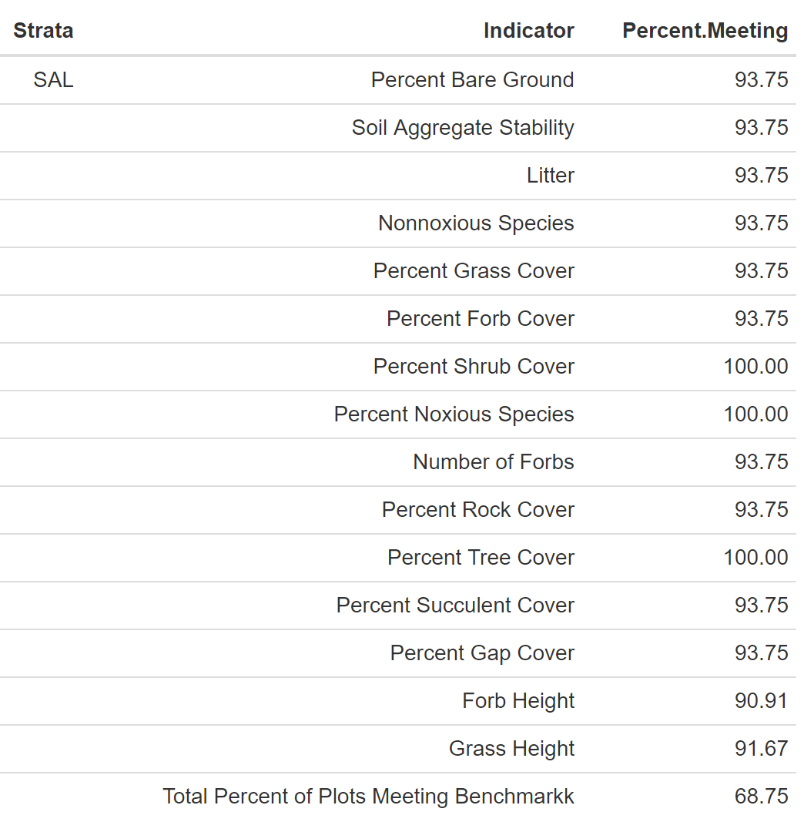

### 6.1.9 Sandy

The Sandy stratum occupies approximately 37,332 acres in the SLVFO, and from 2015-2018, 21 plots had been sampled within the stratum. ESs include Salt Flats, Foothill Loam, Foothill Sand 9-12", Sand Hummocks and Sandy Bench (Appendix 52). Multiple variations from the typical ES profile occur including characteristics texture (11 plots), percent slope (9 plots), percent rock fragment (8 plots), landscape type (9 plots), elevation (5 plots), percent clay (3 plots), annual precipitation (2 plots) and rock fragment type (1 plot). TerrADat Plots record is missing for one plot (SAND-298). Annual precipitation ranges from 7-10.78 inches with a mean of 8.35 inches. Slope ranges from 0.008-14.12 inches with a mean of 3.36 inches. Elevation ranges from 2,263-2,418 meters with a mean of 2,325 meters. Landscape type is predominantly Fan Piedmont (9 plots), Dunes (4 plots), Flat Plain (3 plots), Other (2 plots), Terrace (2 plots) and Flood Plain/Basin (1 plot). Soil texture is predominantly sandy loam (20 horizons), loamy sand (13 horizons) and sand (11 horizons). Rock fragments range from 0-70% with a mean of 12.65%. Effervescence ranges from non-effervescent to violently, non-effervescent being most common. Clay ranged from 0-35% with a mean of 11.27%. BOGR2, ACHY, SPCR, DISP, ERNA10, SAVE4 and ELEL5 are common species.

#### 6.1.9.1 Soil Stability

The average soil stability for all samples is 2.08 with a difference of 0.93 between samples under and not under cover (Table 30).

Table 30. Summary of soil stability test results in the SAN stratum. ME is the margin of error calculated using an 80% confidence interval.

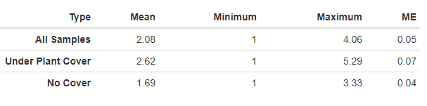

#### 6.1.9.2 Vegetation and Surface Cover

Bare soil and grass are the most dominant cover type in the SAN stratum (Figure 32). Grass species BOGR2 and ACHY dominate this stratum (Figure 33 and Table 31). The SAN stratum does not have any noxious species reports and annual grass species has one species reported (Figure 2, Figure 3). Sandy-208 has 0.67% of annual grass cover.

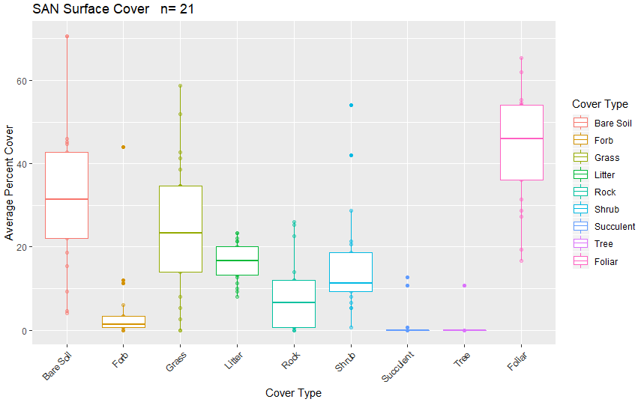

Figure 32. Surface and vegetation cover using line-point intercept results for the SAN stratum. n=population size.

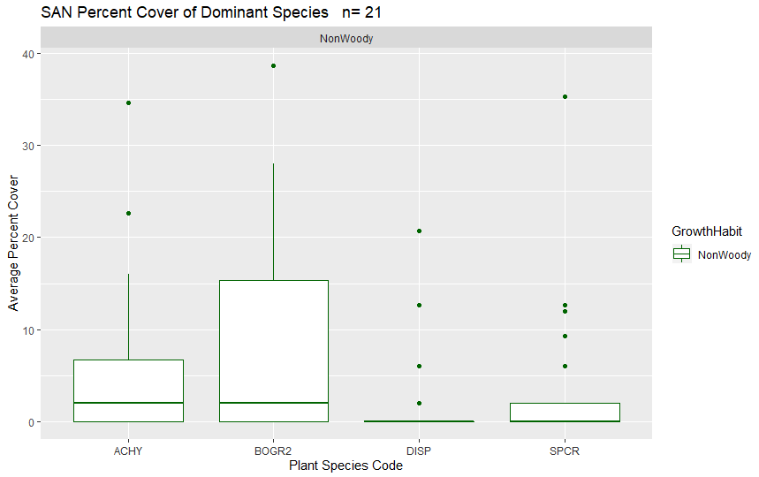

Figure 33. Dominant species categorized by growth habit (woody or nonwoody) in the SAN stratum based on LPI results. n=population size.

#### 6.1.9.3 Canopy Gap

Canopy gap ranges from 30.45-89.56% with an average of 58.58% per plot. Canopy cover ranges from 10.44-69.55% with an average of 41.42% per plot (Figure 34).

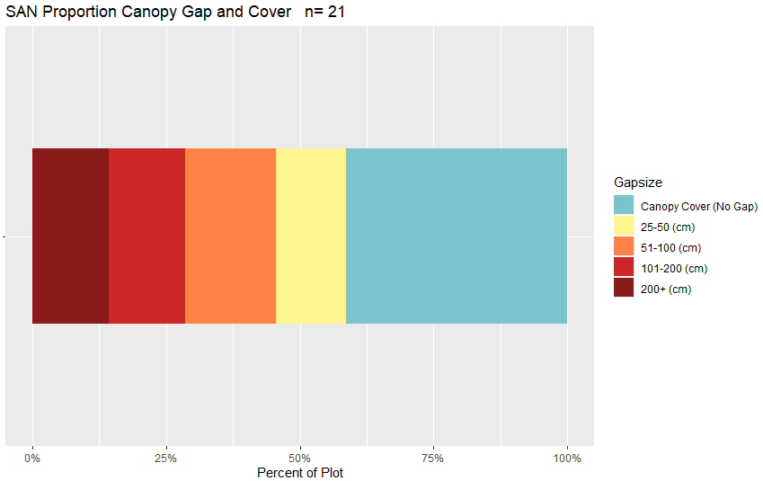

Figure 34. Bar chart of canopy cover and canopy gaps average per plot for the SAN stratum based on Gap Intercept results. Canopy cover was determined by subtracting the percent canopy gaps from 100. n=population size.

Table 31. Surface indicators, vegetation cover, canopy gap and cover, and species richness values determined using LPI for the SAN stratum. Percent values are the average percent hit. ME is the margin of error calculated using an 80% confidence interval.

|  |  |  |  |  |  |
| --- | --- | --- | --- | --- | --- |
| **Indicator** | **Mean** | **Minimum** | **Maximum** | **St.Dev.** | **ME** |
| **Surface Indicator (%)** | | |  |  |  |
| Rock Fragment | 8 | 0 | 26 | 8.39 | 0.51 |
| Litter | 16.44 | 8 | 23.33 | 4.59 | 0.28 |
| Bare Soil | 31.59 | 4 | 70.67 | 17.88 | 1.09 |
| **Foliar Cover (%)** | |  |  |  |  |
| Shrub/Sub-shrub | 16 | 0.67 | 54 | 12.51 | 0.76 |
| Grass | 25.3 | 0 | 58.67 | 16.69 | 1.02 |
| Succulent | 1.14 | 0 | 12.67 | 3.52 | 0.21 |
| Tree | 0.51 | 0 | 10.67 | 2.33 | 0.14 |
| Noxious Forb/Herb | 0 | 0 | 0 | 0 | 0 |
| Nonnoxious Forb/Herb | 4.57 | 0 | 44 | 9.65 | 0.59 |
| **Vegetation Height (cm)** | | |  |  |  |
| Grass | 26.22 | 11.21 | 45.66 | 10.52 | 0.64 |
| Forb/Herb | 23.41 | 2 | 61.8 | 14.63 | 0.89 |
| Tree | 164.8 | 123 | 210 | 36.35 | 2.22 |
| Shrub | 35.03 | 4 | 99 | 19.93 | 1.22 |
| **Dominant Grass Cover (%)** | | |  |  |  |
| BOGR2 | 9.78 | 0 | 38.67 | 13 | 0.79 |
| DISP | 2.06 | 0 | 20.67 | 5.21 | 0.32 |
| ACHY | 6.06 | 0 | 34.67 | 9.13 | 0.56 |
| SPCR | 3.75 | 0 | 35.33 | 8.33 | 0.51 |
| **Dominant Herb. Cover (%)** | | |  |  |  |
| NA | NA | NA | NA | NA | NA |
| **Dominant Woody Cover (%)** | | |  |  |  |
| NA | 0 | 0 | 0 | 0 | 0 |
| **Canopy Gaps (%)** | |  |  |  |  |
| Gaps 25-50 cm | 12.95 | 2.57 | 23.67 | 5.92 | 0.36 |
| Gaps 51-100 cm | 17.01 | 5.88 | 27.64 | 5.5 | 0.34 |
| Gaps 101-200 cm | 14.4 | 1.99 | 27.72 | 6.98 | 0.43 |
| Gaps >200 cm | 14.21 | 0 | 65.83 | 18.47 | 1.13 |
| **Canopy Cover (%)** | |  |  |  |  |
| Total Canopy Cover | 41.42 | 10.44 | 69.55 | 15.94 | 0.97 |
| **Species Richness** | |  |  |  |  |
| No. Species per Plot | 15.43 | 9 | 25 | 4.43 | 0.27 |

#### 6.1.9.4 Percent Meeting Benchmark

6 plots (28.57%) met indicator benchmarks (Figure 35, Table 32). Within the allotments, ½ Blanca WHA, 3/3 Dry Lakes, 3/3 Foothills and 2/3 Pinon plots do not meet all indicator benchmarks (Appendix 61). The plots with the lowest percent of indicators meeting benchmark include SAND-299 within the Foothills allotment, SAND-286 (not within an allotment), Sandy-207 within the Flat Top allotment and SAND-289 and SAND-293 within the Dry Lakes allotment (Appendix 61). Grass height, bare ground, shrub and succulent cover are the indicator benchmarks most commonly not met (Table 32).

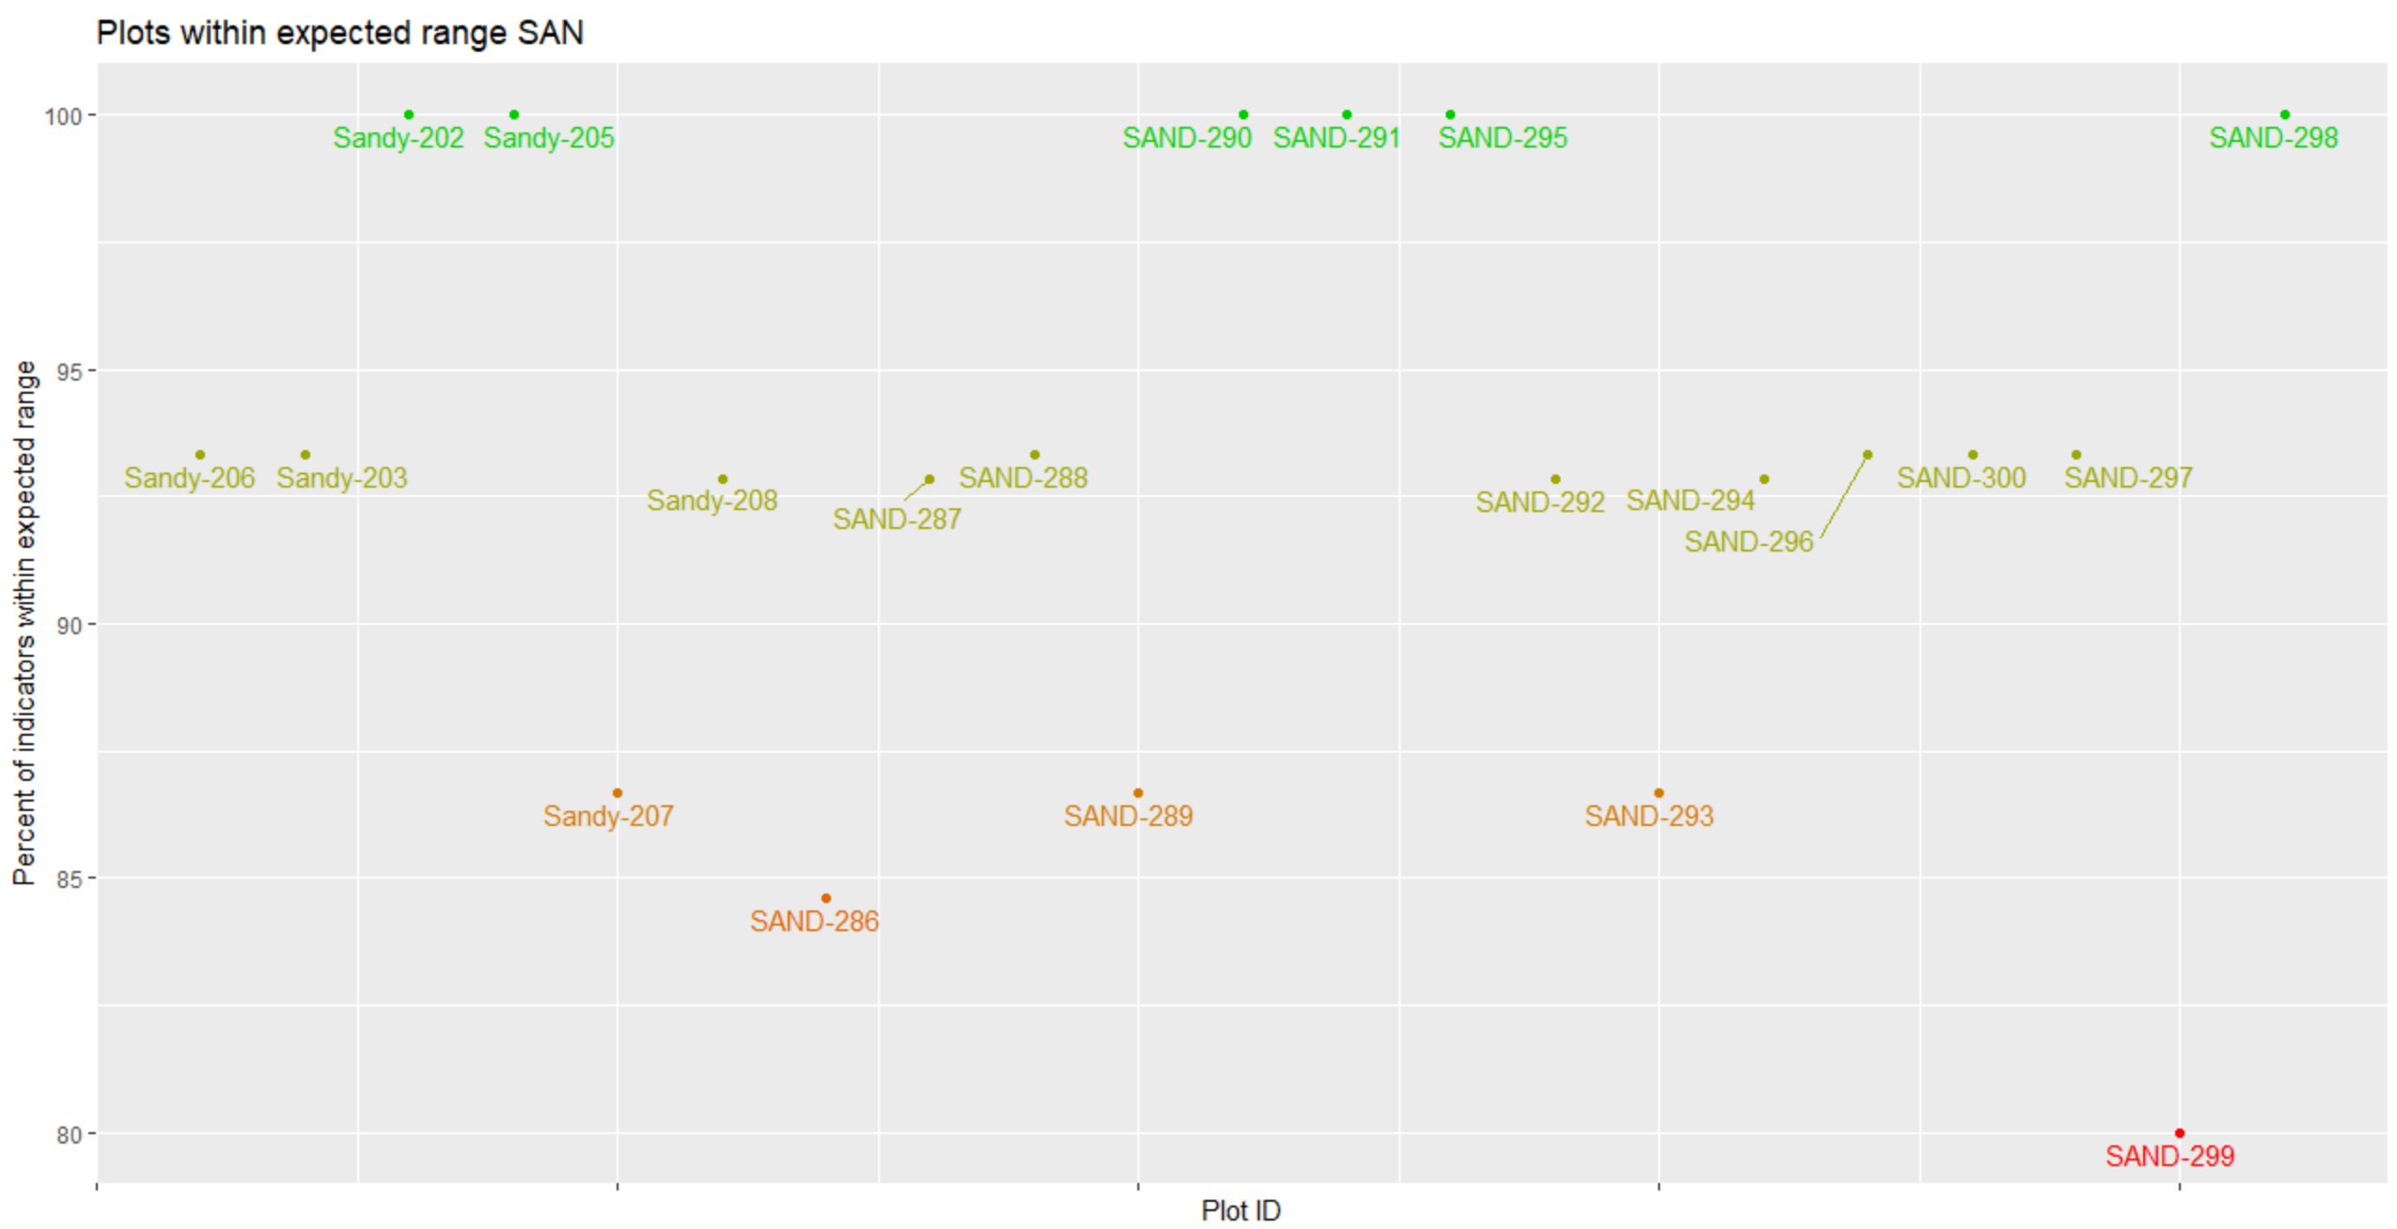

Figure 35. Percent of indicators meeting their expected benchmark range for each plot in the SAL stratum.

Table 32. Percent of plots in the SAN stratum that met each indicator.

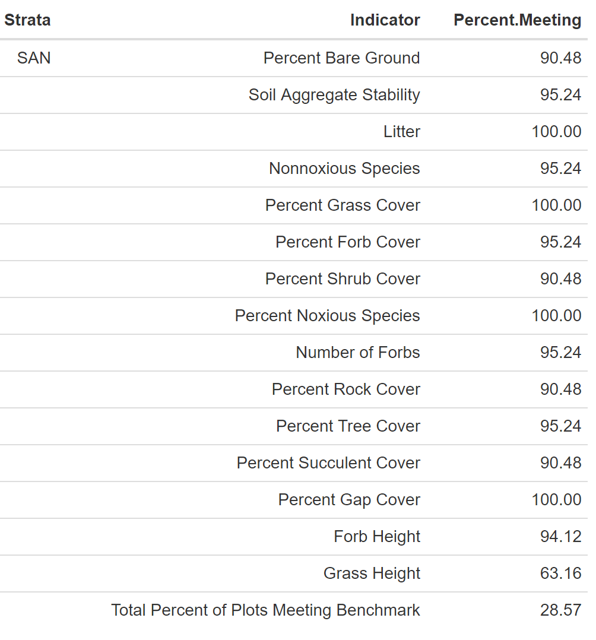

### 6.1.10 Forest

The Forest stratum occupies approximately 26,048 acres in the SLVFO, and from 2015-2018, 12 plots had been sampled within the stratum. ESs include Basalt Hill 7-12" or is not assigned but has an ESD (Appendix 52). Variation from ES occur in multiple characteristics including landscape type (2 plots), elevation (2 plots), texture (3 plots), percent rock fragment (7 plots) and percent clay (3 plots). Annual precipitation ranges from 10.5-30.60 inches with a mean of 17.85 inches. Slope ranges from 4.36-43.02% with a mean of 25.15%. Elevation ranges from 2,500-2,945 meters with a mean of 2,945 meters. Landscape type is predominantly Hills/Mountains (11 plots) followed by Fan Piedmont (1 plot). Soil texture is predominantly clay loam (7 horizons) and loam (6 horizons). Rock fragments range from 0-90% with a mean of 26.34%. Effervescence ranges from non-effervescent to violently (excluding slightly), with non-effervescent being the most common. Clay ranges from 3-58% with a mean of 25.88%. PIFL2, PIED, PSME, FEAR2, PIPO, MUMO, BOGR2 and JUMO are common plant species.

#### 6.1.9.10 Soil Stability

The average soil stability for all samples is 4.57. No samples were classified as having no cover (Table 33).

Table 33. Summary of soil stability test results in the FORE stratum. ME is the margin of error calculated using an 80% confidence interval.

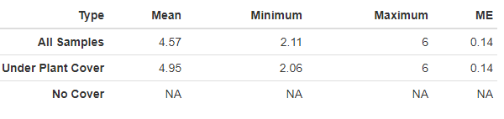

#### 6.1.10.2 Vegetation and Surface Cover

Tree, litter and grass are the dominate cover type for the FORE stratum (Figure 36). Tree species PSME, PIED and PIFL2 dominate the stratum (Figure 37, Table 34). Noxious and annual grass species have not yet been reported (Figure 2, Figure 3).

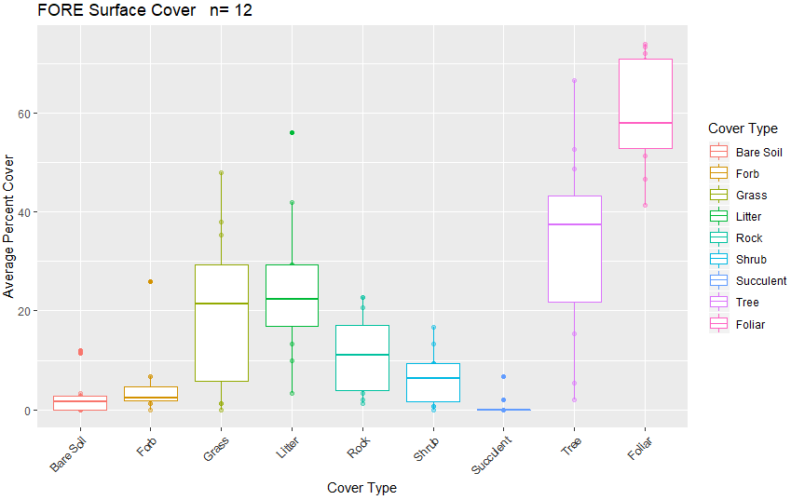

Figure 36. Surface and vegetation cover using line-point intercept results for the FORE stratum. n=population size

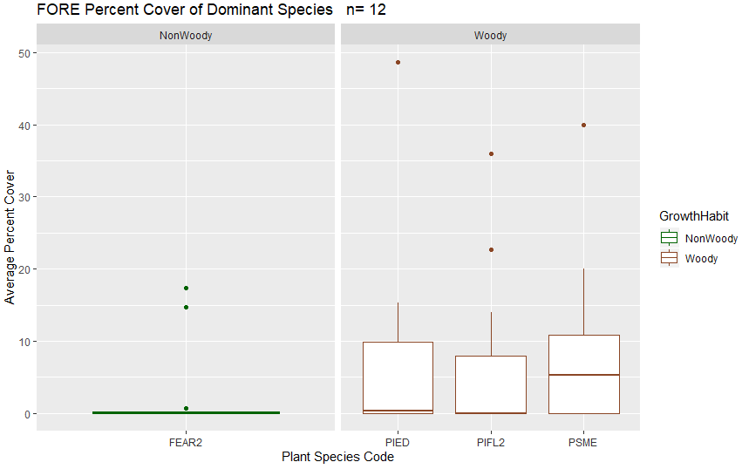

Figure 37. Dominant species categorized by growth habit (woody or nonwoody) in the FORE stratum based on LPI results. n=population size.

#### 6.1.10.3 Canopy Gap

Canopy gap ranged from 24.89-66.51% with an average of 45.40%. Canopy cover ranged from 33.49-75.11% with an average of 54.6% (Figure 38).

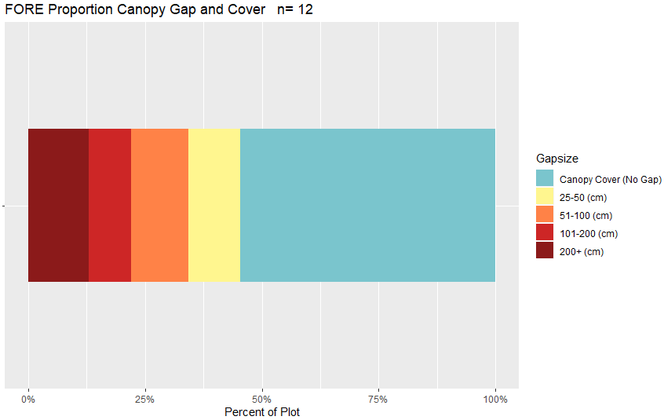

Figure 38. Bar chart of canopy cover and canopy gaps average per plot for the FORE stratum based on Gap Intercept results. Canopy cover was determined by subtracting the percent canopy gaps from 100. n=population size.

Table 34. Surface indicators, vegetation cover, canopy gap and cover, and species richness values determined using LPI for the FORE stratum. Percent values are the average percent hit. ME is the margin of error calculated using an 80% confidence interval.

|  |  |  |  |  |  |
| --- | --- | --- | --- | --- | --- |
| **Indicator** | **Mean** | **Minimum** | **Maximum** | **St.Dev.** | **ME** |
| **Surface Indicator (%)** | | |  |  |  |
| Rock Fragment | 11.06 | 1.33 | 22.67 | 8.05 | 0.86 |
| Litter | 24.22 | 3.33 | 56 | 14.17 | 1.51 |
| Bare Soil | 3 | 0 | 12 | 4.22 | 0.45 |
| **Foliar Cover (%)** | |  |  |  |  |
| Shrub/Sub-shrub | 6.44 | 0 | 16.67 | 5.35 | 0.57 |
| Grass | 19.94 | 0 | 48 | 16.01 | 1.71 |
| Succulent | 0.72 | 0 | 6.67 | 1.96 | 0.21 |
| Tree | 33.5 | 2 | 66.67 | 19.25 | 2.06 |
| Noxious Forb/Herb | 0 | 0 | 0 | 0 | 0 |
| Nonnoxious Forb/Herb | 4.78 | 0 | 26 | 6.99 | 0.75 |
| **Vegetation Height (cm)** | | |  |  |  |
| Grass | 24.15 | 8.5 | 34.5 | 9.28 | 0.99 |
| Forb/Herb | 19.33 | 5 | 40.5 | 14.75 | 1.58 |
| Tree | 619.21 | 7 | 2000 | 486.75 | 52 |
| Shrub | 37.44 | 2 | 120 | 31.85 | 3.4 |
| **Dominant Grass Cover (%)** | | |  |  |  |
| FEAR2 | 2.72 | 0 | 17.33 | 6.23 | 0.67 |
| **Dominant Herb. Cover (%)** | | |  |  |  |
| NA | NA | NA | NA | NA | NA |
| **Dominant Woody Cover (%)** | | |  |  |  |
| PIFL2 | 6.89 | 0 | 36 | 11.63 | 1.24 |
| PIED | 7.33 | 0 | 48.67 | 14.08 | 1.5 |
| PSME | 8.33 | 0 | 40 | 11.69 | 1.25 |
| **Canopy Gaps (%)** | |  |  |  |  |
| Gaps 25-50 cm | 11.14 | 0.44 | 23.48 | 7.56 | 0.81 |
| Gaps 51-100 cm | 12.23 | 1 | 20.71 | 5.57 | 0.59 |
| Gaps 101-200 cm | 9.15 | 0 | 17.44 | 5.35 | 0.57 |
| Gaps >200 cm | 12.88 | 0 | 57.39 | 16.58 | 1.77 |
| **Canopy Cover (%)** | |  |  |  |  |
| Total Canopy Cover | 54.6 | 33.49 | 75.11 | 11.26 | 1.2 |
| **Species Richness** | |  |  |  |  |
| No. Species per Plot | 33.58 | 19 | 46 | 8.66 | 0.93 |

#### 6.1.10.4 Percent Meeting Benchmark

5 plots (58.33%) met all indicator benchmarks (Figure 39, Table 35). Within the allotments, ½ Poncha Pass East plots met all of the indicator benchmarks (Appendix 62). The plots with the lowest percent of indicators meeting benchmark include FO-322 within the East Bend allotment, FO-341 within the Grand Mogote allotment and FO-327 within the Twin Lakes allotment (Appendix 62). Grass height is the indicator benchmark most commonly not met (Table 35).

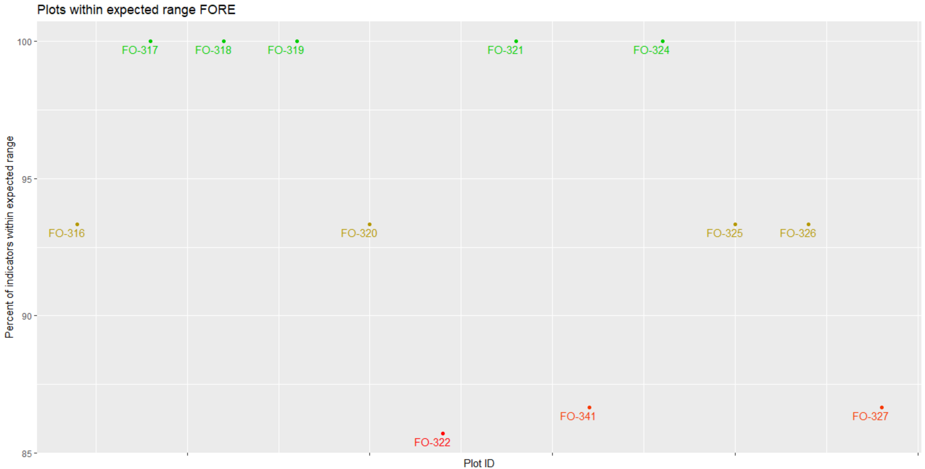

Figure 39. Percent of indicators meeting their expected benchmark range for each plot in the FORE stratum.

Table 35. Percent of plots in the FORE stratum that met each indicator.

|  |  |  |
| --- | --- | --- |
| **Strata** | **Category** | **Percent.Meeting** |
| FORE | Percent Bare Ground | 91.67 |
|  | Soil Aggregate Stability | 100 |
|  | Litter | 91.67 |
|  | Nonnoxious Species | 100 |
|  | Percent Grass Cover | 100 |
|  | Percent Forb Cover | 91.67 |
|  | Percent Shrub Cover | 91.67 |
|  | Percent Noxious Species | 100 |
|  | Number of Forbs | 100 |
|  | Percent Rock Cover | 100 |
|  | Percent Tree Cover | 100 |
|  | Percent Succulent Cover | 91.67 |
|  | Percent Gap Cover | 100 |
|  | Forb Height | 100 |
|  | Grass Height | 58.33 |
|  |  |  |

## 6.2 Intensification Plots

### 6.2.1 Summary of PV Intensification plots

Analysis was completed using the same method as the master sample analysis. Ten plots have been sampled for the PV intensification. ESs include Mountain Loam, 10-14" P.Z., Mountain Outwash and 4 Unknown (Appendix 52). Average annual precipitation ranges from 11.79-15.66 inches with a mean of 13.67 inches. Slope ranges from 4.1-14.96% with a mean of 7.2%. Elevation ranges from 2,468-2,784 meters with a mean of 2,575 meters. Landscape type includes Other (4 plots), Terrace (3 plots), Hills/Mountains (2 plots) and Flood Plain/Basin (1 plot). Soil texture is predominantly sandy loam (11 horizons) and sandy clay loam (6 horizons). Rock fragments range from 0-40% with a mean of 14.31%. Effervescence is predominantly non-effervescent (58.62% of horizons) followed by violently effervescent (24.14% of horizons) and very slightly (17.24% of horizons). Clay percentage ranges from 2-88% with a mean of 18.62%. TerrADat Plots record was missing for one plot (plot PV-07). Common species with at least 5% cover per plot include HECO26, BOGR2, ELEL5, CADO2, ACHY, QUGA, ARTRV and RICE.

#### 6.2.1.1 Soil Stability

The average soil stability was 2.71 for all samples and there was a difference of 0.78 between samples under and not under cover (Table 36).

Table 36. Summary of soil stability test results for PV intensification plots.

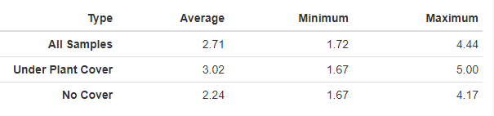

#### 6.2.2.2 Vegetation and Surface Cover

Grass, litter and shrub are the dominant cover types for the PV Intensification plots (Figure 40). Grass species BOGR2, CADO, HECO26 and ELEL5 dominate the stratum (Figure 41, Table 37).

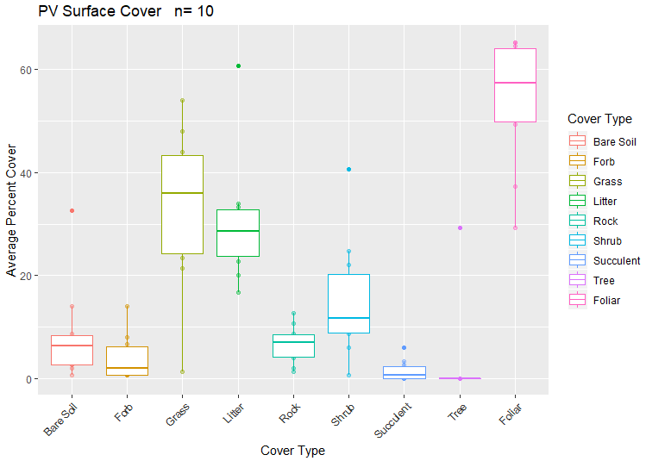

Figure 40. Surface and vegetation cover using line-point intercept results for the PV Intensification plots. n=population size

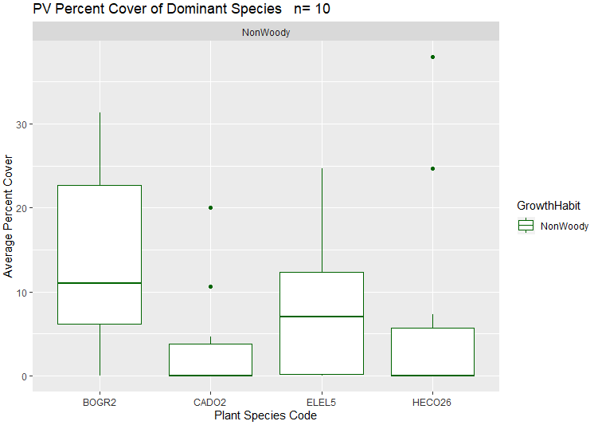

Figure 41. Dominant vegetation species for the PV intensification sites based on LPI results. n=population size

No noxious or annual grass species have been reported for the PV intensification sites (Figure 42, Figure 43).

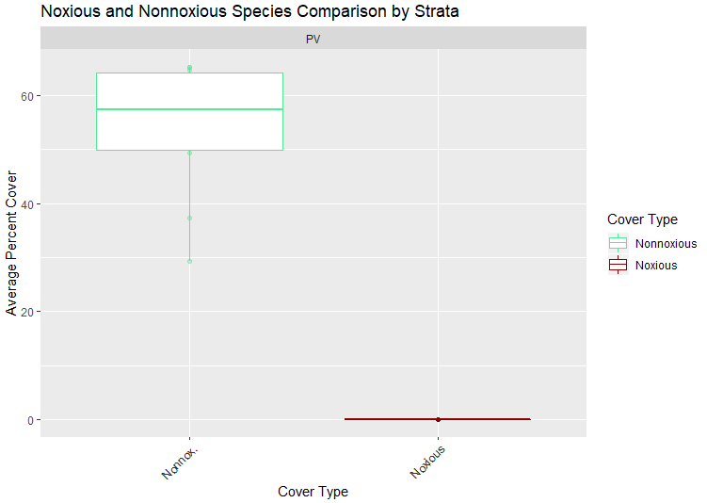

Figure 42. Percent cover of noxious and nonnoxious species for PV intensification plots based on LPI results. n=population size

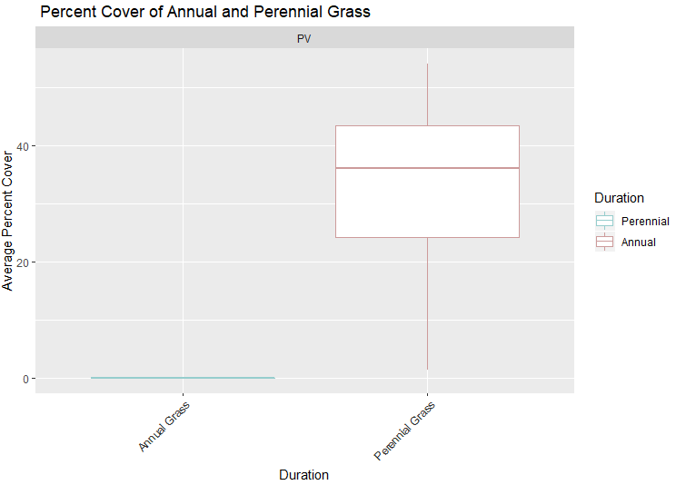

Figure 43. Percent cover of annual and perennial grass for the PV intensification plots based on LPI results. n=population size.

#### 6.2.1.3 Canopy Gap

Average canopy gap ranges from 10.21-73.01% with a mean of 32.93% per plot. Average canopy cover ranges from 26.99-89.79% with a mean of 67.07% per plot (Figure 44).

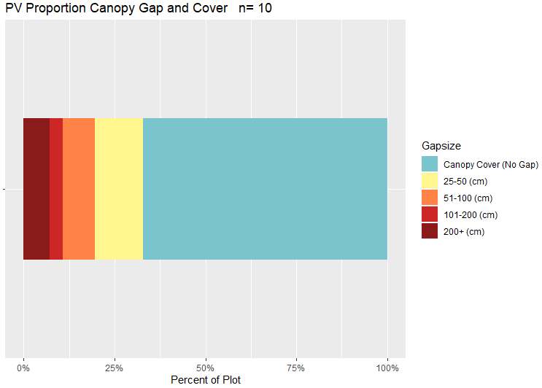

Figure 44. Bar chart of canopy cover and canopy gaps for PV Intensification plots based on Gap Intercept results. Canopy cover was determined by subtracting the percent canopy gaps from 100. n=population size.

Table 37. Surface indicators, vegetation cover, canopy gap and cover, and species richness values determined using LPI for PV Intensification plots. Percent values are the average percent hit.

|  |  |  |  |  |  |
| --- | --- | --- | --- | --- | --- |
| **Indicator** | **Mean** | **Minimum** | **Maximum** | **St.Dev.** | **ME** |
| **Surface Indicator (%)** | |  |  |  |  |
| Rock Fragment | 6.6 | 1.33 | 12.67 | 3.64 | 0.47 |
| Litter | 30.27 | 16.67 | 60.67 | 12.1 | 1.55 |
| Bare Soil | 8.33 | 0.67 | 32.67 | 9.41 | 1.21 |
| **Foliar Cover (%)** | |  |  |  |  |
| Shrub/Sub-shrub | 15 | 0.67 | 40.67 | 11.47 | 1.47 |
| Grass | 33.2 | 1.33 | 54 | 15.56 | 1.99 |
| Succulent | 1.47 | 0 | 6 | 1.98 | 0.25 |
| Tree | 2.93 | 0 | 29.33 | 9.28 | 1.19 |
| Noxious Forb/Herb | 0 | 0 | 0 | 0 | 0 |
| Nonnoxious Forb/Herb | 4 | 0.67 | 14 | 4.42 | 0.57 |
| **Vegetation Height (cm)** | | |  |  |  |
| Grass | 15.83 | 7.82 | 21.85 | 4.17 | 0.53 |
| Forb/Herb | 15.49 | 4 | 21.6 | 6.28 | 0.8 |
| Tree | 1116 | 450 | 1800 | 472.8 | 60.61 |
| Shrub | 46.2 | 2 | 290 | 49.09 | 6.29 |
| **Dominant Grass Cover (%)** | | |  |  |  |
| BOGR2 | 13.33 | 0 | 31.33 | 11.19 | 1.43 |
| HECO26 | 7.07 | 0 | 38 | 13.36 | 1.71 |
| ELEL5 | 7.93 | 0 | 24.67 | 8.45 | 1.08 |
| CADO2 | 3.67 | 0 | 20 | 6.69 | 0.86 |
| **Dominant Herb. Cover (%)** | | |  |  |  |
| NA | NA | NA | NA | NA | NA |
| **Dominant Woody Cover (%)** | | |  |  |  |
| NA | NA | NA | NA | NA | NA |
| **Canopy Gaps (%)** | |  |  |  |  |
| Gaps 25-50 cm | 13.32 | 2.73 | 31.16 | 7.76 | 1 |
| Gaps 51-100 cm | 8.77 | 2.85 | 15.64 | 4.49 | 0.58 |
| Gaps 101-200 cm | 3.77 | 0 | 8.31 | 2.94 | 0.38 |
| Gaps >200 cm | 7.07 | 0 | 58.87 | 18.31 | 2.35 |
| **Canopy Cover (%)** | |  |  |  |  |
| Total Canopy Cover | 67.07 | 26.99 | 89.79 | 17.7 | 2.27 |
| **Species Richness** | |  |  |  |  |
| No. Species per Plot | 20.6 | 10 | 29 | 6.77 | 0.87 |

#### 6.2.1.4 Percent of Plots Meeting Benchmark

5 plots (50%) met all indicator benchmarks (Figure 45, Table 38). Within allotments, ½ Ponch Pass-West and ¾ Poncha Pass East plots did not meet all of the indicator benchmarks (Appendix 63). The plots with the lowest percent of indicators meeting benchmark include PV-07 within the Ponch Pass-West allotment, PV-06, PV-04 and PV-10 within the Poncha Pass East allotment and PV-02 which is not within an allotment (Appendix 63).

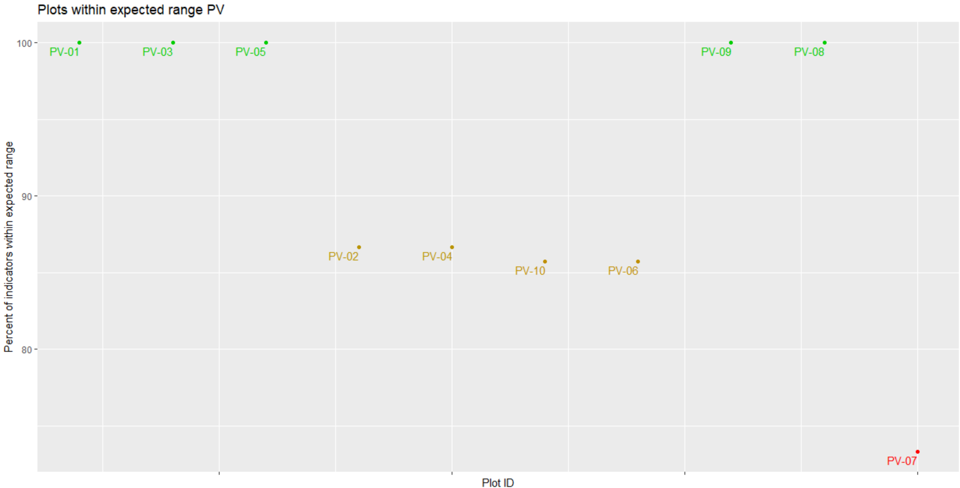

Figure 45. Percent of indicators meeting their expected benchmark range for each plot in the PV intensification.

Table 38. Percent of plots in the PV intensification that met each indicator.

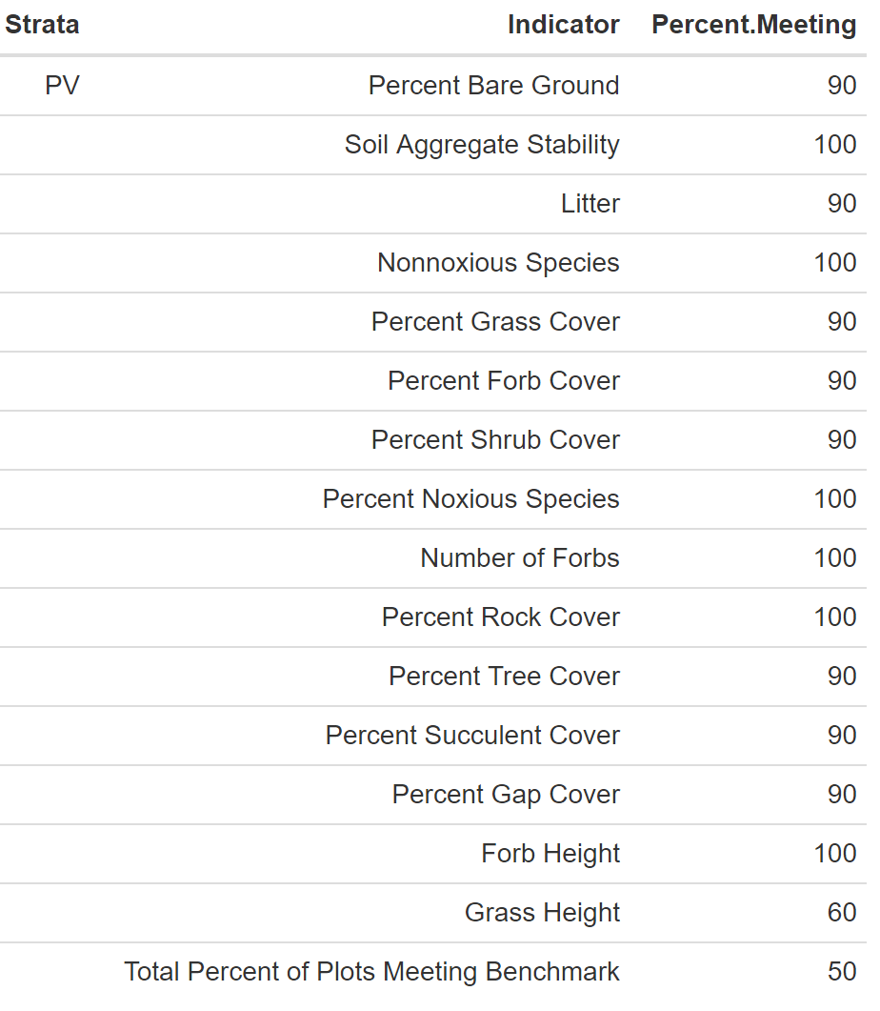

### 6.2.2 Summary of GUSG Intensification plots

The analysis was completed using the same methods as the master sample. 9 plots have been completed within the GUSG intensification area. ESs include Mountain Loam, 10-14" P.Z., Mountain Outwash and Shallow Loam sites (Appendix 52). Annual precipitation ranges from 14.4-18.13 inches. GUSGW has the lowest average annual precipitation (15.73 inches) and GUSGP has the highest (17.04 inches). Landscape type is predominantly Terraces and Hills/Mountains with a slope ranging from 1.29-20.31%. GUSGO has the lowest percent slope (3.22%) and GUSGP has the highest (15.18%). Elevation ranges from 2,062-2,788 meters. GUSGW has the lowest average elevation at 2,448 meters and GUSGP has the highest at 2,709 meters. Soil texture is predominantly loam followed by clay loam. Rock fragments range from 2-90%. GUSGO has the lowest average percent rock fragments (30.33%) and GUSGW has the highest (30.61%). Effervescence ranged from non-effervescent to violently effervescent. Non-effervescent was the most common. Dominate vegetation include grasses such as AGCR, ACSC11, ELEL5, HECO26 and POSE. Dominate woody species include ARTRV, QUGA and CHGR6

#### 6.2.2.1 Soil Stability

The average soil stability for the GUSG intensification plots is 2.43. GUSGO has the lowest average soil stability (2.17) and GUSGP has the highest (2.81).

#### 6.2.2.2 Vegetation and Surface Cover

Strata were compared to determine the stratum with the highest average percent cover by cover type (Table 39).

Table 39. Strata with the highest value of each covertype. Values are all percent except for soil stability and are the average value for all plots.

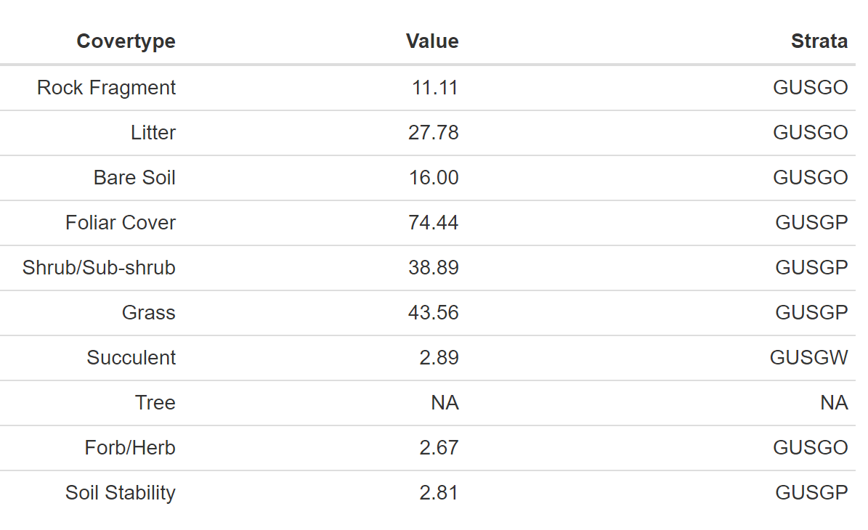

GUSGP has the highest grass, shrub and foliar cover (Figure 46).

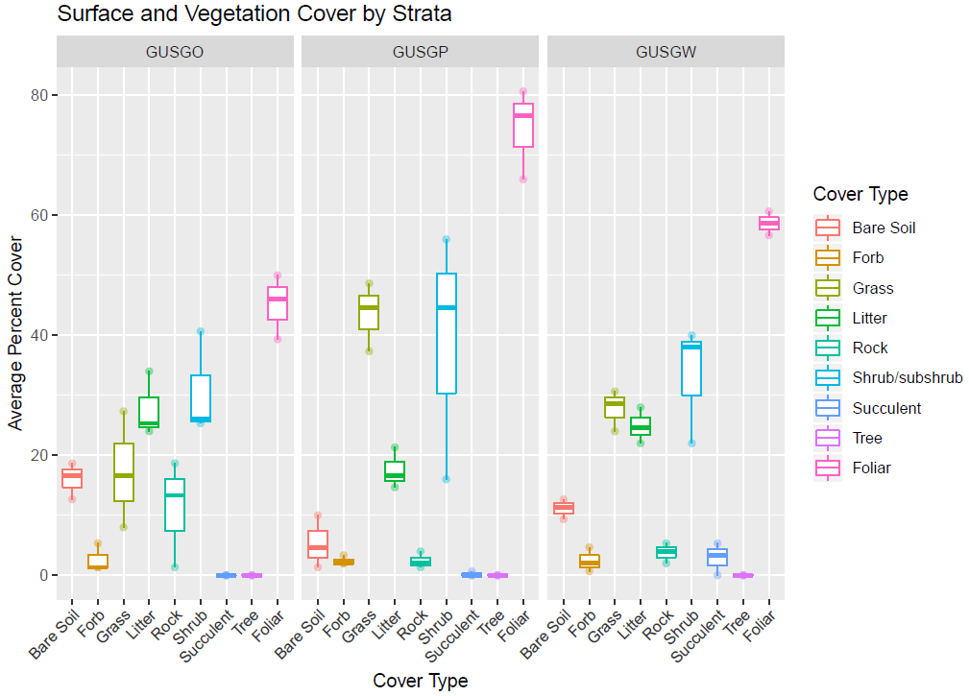

Figure 46. Surface and vegetation cover using line-point intercept results for the GUSG Intensification plots. n=population size.

No noxious species have been reported for the GUSG plots (Figure 47).

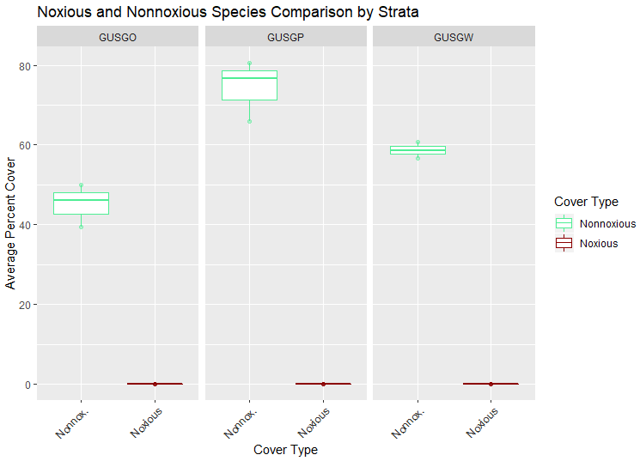

Figure 47. Percent nonnoxious and noxious species for the GUSG Intensification categorized by stratum based on LPI results.

Annual grass is only reported in the GUSGP stratum (Figure 48).

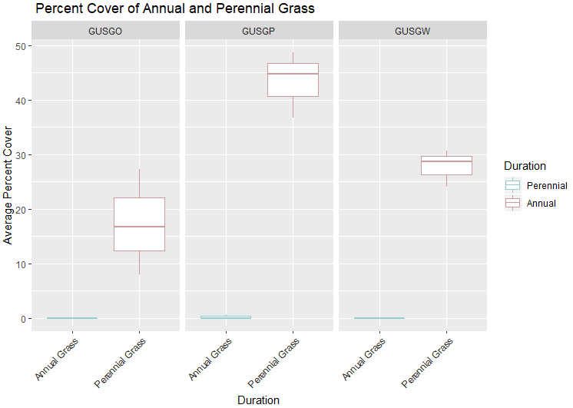

Figure 48. Percent perennial and annual grass hit during LPI for the GUSG Intensification categorized by stratum.

#### 6.2.2.3 Canopy Gap

Percent canopy gap ranges from 10.67-52.73% with an average percent canopy gap of 27.01% per plot. Percent canopy cover ranges from 47.27-89.33% with an average percent canopy cover of 72.99% per plot.

### 6.2.3 GUSGO

3 plots were completed within the GUSGO stratum. ESs for the GUSGO stratum include Mountain Loam, 10-14" P.Z. (Appendix 52). Annual precipitation ranges from 16.44-17.15 inches with an average of 16.8 inches. Landscape type includes Fan Piedmont (1), Flood Plain/Basin (1) and Hills/Mountains (1) with a slope ranging from 1.29-5.87% and an average of 3.22%. Elevation ranges from 2,684-2,721 meters with an average of 2,697 meters. Soils include loam (6 horizons) and clay loam (6 horizons). Rock fragments range from 2-77% with a mean of 30.33%. Soil is typically non-effervescent (66.67% of horizons) followed by slightly and very slightly (16.67%). Clay ranges from 7-40% with a mean of 25%. Common species with at least 5% cover per plot include ARTRV, CHGR6, POSE, ASCS11 and BOGR2.

#### 6.2.3.1 Soil Stability

The average soil stability for this stratum was 2.17 with a difference of 0.81 between samples under and not under cover (Table 40).

Table 40. Summary of soil stability test results for the GUSGO stratum.

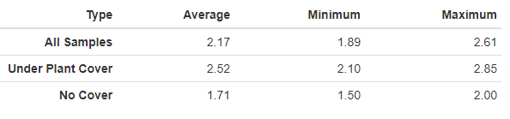

#### 6.2.3.2 Vegetation and Surface Cover

Shrub, litter and grass are the dominant cover types for this stratum (Figure 49). Grass species AGCR and POSE and woody species ARTRV and CHGR6 are the dominate vegetation of this stratum (Figure 50, Table 41). No noxious or annual grass species have been reported (Figure 46, Figure 47).

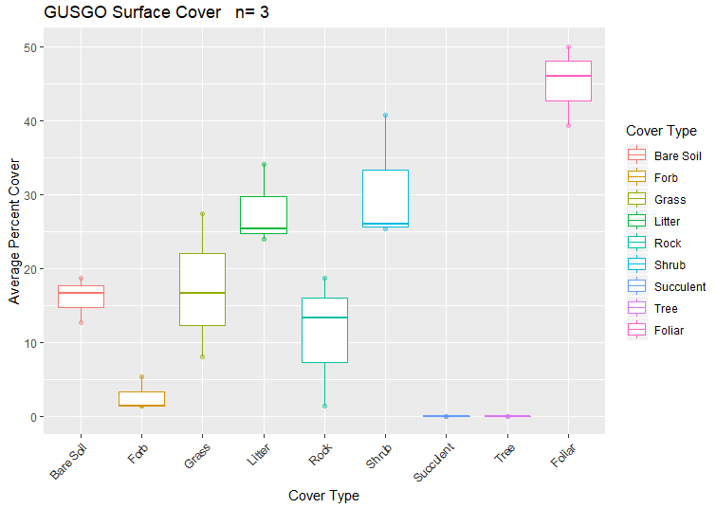

Figure 49. Surface and vegetation cover using line-point intercept results for the GUSGO stratum. n= population size.

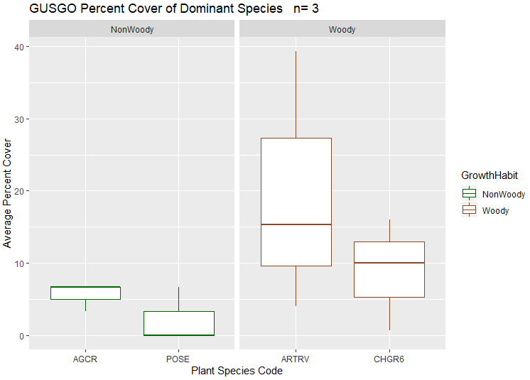

Figure 50. Dominant species categorized by growth habit (woody or nonwoody) in the GUSGO stratum based on LPI results. n = population size.

#### 6.2.3.3 Canopy Gap

Canopy gap ranges from 34.28-52.73% with an average percent canopy gap of 41.11% per plot. Average canopy cover ranges from 47.27-65.72% with an average percent canopy cover of 58.89% per plot (Figure 51).

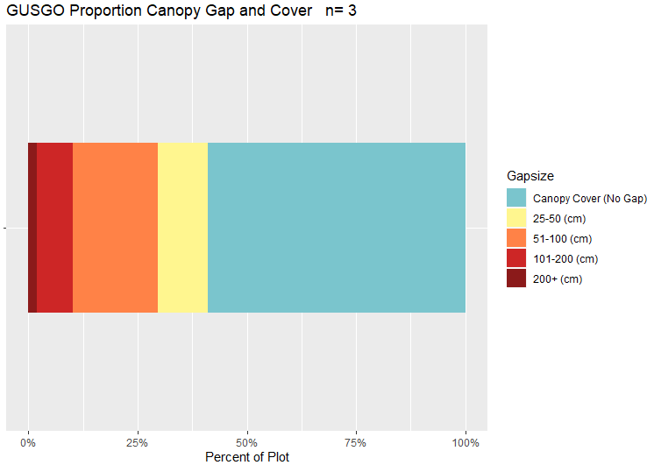

Figure 51. Bar chart of canopy cover and canopy gaps for the GUSGO stratum. Canopy cover was determined by subtracting the percent canopy gaps from 100. n=population size.

Table 41. Surface indicators, vegetation cover, canopy gap and cover, and species richness values determined using LPI for GUSGO plots. Percent values are the average percent hit.

|  |  |  |  |  |  |
| --- | --- | --- | --- | --- | --- |
| **Indicator** | **Mean** | **Minimum** | **Maximum** | **St.Dev.** | **ME** |
| **Surface Indicator (%)** | |  |  |  |  |
| Rock Fragment | 11.11 | 1.33 | 18.67 | 8.88 | 3.79 |
| Litter | 27.78 | 24 | 34 | 5.43 | 2.32 |
| Bare Soil | 16 | 12.67 | 18.67 | 3.06 | 1.31 |
| **Foliar Cover (%)** | |  |  |  |  |
| Shrub/Sub-shrub | 30.67 | 25.33 | 40.67 | 8.67 | 3.7 |
| Grass | 17.33 | 8 | 27.33 | 9.68 | 4.14 |
| Succulent | 0 | 0 | 0 | 0 | 0 |
| Tree | 0 | 0 | 0 | 0 | 0 |
| Noxious Forb/Herb | 0 | 0 | 0 | 0 | 0 |
| Nonnoxious Forb/Herb | 2.67 | 1.33 | 5.33 | 2.31 | 0.99 |
| **Vegetation Height (cm)** | | |  |  |  |
| Grass | 17.9 | 16 | 20.41 | 2.27 | 0.97 |
| Forb/Herb | 10.44 | 8.5 | 11.82 | 1.73 | 0.74 |
| Tree | NA | NA | NA | NA | NA |
| Shrub | 37.05 | 5 | 106 | 24.38 | 10.42 |
| **Dominant Grass Cover (%)** | | |  |  |  |
| AGCR | 5.56 | 3.33 | 6.67 | 1.92 | 0.82 |
| POSE | 2.22 | 0 | 6.67 | 3.85 | 1.64 |
| **Dominant Herb. Cover (%)** | | |  |  |  |
| NA | NA | NA | NA | NA | NA |
| **Dominant Woody Cover (%)** | | |  |  |  |
| ARTRV | 19.56 | 4 | 39.33 | 18.04 | 7.71 |
| CHGR6 | 19.56 | 0.67 | 16 | 7.73 | 3.3 |
| **Canopy Gaps (%)** | |  |  |  |  |
| Gaps 25-50 cm | 11.55 | 7.32 | 15.71 | 4.19 | 1.79 |
| Gaps 51-100 cm | 19.37 | 10.08 | 29.05 | 9.49 | 4.06 |
| Gaps 101-200 cm | 8.25 | 1.63 | 14.12 | 6.28 | 2.68 |
| Gaps >200 cm | 1.94 | 0 | 3.05 | 1.68 | 0.72 |
| **Canopy Cover (%)** | |  |  |  |  |
| Total Canopy Cover | 58.89 | 47.27 | 65.72 | 10.12 | 4.32 |
| **Species Richness** | |  |  |  |  |
| No. Species per Plot | 20 | 20 | 20 | 0 | 0 |

#### 6.2.3.4 Percent of Plots Meeting Benchmark

Two plots (66.67%) met all indicator benchmarks (Figure 52, Table 42). All plots were within separate allotments (Appendix 64). The plot with the lowest percent of indicators meeting benchmark, GUSGO-04, is within the Eight Mile allotment (Appendix 64). Grass height was the only indicator benchmark not met on GUSGO-04 (Table 42).

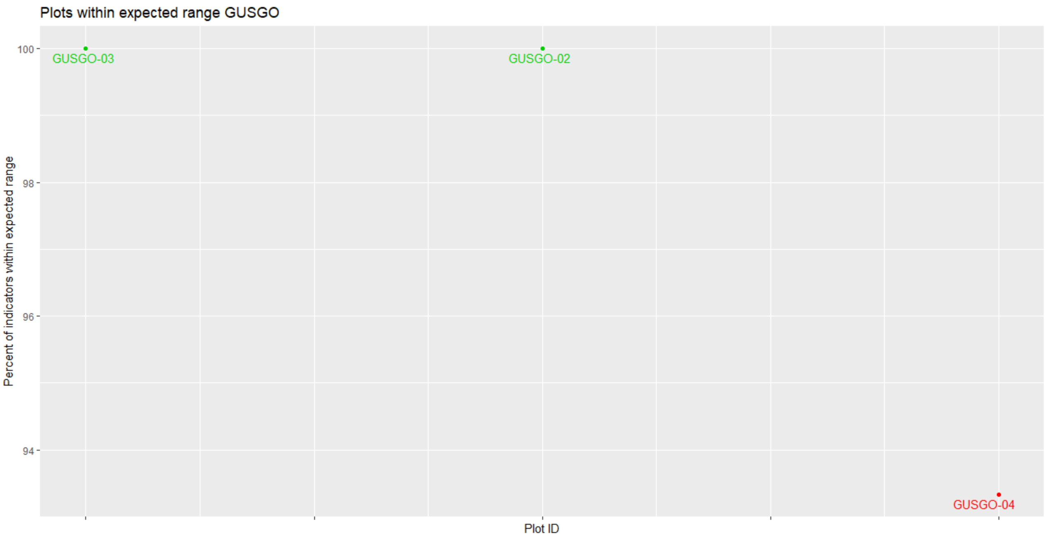

Figure 52. Percent of indicators meeting their expected benchmark range for each plot in the GUSGO stratum.

Table 42. Percent of plots in the GUSGO stratum that met each indicator.

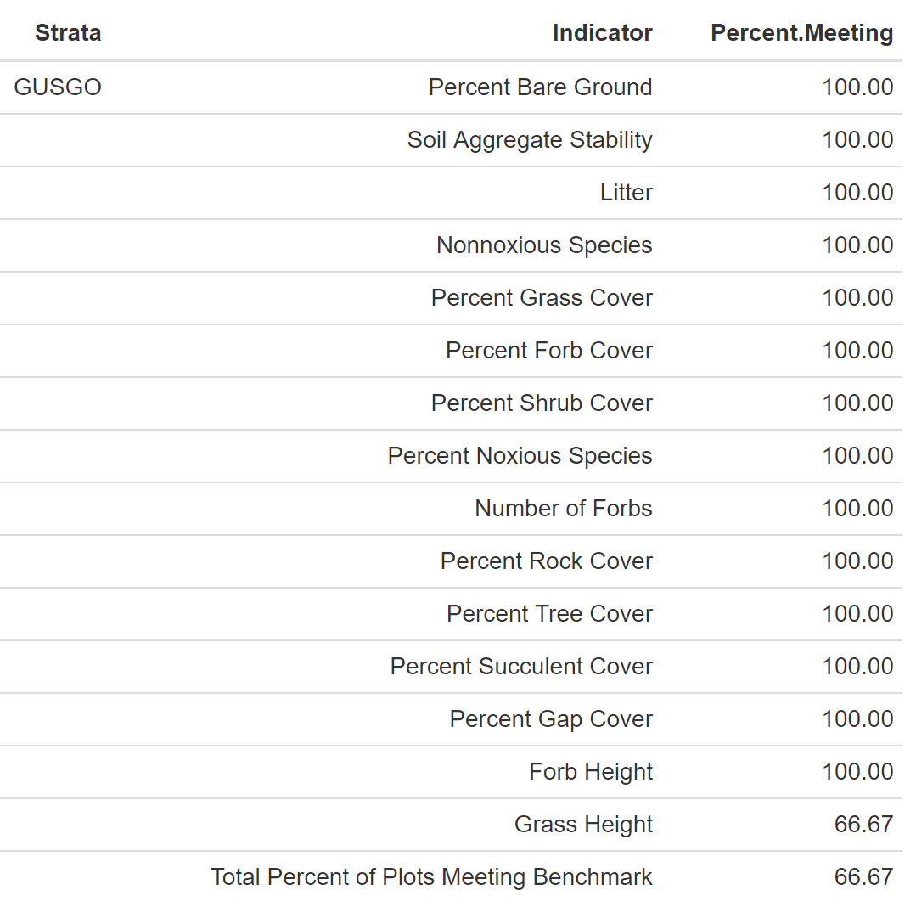

### 6.2.4 GUSGP

3 plots were completed within the GUSGP stratum. ESs include Shallow Loam, Mountain Loam, 10-14" P.Z. and Mountain Outwash (Appendix 52). Average annual precipitation ranges from 15.4-18.13 inches with a mean of 17.04 inches. Slope ranges from 5.24-20.31% with a mean of 15.18%. Elevation ranges from 2,578-2,788 meters with a mean of 2,709 meters. Landscape type includes Hills/Mountains (2 plots) and Flood Plain/Basin (1 plot). Texture includes loam (5 horizons), sandy clay loam (2 horizons), silt loam and sandy loam (1 horizon). Rock fragments range from 9-90% with a mean of 32.44%. Effervescence ranges from non-effervescent to violently (non-effervescent being the most common, 44.44% of the horizons). Percent clay ranges from 5-25% with a mean of 15.11%. Common species present with at least 5% cover per plot include QUGA, ARTRV, HECO26, POSE, BOGR2, POFE, CADO2, KOMA.

#### 6.2.4.1 Soil Stability

The average soil stability for this stratum was 2.81 with a difference of 1.6 between samples taken under cover and not under cover (Table 43).

Table 43. Summary of soil stability test results for the GUSGP stratum.

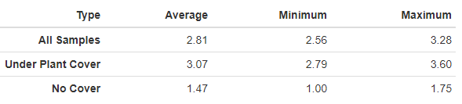

#### 6.2.4.2 Vegetation and Surface Cover

Shrub, grass and litter were the most common cover types in the GUSGP stratum (Figure 53). Grasse species HECO26 and POSE and woody species ARTRV and QUGA are common species (Figure 54, Table 44). No noxious species have been reported (Figure 46). GUSGP-11 has annual grass present on 0.67% of the plot.

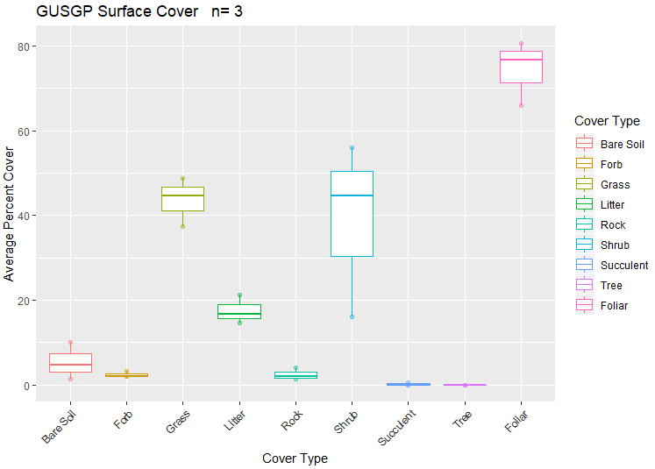

Figure 53. Surface and vegetation cover using line-point intercept results for the GUSGP stratum. n=population size.

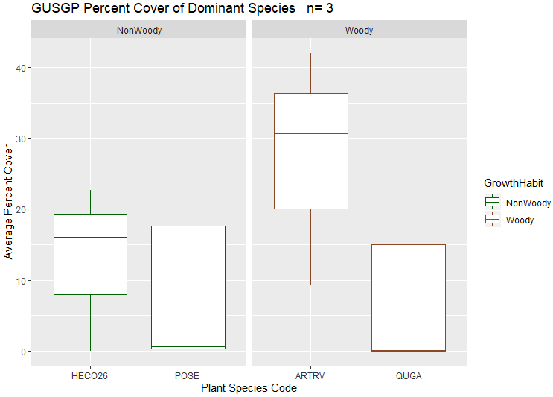

Figure 54. Dominant species categorized by growth habit (woody or nonwoody) in the GUSGP stratum based on LPI results. n=population size.

#### 6.2.4.3 Canopy Gap

Canopy gap ranges from 10.67-22.64% with an average percent canopy gap of 16.33% per plot. Percent canopy cover ranges from 77.36-89.33% with an average percent canopy cover 83.67% per plot (Figure 55).

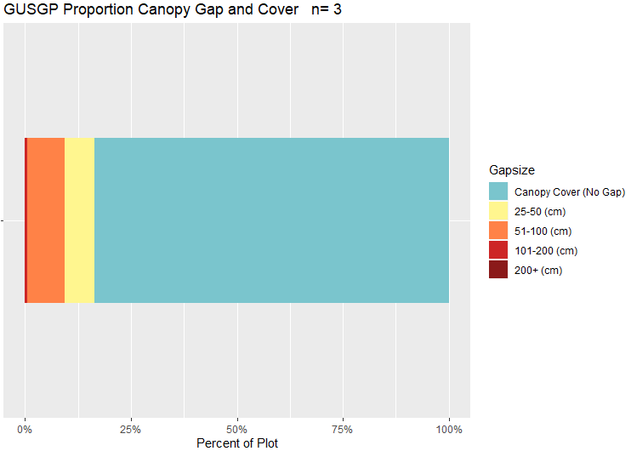

Figure 55. Bar chart of canopy cover and canopy gaps for the GUSGP stratum based on the Gap Intercept results. Canopy cover was determined by subtracting the percent canopy gaps from 100. n=population size.

Table 44. Surface indicators, vegetation cover, canopy gap and cover, and species richness values determined using LPI for the GUSGP plots. Percent values are the average percent hit. Shrub height recorded as 0 was omitted from the woody height data.

|  |  |  |  |  |  |
| --- | --- | --- | --- | --- | --- |
| **Indicator** | **Mean** | **Minimum** | **Maximum** | **St.Dev.** | **ME** |
| **Surface Indicator (%)** | |  |  |  |  |
| Rock Fragment | 2.44 | 1.33 | 4 | 1.39 | 0.59 |
| Litter | 17.56 | 14.67 | 21.33 | 3.42 | 1.46 |
| Bare Soil | 5.33 | 1.33 | 10 | 4.37 | 1.87 |
| **Foliar Cover (%)** | |  |  |  |  |
| Shrub/Sub-shrub | 38.89 | 16 | 56 | 20.62 | 8.81 |
| Grass | 43.56 | 37.33 | 48.67 | 5.75 | 2.46 |
| Succulent | 0.22 | 0 | 0.67 | 0.38 | 0.16 |
| Tree | 0 | 0 | 0 | 0 | 0 |
| Noxious Forb/Herb | 0 | 0 | 0 | 0 | 0 |
| Nonnoxious Forb/Herb | 2.44 | 2 | 3.33 | 0.77 | 0.33 |
| **Vegetation Height (cm)** | | |  |  |  |
| Grass | 19.72 | 17.15 | 21.91 | 2.4 | 1.03 |
| Forb/Herb | 11.27 | 4.5 | 14.8 | 5.86 | 2.51 |
| Tree | NA | NA | NA | NA | NA |
| Shrub | 66.38 | 5 | 365 | 60.68 | 25.93 |
| **Dominant Grass Cover (%)** | | |  |  |  |
| HECO26 | 12.89 | 0 | 22.67 | 11.65 | 4.98 |
| POSE | 11.78 | 0 | 34.67 | 19.83 | 8.47 |
| **Dominant Herb. Cover (%)** | | |  |  |  |
| NA | NA | NA | NA | NA | NA |
| **Dominant Woody Cover (%)** | | |  |  |  |
| ARTRV | 27.33 | 9.33 | 42 | 16.59 | 7.09 |
| QUGA | 10 | 0 | 30 | 17.32 | 7.4 |
| **Canopy Gaps (%)** | |  |  |  |  |
| Gaps 25-50 cm | 6.87 | 6.41 | 7.6 | 0.64 | 0.27 |
| Gaps 51-100 cm | 8.94 | 4.25 | 14.48 | 5.17 | 2.21 |
| Gaps 101-200 cm | 0.52 | 0 | 1.56 | 0.9 | 0.38 |
| Gaps >200 cm | 0 | 0 | 0 | 0 | 0 |
| **Canopy Cover (%)** | |  |  |  |  |
| Total Canopy Cover | 83.67 | 77.36 | 89.33 | 6.01 | 2.57 |
| **Species Richness** | |  |  |  |  |
| No. Species per Plot | 26.67 | 24 | 29 | 2.52 | 1.08 |

#### 6.2.4.4 Percent of Plots Meeting Benchmark

Two plots (66.67%) met all indicator benchmarks (Figure 56, Table 45). All plots are within separate allotments (Appendix 64). The plot not meeting all indicator benchmarks, GUSGP-09, is within the Ciscom Flat allotment (Appendix 64). The only indicator benchmark not met is grass height (Table 44).

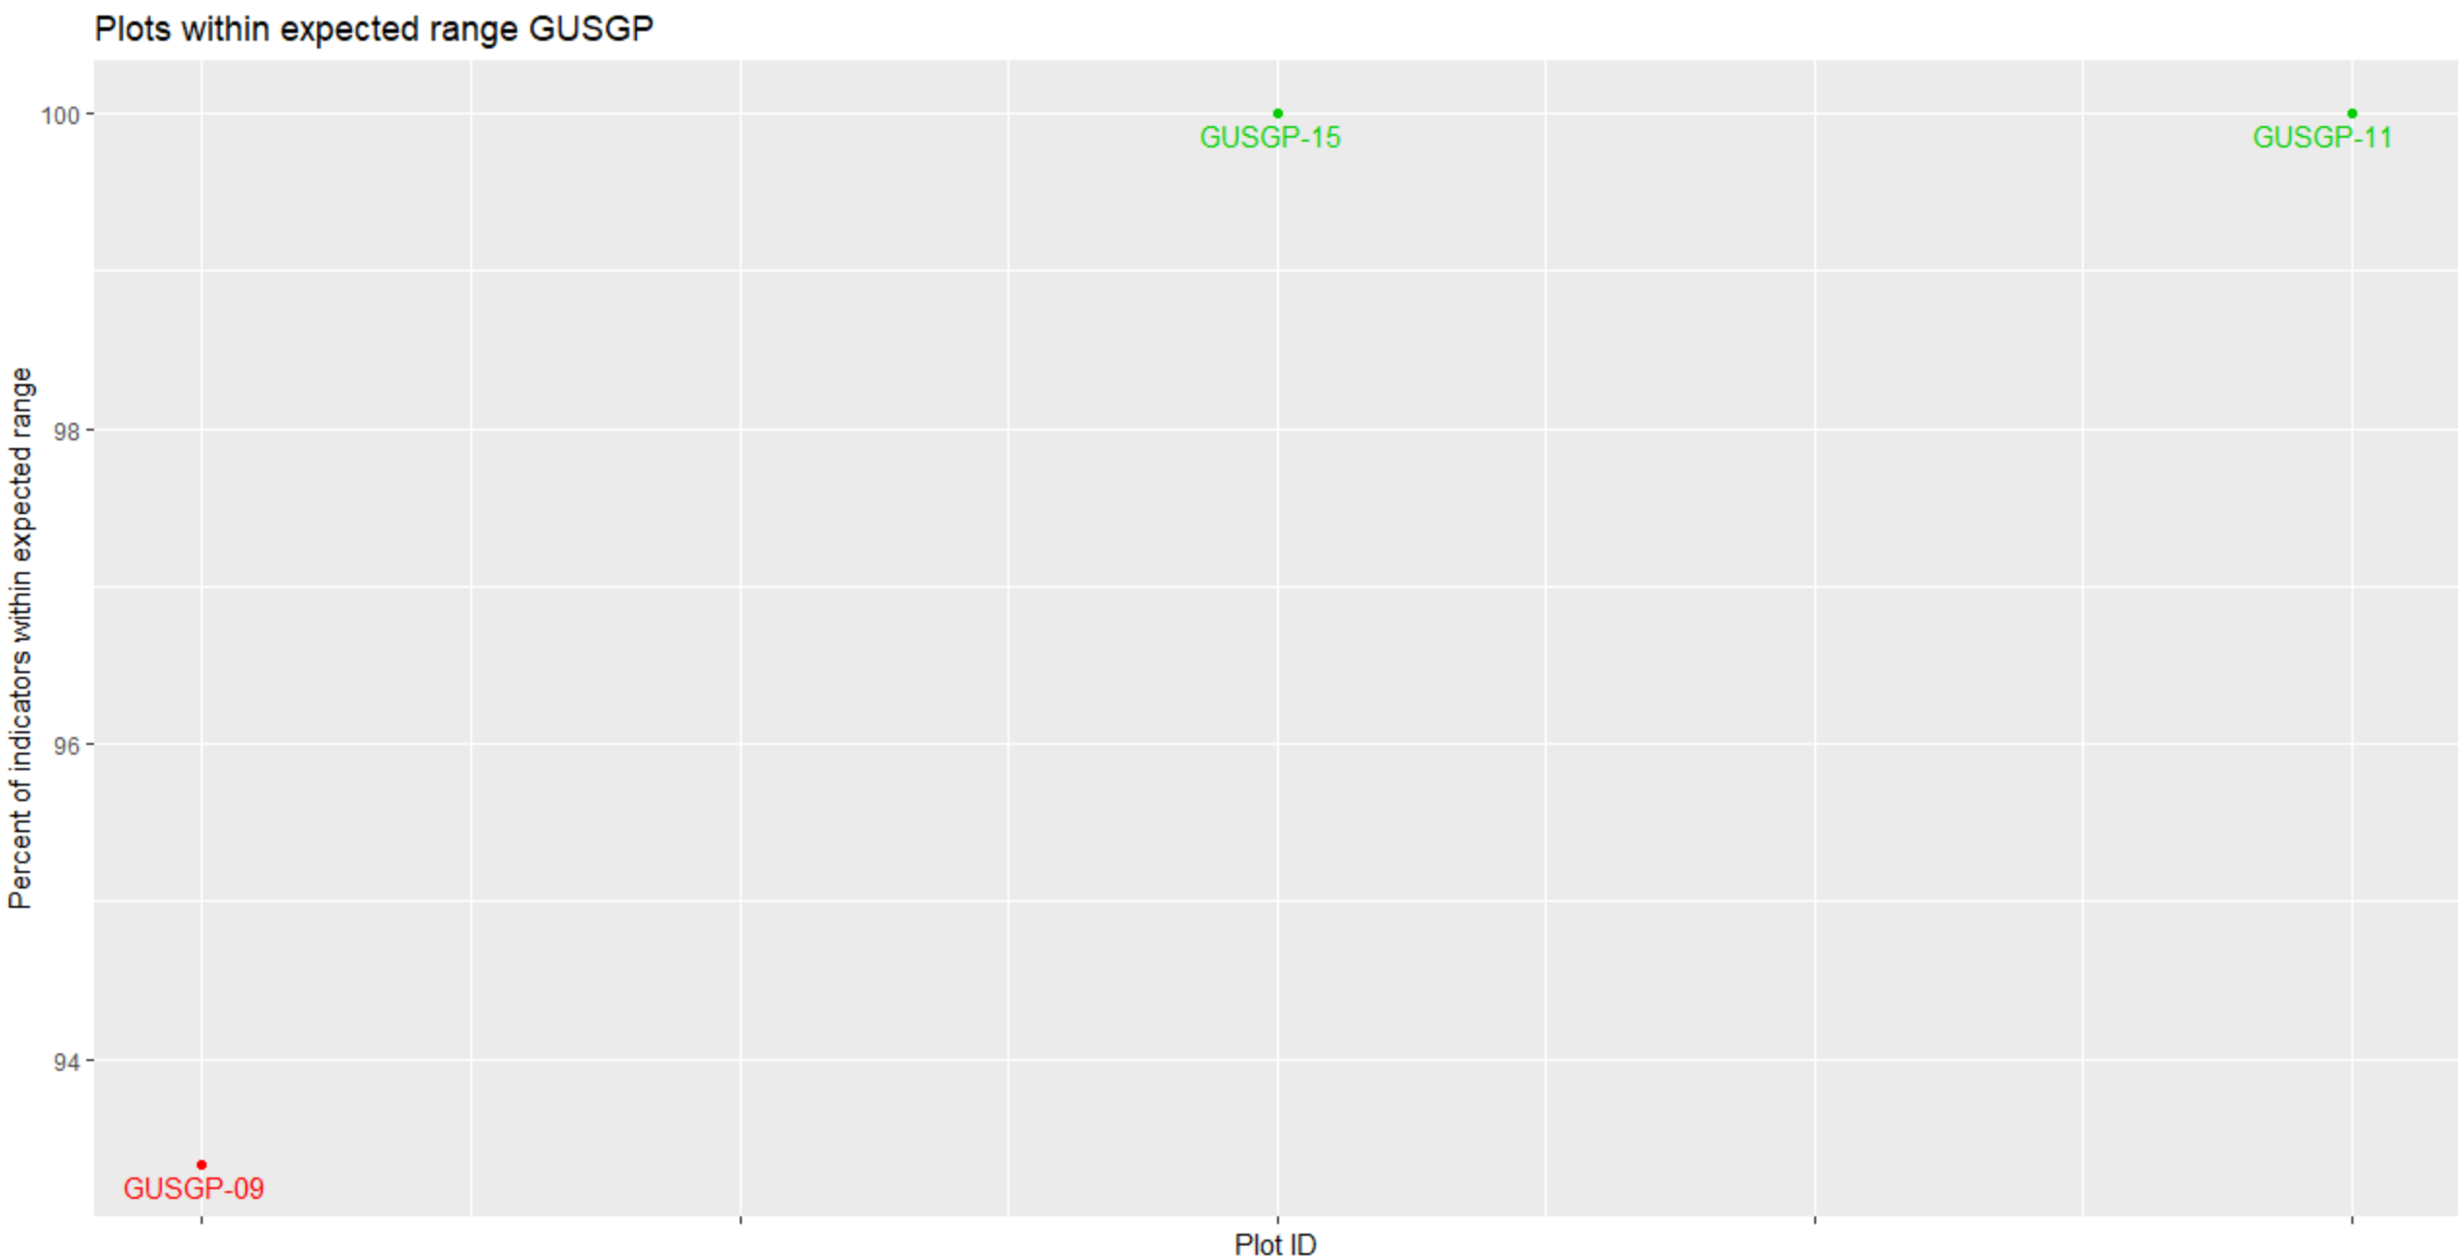

Figure 56. Percent of indicators meeting their expected benchmark range for each plot in the GUSGP stratum.

Table 45. Percent of plots in the GUSGO stratum that met each indicator.

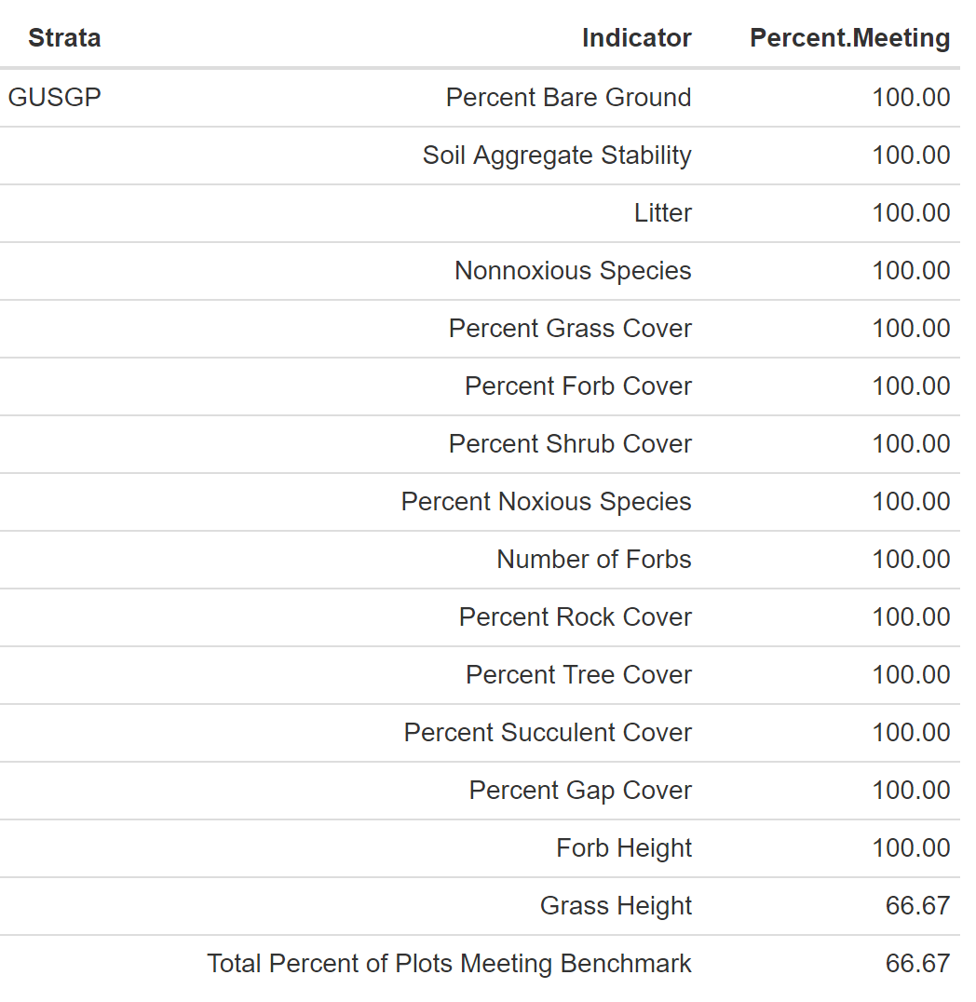

### 6.2.5 GUSGW

3 plots have been sampled within this stratum. ESs include Mountain Outwash (Appendix 52). Annual precipitation ranges from 14.4-17.75 inches with an average of 15.73 inches. Slope ranges from 5.9-7.42% with an average of 6.48. Land scape type includes Terraces. Elevation ranges from 2,062-2,658 meters with an average of 2,448 meters. Soil texture includes loam (6 horizons), sandy loam (3 horizons) and clay loam (1 horizon). Rock fragments range from 22-90% with a mean of 36.1%. All horizons are non-effervescent. Percent clay ranges from 10-27% with a mean of 17.9%. Common species with at least 5% cover per plot include ARTRV, ASCS11, ELEL5, AGCR, CHGR6, BOGR2, QUGA and ARFR4.

#### 6.2.5.1 Soil Stability

The average soil stability for this stratum was 2.31 with a difference of 1.47 between samples under and not under cover (Table 46).

Table 46. Summary of soil stability test results for the GUSGW stratum.

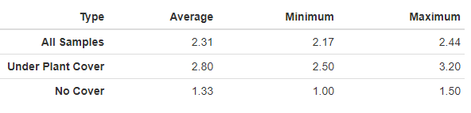

#### 6.2.5.2 Vegetation and Surface Cover

Shrub, grass and litter are the dominant cover types for the GUSGW stratum (Figure 57). Dominant species include woody species ARTRV and grass species ASCS11, ELEL5 and AGCR (Figure 58, Table 47). No noxious or annual grass species have been reported (Figure 46 and Figure 47).

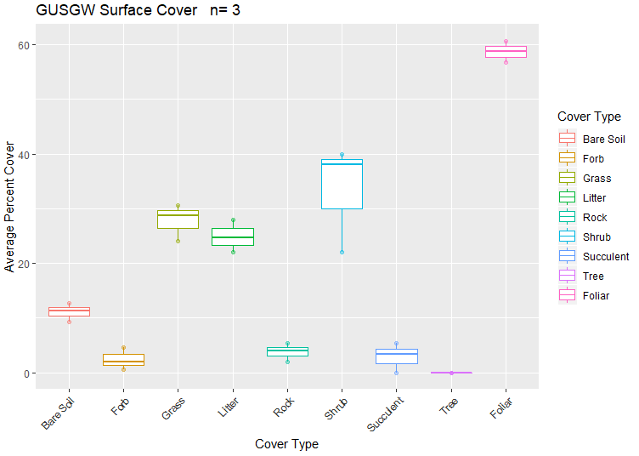

Figure 57. Surface and vegetation cover using line-point intercept results for the GUSGW stratum. n=population size.

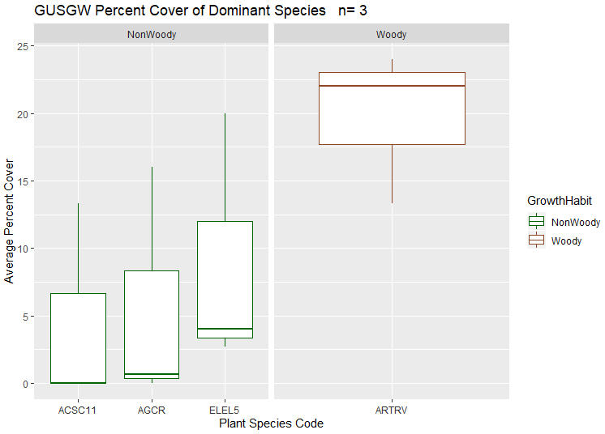

Figure 58. Dominant species categorized by growth habit (woody or nonwoody) in the GUSGW stratum based on LPI results. n=population size.

#### 6.2.5.3 Canopy Gap

Canopy gaps range from 15.93-31.24% with an average percent canopy gap of 23.6% per plot. Canopy cover ranges from 68.76-84.07% with an average percent canopy cover of 76.4% per plot (Figure 59).

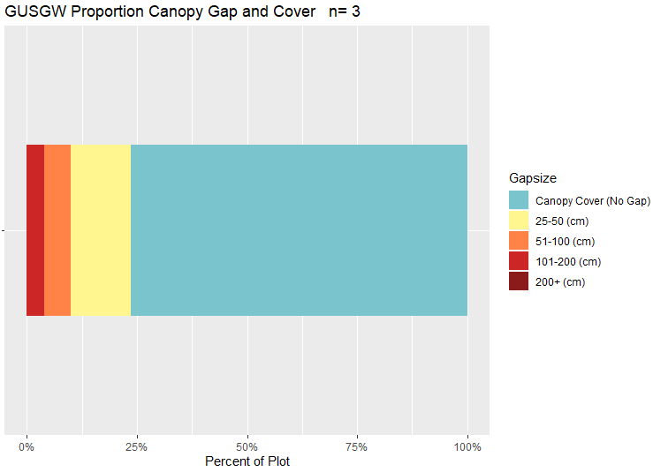

Figure 59. Bar chart of canopy cover and canopy gaps for the GUSGW stratum based on the Gap Intercept results. Canopy cover was determined by subtracting the percent canopy gaps from 100. n=population size.

Table 47. Surface indicators, vegetation cover, canopy gap and cover, and species richness values determined using LPI for GUSGW sites. Percent values are the average percent hit.

|  |  |  |  |  |  |
| --- | --- | --- | --- | --- | --- |
| **Indicator** | **Mean** | **Minimum** | **Maximum** | **St.Dev.** | **ME** |
| **Surface Indicator (%)** | |  |  |  |  |
| Rock Fragment | 3.78 | 2 | 5.33 | 1.68 | 0.72 |
| Litter | 24.89 | 22 | 28 | 3.01 | 1.28 |
| Bare Soil | 11.11 | 9.33 | 12.67 | 1.68 | 0.72 |
| **Foliar Cover (%)** | |  |  |  |  |
| Shrub/Sub-shrub | 33.33 | 22 | 40 | 9.87 | 4.22 |
| Grass | 27.78 | 24 | 30.67 | 3.42 | 1.46 |
| Succulent | 2.89 | 0 | 5.33 | 2.69 | 1.15 |
| Tree | 0 | 0 | 0 | 0 | 0 |
| Noxious Forb/Herb | 0 | 0 | 0 | 0 | 0 |
| Nonnoxious Forb/Herb | 2.44 | 0.67 | 4.67 | 2.04 | 0.87 |
| **Vegetation Height (cm)** | | |  |  |  |
| Grass | 19.29 | 15.14 | 24.05 | 4.49 | 1.92 |
| Forb/Herb | 10.4 | 7.33 | 13.2 | 2.94 | 1.26 |
| Tree | NA | NA | NA | NA | NA |
| Shrub | 43.42 | 8 | 174 | 34.51 | 14.75 |
| **Dominant Grass Cover (%)** | | |  |  |  |
| ACSC11 | 2.67 | 0 | 13.33 | 5.96 | 2.55 |
| AGCR | 4.17 | 0 | 16 | 7.9 | 3.37 |
| ELEL5 | 8.89 | 2.67 | 20 | 9.65 | 4.12 |
| **Dominant Herb. Cover (%)** | | |  |  |  |
| NA | NA | NA | NA | NA | NA |
| **Dominant Woody Cover (%)** | | |  |  |  |
| ARTRV | 19.78 | 13.33 | 24 | 5.67 | 2.42 |
| **Canopy Gaps (%)** | |  |  |  |  |
| Gaps 25-50 cm | 13.64 | 11.33 | 15.03 | 2.01 | 0.86 |
| Gaps 51-100 cm | 5.93 | 2.85 | 7.81 | 2.69 | 1.15 |
| Gaps 101-200 cm | 4.03 | 1.48 | 8.87 | 4.19 | 1.79 |
| Gaps >200 cm | 0 | 0 | 0 | 0 | 0 |
| **Canopy Cover (%)** | |  |  |  |  |
| Total Canopy Cover | 76.4 | 68.76 | 84.07 | 7.65 | 3.27 |
| **Species Richness** | |  |  |  |  |
| No. Species per Plot | 16 | 13 | 18 | 2.65 | 1.13 |

#### 6.2.5.4 Percent of Plots Meeting Benchmark

Two plots (66.67%) met all indicator benchmarks (Figure 60, Table 48). All plots were in separate allotments (Appendix 64). The plot not meeting all indicator benchmarks, GUSGW-17, is within the Poison Gulch allotment (Appendix 64). Grass Height was the only indicator benchmark not met (Table 48).

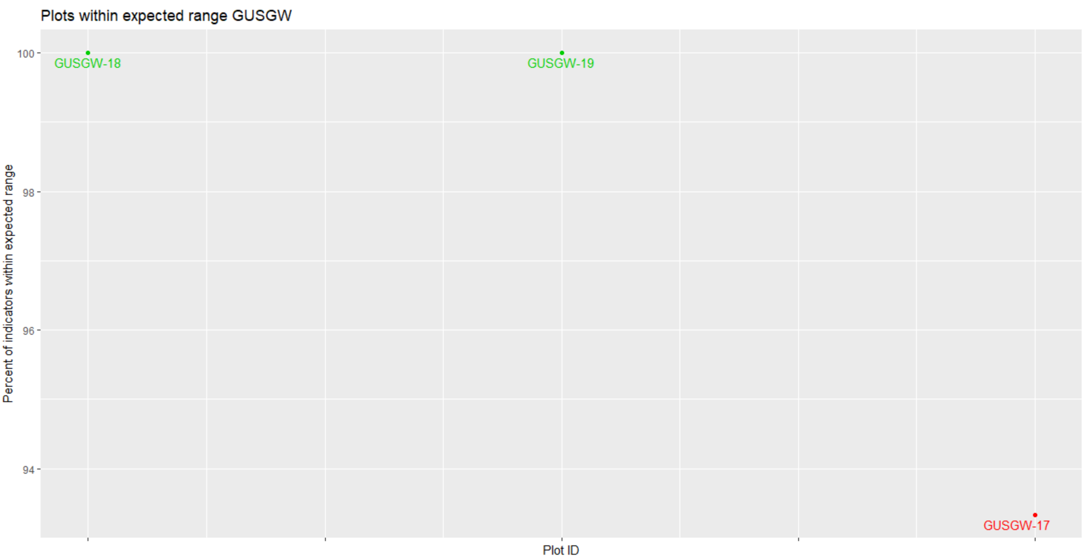

Figure 60. Percent of indicators meeting their expected benchmark range for each plot in the GUSGP stratum.

Table 48. Percent of plots in the GUSGO stratum that met each indicator.

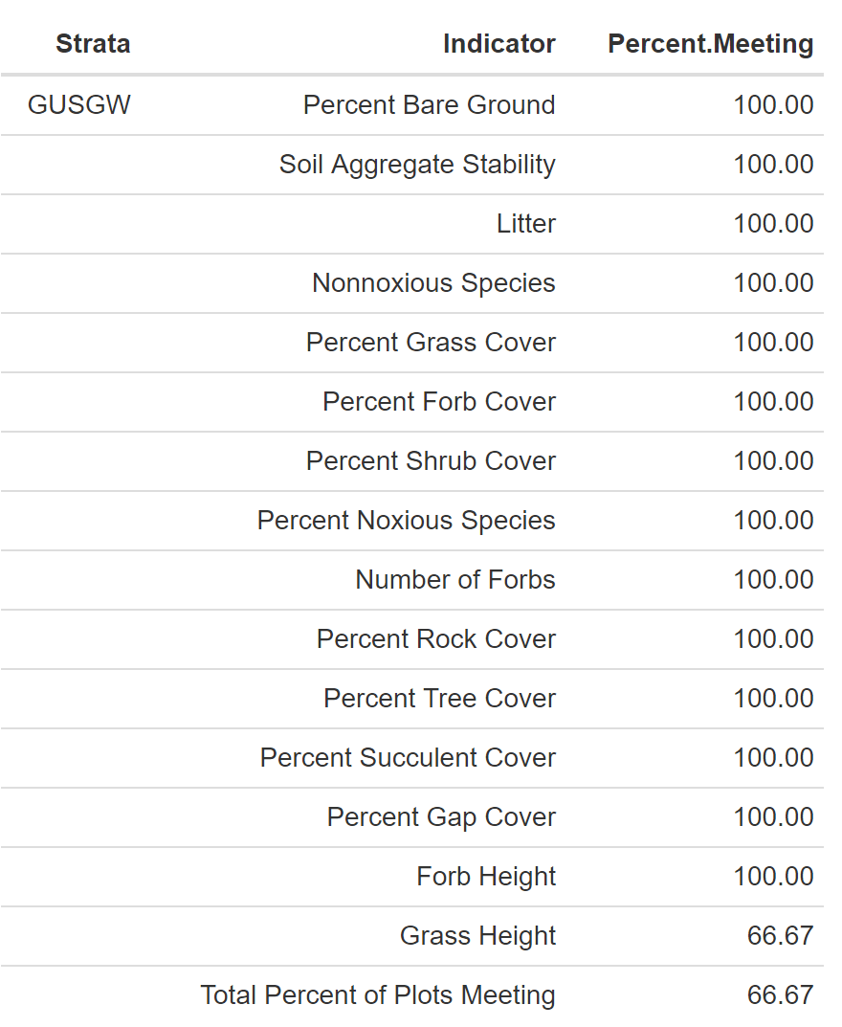

## 6.3 Plots Found within Sage Grouse Habitat

The mapped Gunnison Sage-Grouse habitat in the SLVFO occupies approximately 11,000 acres throughout the SLVFO (Figure 61). This includes occupied habitat and spans across a mix of private, BLM and USFS. For the purposes of evaluating UFSG, points that fall within this area will have additional analysis. With the development of the HAF tool this analysis will be completed by next year.

Figure 61. SLVFO sage grouse habitat areas. These areas were not targeted in the intensification or master sample study design, but data points from each project that fall within this range will be informative of the sage grouse habitat condition. Pink areas indicate areas that are currently occupied.

# 7. References

BLM: San Luis Valley Field Office [Internet]. U.S. Department of the Interior, Bureau of Land Management. [cited 2020 Mar 3]. Available from : https://www.blm.gov/office/san-luis-valley-field-office.

Colorado Rare Plant Guide. [Internet]. c2013. Colorado Natural Heritage Program. [cited 2020 Mar 3]. Available from: <http://cnhp.colostate.edu/rareplants/>.

Dzwonko, Z., & Loster, S. 1989. Distribution of Vascular Plant Species in Small Woodlands on the Western Carpathian Foothills. Oikos*,* *56*(1), 77-86. doi:10.2307/3566089

Frieswyk, C., Johnston, C., and Zedler, J. 2007. Identifying and Characterizing Dominant Plants as an Indicator of Community Condition. Journal of Great Lakes Research. 33(3):125-135.

García‐Palacios, P., Soliveres, S., Maestre, F., Escudero, A., Castillo-Monroy, A.P., Valladares, F. 2010. Dominant plant species modulate responses to hydroseeding, irrigation and fertilization during the restoration of semiarid motorway slopes. Ecological Engineering. 36: 1290-1298. 10.1016/j.ecoleng.2010.06.005.

Gaston KJ, Blackburn TM, Greenwood JJD, Gregory RD, Quinn RM, Lawton JH. 2000. Abundance–occupancy relationships. Journal of Applied Ecology. 37(s1):39–59. doi:10.1046/j.1365-2664.2000.00485.x.

Herrick, J.E., VanZee ,J.W., McCord ,S.E., Courtright, E.M. , Karl, J.W., and Burkett, L.M. 2015. Monitoring Manual for Grassland, Shrubland, and Savanna Ecosystems, Second Edition, Volume I: Core Methods.

Herrick, J.E., Metz, L. 2011. Describing Indicators of Rangeland Health (DIRH) Instructions, Version 2.

Kompala-Baba, A., Sierka, E., Dyderski, M., Bierza, W., Magurno, F., Besenyei, L., Błońska, A., Ryś, K., Jagodziński, A., Woźniak, G. 2020. Do the dominant plant species impact the substrate and vegetation composition of post-coal mining spoil heaps?. Ecological Engineering. (143): 105685. 10.1016/j.ecoleng.2019.105685.

Introduced, Invasive, and Noxious Plants [Internet]. c2020. NRCS, USDA:Plants Database. [cited 2020 Mar 3]. Available from: https://plants.usda.gov/java/noxious?rptType=State&statefips=08.

Plants Database Home [Internet]. c2019. NRCS, USDA:Plants Database. [cited 2020 Mar 3]. Available from: https://plants.sc.egov.usda.gov/java/.

Pellant, M., Shaver, P. Pyke, D.A. and Herrick, J.E. 2005. Interpreting indicators of rangeland health, version 4. Technical Reference 1734-6. Denver: U.S. Department of the Interior, Bureau of Land Management, National Science and Technology Center.

Stevens, D.L., Olsen, A.R. 2004. Spatially Balanced Sampling of Natural Resources. Journal of the American Statistical Association. 99 (465): 262-278.

Stiver, S.J., Rinkes, E.T. Naugle, D.E.,. Makela, P.D, Nance, D.A. and Karl, J.W. 2015. Sage-Grouse Habitat Assessment Framework: A Multiscale Assessement Tool. Technical Reference 6701-1. Denver: Bureau of Land Management and Western Association of Fish and Wildlife Agencies.

Toevs, G.R, Taylor, J.J., Spurrier, C.S., MacKinnon, W.C. and Bobo, M.R. 2011. Bureau of Land Management Assessment, Inventory, and Monitoring Strategy: For integrated renewable resources management. Denver: U.S. Department of the Interior: Bureau of Land Management, National Operations Center.

# 8. Appendix

Table 49. Strata Range Sites used to assign strata for the master sample design.

|  |  |  |  |  |  |  |  |
| --- | --- | --- | --- | --- | --- | --- | --- |
| **Stratum** | **Range Site** | **Number of Plots w/in the range site** | | **Stratum** | **Range Site** | **Number of Plots w/in the range site** | |
| BH | Basalt Hills | | 38 | OTH | Unclassified | | 6 |
|  | Foothill Loam | | 1 |  | Valley Bench | | 2 |
| LB | Unknown | | 1 |  | Wet Meadow | | 1 |
|  | Limy Bench | | 42 | ROF | Rocky Foothills | | 23 |
| LOA | Foothill Loam | | 4 | SAL | Alkali Overflow | | 4 |
|  | Mountain Loam | | 8 |  | Salt Flats | | 12 |
|  | Shallow Loam | | 17 | SAN | Foothill Sand | | 1 |
| MO | Limy Bench | | 1 |  | Sandy Bench | | 14 |
|  | Mountain Outwash | | 18 |  | Sand Hummocks | | 6 |
| OTH | Pinon/Juniper Woodland | | 8 | FORE | Unknown | | 2 |
|  | Ponderosa Pine/Douglas Fir | | 3 |  | Ponderosa Pine/Douglas Fir | | 8 |
|  | Shallow Loam | | 1 |  | Unclassified | | 2 |

Table 50. Map Units used in assigning strata for the master sample design.

|  |  |  |  |  |  |  |  |  |  |  |  |
| --- | --- | --- | --- | --- | --- | --- | --- | --- | --- | --- | --- |
| **Stratum** | **Map Unit** | | **Number of Plots** | **Stratum** | **Map Unit** | **Number of Plots** | | **Stratum** | **Map Unit** | **Number of Plots** | |
| *BH* | 76 | 3 | | *LOA* | 37 | | 6 | *OTH* | Hp | | 2 |
|  | 77 | 6 | |  | 54 | | 6 |  | UrF | | 1 |
|  | TrE | 2 | |  | 9 | | 2 | *ROF* | 16 | | 6 |
|  | TsE | 6 | |  | Jo | | 1 |  | 33 | | 3 |
|  | 54 | 21 | |  | TeE | | 1 |  | 51 | | 5 |
| *LB* | Unknown | 1 | | *MO* | 18 | | 1 |  | 73 | | 7 |
|  | 17 | 2 | |  | 37 | | 1 |  | CrE | | 2 |
|  | 18 | 19 | |  | 38 | | 2 | *SAL* | 40 | | 2 |
|  | 25 | 4 | |  | 55 | | 4 |  | 5 | | 2 |
|  | 26 | 1 | |  | 58 | | 6 |  | Ho | | 3 |
|  | 28 | 1 | |  | 59 | | 1 |  | Hs | | 2 |
|  | 29 | 2 | | *MO* | 61 | | 1 |  | SlB | | 5 |
|  | 43 | 2 | |  | 67 | | 1 | *SAN* | 31 | | 2 |
|  | 44 | 2 | |  | MoB | | 1 |  | 32 | | 2 |
|  | 53 | 4 | | *OTH* | 12 | | 2 |  | 44 | | 4 |
|  | GaB | 1 | |  | 13 | | 2 |  | 9 | | 1 |
|  | GaE | 1 | |  | 3 | | 1 |  | CsA | | 1 |
|  | LuB | 1 | |  | 37 | | 1 |  | MtD | | 1 |
|  | LuC | 1 | |  | 52 | | 2 |  | SpB | | 5 |
| *LOA* | 10 | 5 | |  | 57 | | 2 | *FORE* | 47 | | 2 |
|  | 11 | 6 | |  | 67 | | 3 |  | 67 | | 8 |
|  | 19 | 1 | |  | 78 | | 4 |  | SkF | | 2 |
|  | 27 | 1 | |  | CmF | | 1 |  |  | |  |

Table 51. Grazing allotments within project area.

|  |  |  |  |  |  |  |  |  |
| --- | --- | --- | --- | --- | --- | --- | --- | --- |
| **Allotment Name** | **Number of Plots Assessed** | **Allotment Area (Acres)** | **Allotment Name** | **Number of Plots Assessed** | **Allotment Area (Acres)** | **Allotment Name** | **Number of Plots Assessed** | **Allotment Area (Acres)** |
| Arroyo | 1 | 1954 | Hat Springs | 3 | 5107 | Poncha Pass West | 3 | 2029 |
| Biedell | 1 | 2008 | Hellgate | 1 | 951 | Pup Peak | 5 | 10087 |
| Bighorn Creek | 2 | 772 | Jadero Flat | 2 | 5076 | Rabbit Canyon | 1 | 3794 |
| Bishop Rock | 6 | 12264 | Kelly Creek | 3 | 6609 | Rajadero Canyon | 4 | 6430 |
| Blanca WHA | 3 | 5954 | Kerber Creek | 2 | 3281 | Raton Creek | 2 | 3826 |
| Braiden South | 2 | 332 | La Sauses | 1 | 6282 | Rio Grande | 2 | 3179 |
| Capulin | 3 | 8184 | Lakes | 4 | 1997 | Rio Grande Canal | 2 | 5169 |
| Ciscom Flat | 1 | 3750 | Little Mogotes | 5 | 13758 | River | 3 | 2674 |
| Copper Butte | 1 | 4965 | Llano | 4 | 5302 | San Antonio | 2 | 4881 |
| Cotton Creek | 1 | 3898 | Los Mogotes | 2 | 5543 | San Luis Creek | 1 | 2913 |
| Cottonwood | 1 | 4082 | McIntyre Gulch | 3 | 4532 | San Luis Hills | 1 | 4893 |
| Cross Creek | 3 | 6730 | McMahon/Greenie | 10 | 22798 | Sheep Creek | 1 | 2101 |
| Crow | 1 | 2039 | Mirage | 2 | 2421 | South Carnero | 1 | 2766 |
| Dry Gulch #2 | 1 | 4257 | Mitchell | 1 | 733 | Steel Canyon | 2 | 2523 |
| Dry Lakes | 3 | 3772 | Noland Gulch | 3 | 7755 | Stonehouse | 1 | 4022 |
| East Bend | 4 | 2655 | None | 31 |  | Taylor Canyon | 1 | 2897 |
| East Carnero Creek | 4 | 6604 | North Tracy | 4 | 9262 | Tobin Creek | 2 | 3664 |
| Eight Mile | 2 | 5828 | Nye | 1 | 1446 | Tracy Common | 12 | 1552 |
| Findley Gulch | 2 | 8218 | Piney Creek | 1 | 1373 | Triangle | 2 | 5387 |
| Flat Top | 3 | 5457 | Pinon | 6 | 10791 | Trickle Mountain | 15 | 19978 |
| Foothills | 4 | 6887 | Pinon Hills | 6 | 14123 | Trujillo | 2 | 5136 |
| Garambuyo | 3 | 7636 | Poison Gulch | 5 | 12884 | Twin Lakes | 4 | 7807 |
| Grand Mogote | 2 | 7170 | Poncha Pass East | 15 | 12846 | Valley View Hot Spring | 5 | 4873 |

Table 52. Number of ecological sites with ecological site ID in each stratum.

|  |  |  |  |
| --- | --- | --- | --- |
| **Strata** | **Ecological Site** | **Ecological Site ID** | **Number of plots** |
| *BH* | Basalt Hill 7-12” | R051XY277CO | 31 |
|  | Basalt Hills | R048AY277CO | 8 |
| *LB* | Limy Bench | R051XY276CO | 35 |
|  | None | ESD = 25 | 2 |
|  | None | ESD = 26 | 1 |
|  | None | ESD = 162 | 1 |
|  | None | ESD = 44 | 1 |
| *LOA* | Mountain Loam 10-14” P.Z. | R051XY233CO | 14 |
|  | Shallow Loam | R048AY230CO | 10 |
|  | Foothill Loam | R048AY317CO | 2 |
|  | Limy Bench | R051XY276CO | 1 |
| *MO* | Mountain Outwash | R051XY281CO | 12 |
|  | Salt Meadow | R051XY267CO | 2 |
|  | Limy Bench | R051XY276CO | 1 |
|  | Mountain Loam 10-14” | R051XY233CO | 1 |
| *OTH* | Chico Land | R051XY264CO | 2 |
|  | Pinyon-Juniper | FO48AY909CO | 8 |
|  | Shallow Loam | R048AY230CO | 1 |
|  | Basalt Hill 7-12” | R051XY277CO | 1 |
|  | Mountain Outwash | R051XY281CO | 1 |
|  | Valley Bench 10-12” | R051XY278CO | 2 |
|  | Wet Meadow 6-10” | R051XY281CO | 1 |
| *Table 52. Cont.* |  |  |  |
| *ROF* | Rocky Foothills | R051XY286CO | 20 |
|  | Mountain Outwash | R051XY281CO | 1 |
|  | Rocky Foothill | R048AY206CO | 2 |
| *SAL* | Alkali Overflow | R051XY314CO | 4 |
|  | Salt Flats | R051XY263CO | 10 |
|  | Sand Hummocks | R051XY312CO | 2 |
| *SAN* | Salt Flats | R051XY263CO | 3 |
|  | Foothill Loam | R051XY317CO | 1 |
|  | Foothill Sand 9-12” | R051XY279CO | 1 |
|  | Sand Hummocks | R051XY312CO | 3 |
|  | Sandy Bench | R051XY273CO | 13 |
| *FORE* | Basalt Hills 7-12” | R051XY277CO | 1 |
|  | None | ESD = 67 | 9 |
|  | None | ESD = SkF | 1 |
|  | None | ESD = 47 | 1 |
| *PV* | Mountain Loam, 10-14” P.Z. | R051XY233CO | 1 |
|  | Mountain Outwash | R051XY281CO | 5 |
|  |  | Unknown | 4 |
| *GUSGO* | Mountain Loam, 10-14” P.Z. | R051XY233CO | 3 |
| *GUSGP* | Shallow Loam | R048AY230CO | 1 |
|  | Mountain Loam, 10-14” P.Z. | R051XY233CO | 1 |
|  | Mountain Outwash | R051XY281CO | 1 |
| *GUSGW* | Mountain Outwash | R051XY281CO | 3 |

Table 53. Percent of plots meeting all of the indicator benchmarks for each allotment.

|  |  |  |  |  |  |  |  |
| --- | --- | --- | --- | --- | --- | --- | --- |
| **Allotment** | **Plots Meeting Benchmark** | **Plots in Allotment** | **Plots Meeting (%)** | **Allotment** | **Plots Meeting Benchmark** | **Plots in Allotment** | **Plots Meeting (%)** |
| Rio Grande Canal | 0 | 2 | 0 | Arroyo | 1 | 1 | 100 |
| La Sauses | 0 | 1 | 0 | Mitchell | 0 | 1 | 0 |
| Cottonwood | 1 | 1 | 100 | Piney Creek | 0 | 1 | 0 |
| River | 2 | 3 | 66.67 | Jadero Flat | 1 | 2 | 50 |
| North Tracy | 1 | 4 | 25 | Pinon Hills | 2 | 6 | 33.33 |
| None | 6 | 31 | 19.35 | Cross Creek | 2 | 3 | 66.67 |
| McMahon/Greenie | 5 | 10 | 50 | Kerber Creek | 0 | 2 | 0 |
| Garambuyo | 3 | 3 | 100 | Biedell | 0 | 1 | 0 |
| Braiden South | 1 | 2 | 50 | East Carnero Creek | 3 | 4 | 75 |
| Tracy Common | 5 | 11 | 45.45 | South Carnero | 1 | 1 | 100 |
| Hat Springs | 2 | 3 | 66.67 | Dry Gulch #2 | 0 | 1 | 0 |
| Trickle Mountain | 7 | 15 | 46.67 | Los Mogotes | 1 | 2 | 50 |
| Poison Gulch | 3 | 5 | 60 | Valley View Hot Spng | 3 | 5 | 60 |
| Rajadero Canyon | 2 | 4 | 50 | Cotton Creek | 0 | 1 | 0 |
| Romero Canyon | 1 | 1 | 100 | Crow | 1 | 1 | 100 |
| Poncha Pass East | 5 | 15 | 33.33 | San Luis Creek | 0 | 1 | 0 |
| Little Mogotes | 3 | 5 | 60 | Stonehouse | 0 | 1 | 0 |
| Pup Peak | 4 | 5 | 80 | Nye | 0 | 1 | 0 |
| Poncha Pass-West | 1 | 3 | 33.33 | Mirage | 0 | 2 | 0 |
| Llano | 1 | 4 | 25 | Foothills | 1 | 4 | 25 |
|  |  |  |  |  |  |  |  |
| *Table 53 Cont.* |  |  |  |  |  |  |  |
| East Bend | 1 | 4 | 25 | Lakes | 0 | 4 | 0 |
| Noland Gulch | 1 | 3 | 33.33 | Hellgate | 0 | 1 | 0 |
| Bishop Rock | 3 | 6 | 50 | Sheep Creek | 1 | 1 | 100 |
| Grand Mogote | 1 | 2 | 50 | Copper Butte | 1 | 1 | 100 |
| Rabbit Canyon | 1 | 1 | 100 | Steel Canyon | 0 | 2 | 0 |
| Eight Mile | 1 | 2 | 50 | Bighorn Creek | 1 | 2 | 50 |
| Twin Lakes | 2 | 4 | 50 | Raton Creek | 2 | 2 | 100 |
| Triangle | 1 | 2 | 50 | Blanca WHA | 1 | 3 | 33.33 |
| San Antonion | 0 | 2 | 0 | Tobin Creek | 0 | 2 | 0 |
| Findley Gulch | 1 | 2 | 50 | Taylor Canyon | 0 | 1 | 0 |
| Flat Top | 0 | 3 | 0 | Dry Lakes | 0 | 3 | 0 |
| Pinon | 2 | 6 | 33.33 | San Luis Hills | 1 | 1 | 100 |
| Trujillo | 2 | 2 | 100 | Rio Grande | 2 | 2 | 100 |
| Capulin | 2 | 3 | 66.67 | Kelly Creek | 3 | 3 | 100 |
| McIntyre Gulch | 0 | 3 | 0 | Ciscom Flat | 0 | 1 | 0 |

Table 54. BH indicator benchmarks being met for each plot. Corresponding allotment is provided. Meeting has a value of 1, not meeting 0.

|  |  |  |  |  |  |  |  |  |  |  |  |  |  |  |  |  |  |
| --- | --- | --- | --- | --- | --- | --- | --- | --- | --- | --- | --- | --- | --- | --- | --- | --- | --- |
| Plot.ID | Allotment | Bare.Soil | Soil.Stability | Forb | Grass | Shrub | Tree | Forb.Height | Nonnoxious | Noxious | Gaps | Litter | Rock | Succulent | Forb.Number | Grass.Height | Percent.Meeting |
| HILL-051(16) | Pup Peak | 1 | 1 | 1 | 0 | 1 | 1 | NA | 0 | 1 | 1 | 0 | 1 | 1 | 1 | 0 | 71.43 |
| HILL-019 | Llano | 1 | 1 | 1 | 0 | 1 | 1 | NA | 1 | 1 | 0 | 1 | 0 | 1 | 1 | 0 | 71.43 |
| Basalt Hills-013 | Rio Grande Canal | 0 | 0 | 1 | 1 | 1 | 1 | 1 | 1 | 1 | 1 | 1 | 1 | 1 | 1 | 1 | 86.67 |
| HILL-001 | Tracy Common | 1 | 0 | 1 | 1 | 1 | 1 | 1 | 1 | 1 | 1 | 1 | 1 | 1 | 1 | 0 | 86.67 |
| HILL-003 | Trickle Mountain | 1 | 1 | 1 | 1 | 1 | 1 | 1 | 1 | 1 | 1 | 1 | 0 | 1 | 1 | 0 | 86.67 |
| HILL-008 | Rajadero Canyon | 1 | 1 | 1 | 1 | 1 | 1 | 1 | 1 | 1 | 1 | 1 | 1 | 0 | 1 | 0 | 86.67 |
| HILL-012 | Poncha Pass-West | 1 | 1 | 0 | 1 | 1 | 1 | 1 | 1 | 1 | 1 | 1 | 1 | 1 | 0 | 1 | 86.67 |
| Basalt Hills-010 | River | 1 | 1 | 1 | 1 | 1 | 1 | NA | 1 | 1 | 1 | 1 | 1 | 1 | 1 | 0 | 92.86 |
| Basalt Hills-008 | North Tracy | 1 | 1 | 1 | 1 | 1 | 1 | NA | 1 | 1 | 1 | 1 | 1 | 1 | 1 | 0 | 92.86 |
| HILL-007 | McMahon/Greenie | 1 | 1 | 1 | 1 | 1 | 1 | NA | 1 | 1 | 1 | 1 | 1 | 1 | 1 | 0 | 92.86 |
| HILL-011 | Poncha Pass East | 1 | 1 | 1 | 1 | 0 | 1 | NA | 1 | 1 | 1 | 1 | 1 | 1 | 1 | 1 | 92.86 |
| HILL-017 | Poison Gulch | 1 | 1 | 1 | 1 | 1 | 1 | NA | 1 | 1 | 1 | 1 | 1 | 1 | 1 | 0 | 92.86 |
| Basalt Hills-002 | La Sauses | 1 | 1 | 1 | 1 | 1 | 1 | 1 | 1 | 1 | 1 | 1 | 1 | 1 | 1 | 0 | 93.33 |
| Basalt Hills-007 | None | 1 | 1 | 1 | 1 | 1 | 1 | 1 | 1 | 1 | 1 | 1 | 1 | 1 | 1 | 0 | 93.33 |
| Basalt Hills-001 | McMahon/Greenie | 1 | 1 | 1 | 1 | 1 | 1 | 1 | 1 | 1 | 1 | 1 | 1 | 1 | 1 | 0 | 93.33 |
| HILL-052 | Little Mogotes | 0 | 1 | 1 | 1 | 1 | 1 | 1 | 1 | 1 | 1 | 1 | 1 | 1 | 1 | 1 | 93.33 |
| HILL-013 | Poncha Pass East | 1 | 1 | 1 | 1 | 1 | 0 | 1 | 1 | 1 | 1 | 1 | 1 | 1 | 1 | 1 | 93.33 |
| HILL-020 | Noland Gulch | 1 | 1 | 0 | 1 | 1 | 1 | 1 | 1 | 1 | 1 | 1 | 1 | 1 | 1 | 1 | 93.33 |
| HILL-015 | Poncha Pass East | 1 | 1 | 1 | 1 | 1 | 1 | 1 | 1 | 1 | 1 | 1 | 1 | 1 | 1 | 0 | 93.33 |

Table 55. LB indicator benchmarks being met for each plot. Corresponding allotment is provided. Meeting has a value of 1, not meeting 0.

|  |  |  |  |  |  |  |  |  |  |  |  |  |  |  |  |  |  |
| --- | --- | --- | --- | --- | --- | --- | --- | --- | --- | --- | --- | --- | --- | --- | --- | --- | --- |
| Plot.ID | Allotment | Bare.Soil | Soil  Stability | Forb | Grass | Shrub | Tree | Forb  Height | Nonnoxious | Noxious | Gaps | Litter | Rock | Succulent | Forb  Number | Grass  Height | Percent  Meeting |
| LIMY-076 | Piney Creek | 1 | 1 | 1 | 0 | 1 | 1 | 1 | 0 | 1 | 0 | 1 | 1 | 0 | 1 | 1 | 73.33 |
| Limy Bench-050 | Tracy Common | 1 | 1 | 1 | 0 | 1 | 1 | 1 | 0 | 1 | 1 | 1 | 1 | 1 | 1 | 0 | 80 |
| LIMY-071 | Twin Lakes | 1 | 1 | 0 | 1 | 1 | 1 | 1 | 1 | 1 | 1 | 0 | 1 | 1 | 1 | 0 | 80 |
| Limy Bench-054 | Findley Gulch | 1 | 1 | 1 | 1 | 1 | 1 | NA | 1 | 1 | 1 | 1 | 1 | 0 | 1 | 0 | 85.71 |
| Limy Bench-048 | None | 1 | 1 | 1 | 1 | 1 | 0 | 1 | 1 | 1 | 1 | 1 | 1 | 1 | 0 | 1 | 86.67 |
| LIMY-056 | McIntyre Gulch | 1 | 1 | 1 | 1 | 1 | 1 | 0 | 1 | 1 | 1 | 1 | 1 | 1 | 1 | 0 | 86.67 |
| LIMY-059 | Pinon | 1 | 1 | 1 | 1 | 1 | 1 | 1 | 1 | 1 | 1 | 1 | 0 | 1 | 1 | 0 | 86.67 |
| LIMY-062 | Rio Grande Canal | 1 | 1 | 0 | 1 | 1 | 1 | 1 | 1 | 1 | 1 | 1 | 1 | 1 | 1 | 0 | 86.67 |
| Limy Bench-051 | Llano | 1 | 1 | 1 | 1 | 1 | 1 | 1 | 1 | 1 | 1 | 1 | 0 | 1 | 1 | NA | 92.86 |
| LIMY-060 | Mitchell | 1 | 1 | 1 | 1 | 1 | 1 | NA | 1 | 1 | 0 | 1 | 1 | 1 | 1 | 1 | 92.86 |
| LIMY-064 | North Tracy | 1 | 1 | 1 | 1 | 1 | 1 | NA | 1 | 1 | 1 | 1 | 1 | 1 | 1 | 0 | 92.86 |
| LIMY-081 | None | 1 | 1 | 1 | 1 | 1 | 1 | NA | 1 | 1 | 1 | 1 | 1 | 1 | 1 | 0 | 92.86 |
| LIMY-082 | Pinon Hills | 1 | 1 | 1 | 1 | 1 | 1 | NA | 1 | 1 | 1 | 1 | 1 | 1 | 1 | 0 | 92.86 |
| LIMY-084 | McIntyre Gulch | 1 | 1 | 1 | 1 | 1 | 1 | NA | 1 | 1 | 1 | 1 | 1 | 1 | 1 | 0 | 92.86 |
| Limy Bench-055 | San Antonion | 1 | 1 | 1 | 1 | 1 | 1 | 1 | 1 | 1 | 1 | 1 | 1 | 1 | 1 | 0 | 93.33 |
| Limy Bench-044 | San Antonion | 1 | 1 | 1 | 1 | 1 | 1 | 1 | 1 | 1 | 1 | 1 | 1 | 1 | 1 | 0 | 93.33 |
| Limy Bench-046 | Flat Top | 1 | 1 | 1 | 1 | 1 | 1 | 0 | 1 | 1 | 1 | 1 | 1 | 1 | 1 | 1 | 93.33 |
| Limy Bench-047 | Pinon | 1 | 1 | 1 | 1 | 1 | 1 | 1 | 1 | 1 | 1 | 1 | 1 | 1 | 1 | 0 | 93.33 |
| Limy Bench-043 | Braiden South | 0 | 1 | 1 | 1 | 1 | 1 | 1 | 1 | 1 | 1 | 1 | 1 | 1 | 1 | 1 | 93.33 |
| LIMY-058 | McMahon/Greenie | 1 | 1 | 1 | 1 | 1 | 1 | 1 | 1 | 1 | 0 | 1 | 1 | 1 | 1 | 1 | 93.33 |
| LIMY-069 | Bishop Rock | 1 | 1 | 0 | 1 | 1 | 1 | 1 | 1 | 1 | 1 | 1 | 1 | 1 | 1 | 1 | 93.33 |
| LIMY-074 | Bishop Rock | 1 | 1 | 1 | 1 | 1 | 1 | 1 | 1 | 1 | 1 | 1 | 1 | 1 | 1 | 0 | 93.33 |
| LIMY-073 | Capulin | 1 | 1 | 1 | 1 | 1 | 1 | 1 | 1 | 1 | 1 | 1 | 1 | 1 | 1 | 0 | 93.33 |
| LIMY-075 | None | 1 | 1 | 1 | 1 | 1 | 1 | 1 | 1 | 1 | 1 | 1 | 1 | 1 | 0 | 1 | 93.33 |
| LIMY-077 | Jadero Flat | 1 | 0 | 1 | 1 | 1 | 1 | 1 | 1 | 1 | 1 | 1 | 1 | 1 | 1 | 1 | 93.33 |
| LIMY-080 | East Bend | 1 | 1 | 1 | 1 | 1 | 1 | 1 | 1 | 1 | 1 | 1 | 1 | 1 | 1 | 0 | 93.33 |

Table 56. LOA indicator benchmarks being met for each plot. Corresponding allotment is provided. Meeting has a value of 1, not meeting 0.

|  |  |  |  |  |  |  |  |  |  |  |  |  |  |  |  |  |  |
| --- | --- | --- | --- | --- | --- | --- | --- | --- | --- | --- | --- | --- | --- | --- | --- | --- | --- |
| Plot.ID | Allotment | Bare  Soil | Soil  Stability | Forb | Grass | Shrub | Tree | Forb  Height | Nonnoxious | Noxious | Gaps | Litter | Rock | Succulent | Forb  Number | Grass  Height | Percent  Meeting |
| Loamy-092 | Kerber Creek | 1 | 0 | 1 | 1 | 1 | 0 | 1 | 1 | 1 | 1 | 1 | 1 | 1 | 1 | 0 | 80 |
| LOAM-126 | Trickle Mountain | 1 | 1 | 1 | 1 | 1 | 1 | 1 | 1 | 1 | 1 | 0 | 0 | 0 | 1 | 1 | 80 |
| Table 56 Cont. |  |  |  |  |  |  |  |  |  |  |  |  |  |  |  |  |  |
| Loamy-086 | Trickle Mountain | 0 | 1 | 1 | 1 | 1 | 1 | 1 | 0 | 1 | 1 | 1 | 1 | 1 | 1 | 1 | 86.67 |
| Loamy-085 | Trickle Mountain | 0 | 1 | 1 | 1 | 1 | 1 | 1 | 1 | 1 | 1 | 1 | 1 | 1 | 1 | 0 | 86.67 |
| Loamy-088 | Poncha Pass East | 1 | 1 | 1 | 1 | 0 | 1 | 1 | 1 | 1 | 1 | 1 | 1 | 1 | 1 | 0 | 86.67 |
| LOAM-123 | Pinon Hills | 1 | 1 | 0 | 1 | 1 | 1 | 1 | 1 | 1 | 1 | 1 | 1 | 1 | 1 | 0 | 86.67 |
| LOAM-127 | Bishop Rock | 1 | 1 | 1 | 1 | 0 | 1 | 1 | 1 | 1 | 1 | 1 | 1 | 1 | 0 | 1 | 86.67 |
| Loamy-091 | Biedell | 1 | 1 | 1 | 1 | 1 | 1 | NA | 1 | 1 | 1 | 1 | 1 | 1 | 1 | 0 | 92.86 |
| Loamy-090 | East Carnero Creek | 1 | 1 | 1 | 1 | 1 | 1 | NA | 1 | 1 | 1 | 1 | 1 | 1 | 1 | 0 | 92.86 |
| LOAM-124 | Hat Springs | 1 | 1 | 1 | 1 | 1 | 1 | NA | 1 | 1 | 1 | 1 | 1 | 1 | 1 | 0 | 92.86 |
| LOAM-133 | Kerber Creek | 1 | 1 | 1 | 1 | 1 | 1 | NA | 1 | 1 | 1 | 1 | 1 | 1 | 1 | 0 | 92.86 |
| LOAM-119 | Dry Gulch #2 | 1 | 1 | 1 | 1 | 1 | 1 | 1 | 1 | 1 | 1 | 1 | 1 | 1 | 1 | 0 | 93.33 |
| LOAM-131 | Los Mogotes | 1 | 1 | 1 | 1 | 1 | 1 | 1 | 1 | 1 | 1 | 1 | 1 | 0 | 1 | 1 | 93.33 |
| LOAM-130 | Trickle Mountain | 1 | 1 | 1 | 1 | 1 | 1 | 1 | 1 | 1 | 1 | 1 | 1 | 1 | 0 | 1 | 93.33 |
| LOAM-129 | Trickle Mountain | 1 | 1 | 1 | 0 | 1 | 1 | 1 | 1 | 1 | 1 | 1 | 1 | 1 | 1 | 1 | 93.33 |
| LOAM-132 | Trickle Mountain | 1 | 1 | 1 | 1 | 1 | 1 | 1 | 1 | 1 | 1 | 1 | 1 | 1 | 1 | 0 | 93.33 |

Table 57. MO indicator benchmarks being met for each plot. Corresponding allotment is provided. Meeting has a value of 1, not meeting 0.

|  |  |  |  |  |  |  |  |  |  |  |  |  |  |  |  |  |  |
| --- | --- | --- | --- | --- | --- | --- | --- | --- | --- | --- | --- | --- | --- | --- | --- | --- | --- |
| Plot.ID | Allotment | Bare  Soil | Soil  Stability | Forb | Grass | Shrub | Tree | Forb  Height | Nonnoxious | Noxious | Gaps | Litter | Rock | Succulent | Forb  Number | Grass  Height | Percent  Meeting |
| MTN-168 | Nye | 1 | 1 | 1 | 0 | 0 | 1 | NA | 1 | 1 | 1 | 1 | 1 | 1 | 1 | 0 | 78.57 |
| Mountain Outwash-121 | None | 1 | 1 | 1 | 0 | 1 | 1 | 1 | 1 | 1 | 0 | 1 | 1 | 1 | 1 | 0 | 80 |
| Mountain Outwash-120 | Tracy Common | 1 | 0 | 1 | 1 | 1 | 0 | NA | 1 | 1 | 1 | 1 | 1 | 1 | 1 | 1 | 85.71 |
| MTN-164 | San Luis Creek | 1 | 1 | 0 | 1 | 1 | 1 | NA | 1 | 1 | 1 | 1 | 1 | 1 | 1 | 1 | 92.86 |
| MTN-165 | Pinon Hills | 1 | 1 | 1 | 1 | 1 | 1 | NA | 1 | 1 | 1 | 1 | 1 | 1 | 1 | 0 | 92.86 |
| MTN-171 | Mirage | 1 | 1 | 1 | 1 | 1 | 1 | NA | 1 | 1 | 1 | 1 | 1 | 1 | 1 | 0 | 92.86 |
| MTN-172 | North Tracy | 1 | 1 | 1 | 1 | 1 | 1 | NA | 1 | 1 | 0 | 1 | 1 | 1 | 1 | 1 | 92.86 |
| Mountain Outwash-119 | Valley View Hot Spng | 1 | 1 | 1 | 1 | 1 | 1 | 1 | 1 | 1 | 1 | 1 | 1 | 1 | 1 | 0 | 93.33 |
| Mountain Outwash-118 | Llano | 1 | 1 | 1 | 1 | 1 | 1 | 1 | 1 | 1 | 1 | 1 | 1 | 1 | 1 | 0 | 93.33 |
| Mountain Outwash-123 | Cotton Creek | 1 | 1 | 1 | 1 | 1 | 1 | 1 | 1 | 1 | 1 | 1 | 1 | 1 | 1 | 0 | 93.33 |
| MTN-162 | None | 0 | 1 | 1 | 1 | 1 | 1 | 1 | 1 | 1 | 1 | 1 | 1 | 1 | 1 | 1 | 93.33 |
| MTN-166 | Stonehouse | 1 | 1 | 1 | 1 | 1 | 1 | 1 | 1 | 1 | 1 | 1 | 1 | 0 | 1 | 1 | 93.33 |
| MTN-169 | Little Mogotes | 1 | 1 | 1 | 1 | 1 | 1 | 1 | 1 | 1 | 1 | 1 | 1 | 1 | 0 | 1 | 93.33 |

Table 58. OTH indicator benchmarks being met for each plot. Corresponding allotment is provided. Meeting has a value of 1, not meeting 0.

|  |  |  |  |  |  |  |  |  |  |  |  |  |  |  |  |  |  |
| --- | --- | --- | --- | --- | --- | --- | --- | --- | --- | --- | --- | --- | --- | --- | --- | --- | --- |
| Plot.ID | Allotment | Bare  Soil | Soil  Stability | Forb | Grass | Shrub | Tree | Forb  Height | Nonnoxious | Noxious | Gaps | Litter | Rock | Succulent | Forb  Number | Grass  Height | Percent  Meeting |
| Other-136 | Lakes | 0 | 1 | 1 | 1 | 1 | 1 | 1 | 0 | 1 | 0 | 1 | 1 | 1 | 1 | 0 | 73.33 |
| OTH-222 | Steel Canyon | 1 | 1 | 1 | 1 | 0 | 1 | 1 | 1 | 1 | 1 | 1 | 1 | 1 | 0 | 0 | 80 |
| OTH-202 | Poncha Pass East | 1 | 1 | 1 | 0 | 0 | 1 | 1 | 1 | 1 | 1 | 1 | 1 | 1 | 1 | 0 | 80 |
| OTH-204 | Mirage | 1 | 0 | 1 | 1 | 1 | 1 | 1 | 1 | 1 | 1 | 1 | 1 | 0 | 1 | 0 | 80 |
| Other-138 | Trickle Mountain | 1 | 1 | 1 | 1 | 1 | 1 | NA | 1 | 1 | 1 | 0 | 1 | 1 | 1 | 0 | 85.71 |
| OTH-191 | None | 1 | 1 | 0 | 1 | 1 | 1 | 0 | 1 | 1 | 1 | 1 | 1 | 1 | 1 | NA | 85.71 |
| Other-141 | Hellgate | 1 | 1 | 1 | 1 | 1 | 1 | NA | 1 | 1 | 1 | 1 | 1 | 1 | 1 | 0 | 92.86 |
| OTH-201 | None | 0 | 1 | 1 | 1 | 1 | 1 | NA | 1 | 1 | 1 | 1 | 1 | 1 | 1 | 1 | 92.86 |
| Other-143 | Cross Creek | 1 | 1 | 1 | 1 | 1 | 1 | 1 | 1 | 1 | 1 | 1 | 1 | 1 | 1 | 0 | 93.33 |
| OTH-194 | None | 1 | 1 | 1 | 1 | 1 | 1 | 1 | 1 | 1 | 1 | 1 | 0 | 1 | 1 | 1 | 93.33 |
| OTH-221(16) | None | 1 | 1 | 1 | 1 | 1 | 1 | 1 | 1 | 1 | 1 | 1 | 1 | 1 | 1 | 0 | 93.33 |
| OTH-200 | Noland Gulch | 1 | 1 | 1 | 1 | 1 | 1 | 1 | 1 | 1 | 1 | 1 | 1 | 0 | 1 | 1 | 93.33 |
| OTH-221(18) | None | 1 | 1 | 1 | 1 | 1 | 1 | 1 | 1 | 1 | 1 | 1 | 1 | 1 | 1 | 0 | 93.33 |

Table 59. ROF indicator benchmarks being met for each plot. Corresponding allotment is provided. Meeting has a value of 1, not meeting 0.

|  |  |  |  |  |  |  |  |  |  |  |  |  |  |  |  |  |  |
| --- | --- | --- | --- | --- | --- | --- | --- | --- | --- | --- | --- | --- | --- | --- | --- | --- | --- |
| Plot.ID | Allotment | Bare  Soil | Soil  Stability | Forb | Grass | Shrub | Tree | Forb  Height | Nonnoxious | Noxious | Gaps | Litter | Rock | Succulent | Forb  Number | Grass  Height | Percent  Meeting |
| Rocky Foothills-170 | Steel Canyon | 1 | 1 | 1 | 1 | 1 | 1 | NA | 1 | 1 | 1 | 1 | 1 | 0 | 1 | 0 | 85.71 |
| Rocky Foothills-171 | Bighorn Creek | 0 | 1 | 1 | 1 | 1 | 1 | 1 | 1 | 1 | 1 | 1 | 1 | 1 | 1 | 0 | 86.67 |
| Rocky Foothills-166 | Poncha Pass East | 1 | 1 | 0 | 1 | 1 | 1 | 1 | 1 | 1 | 1 | 1 | 1 | 1 | 1 | 0 | 86.67 |
| ROCK-226 | McIntyre Gulch | 1 | 1 | 1 | 1 | 0 | 1 | 1 | 1 | 1 | 1 | 1 | 1 | 1 | 1 | 0 | 86.67 |
| ROCK-229 | None | 1 | 1 | 1 | 1 | 1 | 1 | 1 | 1 | 1 | 1 | 1 | 1 | 1 | 0 | 1 | 93.33 |
| ROCK-230 | Valley View Hot Spng | 1 | 1 | 1 | 1 | 1 | 1 | 1 | 1 | 1 | 1 | 1 | 1 | 0 | 1 | 1 | 93.33 |
| ROCK-231 | Tracy Common | 1 | 1 | 1 | 1 | 1 | 1 | 1 | 1 | 1 | 1 | 1 | 1 | 1 | 1 | 0 | 93.33 |
| ROCK-232 | Triangle | 1 | 1 | 0 | 1 | 1 | 1 | 1 | 1 | 1 | 1 | 1 | 1 | 1 | 1 | 1 | 93.33 |
| ROCK-233 | Rajadero Canyon | 1 | 1 | 1 | 1 | 1 | 1 | 1 | 1 | 1 | 1 | 1 | 1 | 1 | 1 | 0 | 93.33 |
| ROCK-241 | McMahon/Greenie | 1 | 1 | 1 | 1 | 1 | 1 | 1 | 1 | 1 | 1 | 0 | 1 | 1 | 1 | 1 | 93.33 |
| ROCK-239 | Tracy Common | 1 | 1 | 1 | 1 | 1 | 1 | 1 | 1 | 1 | 1 | 0 | 1 | 1 | 1 | 1 | 93.33 |

Table 60. SAL indicator benchmarks being met for each plot. Corresponding allotment is provided. Meeting has a value of 1, not meeting 0.

|  |  |  |  |  |  |  |  |  |  |  |  |  |  |  |  |  |  |
| --- | --- | --- | --- | --- | --- | --- | --- | --- | --- | --- | --- | --- | --- | --- | --- | --- | --- |
| Plot.ID | Allotment | Bare  Soil | Soil  Stability | Forb | Grass | Shrub | Tree | Forb  Height | Nonnoxious | Noxious | Gaps | Litter | Rock | Succulent | Forb  Number | Grass  Height | Percent  Meeting |
| SALT-282 | None | 0 | 1 | 0 | 0 | 1 | 0 | 0 | 0 | 1 | 0 | 1 | 1 | 1 | 0 | 0 | 40 |
| SALT-281 | Flat Top | 1 | 1 | 1 | 1 | 1 | 0 | NA | 1 | 1 | 1 | 1 | 0 | 1 | 1 | NA | 84.62 |
| Salty-187 | None | 1 | 0 | 1 | 1 | 1 | 0 | 1 | 1 | 1 | 1 | 1 | 1 | 1 | 1 | NA | 85.71 |
| SALT-271 | None | 1 | 1 | 1 | 1 | 1 | 0 | 1 | 1 | 1 | 1 | 0 | 1 | 1 | 1 | NA | 85.71 |
| SALT-272 | Tobin Creek | 1 | 1 | 1 | 1 | 1 | 0 | 1 | 1 | 1 | 1 | 1 | 1 | 0 | 1 | 1 | 86.67 |
| Salty-188 | None | 1 | 1 | 1 | 1 | 1 | 0 | 1 | 1 | 1 | 1 | 1 | 1 | 1 | 1 | NA | 92.86 |
| Salty-190 | Lakes | 1 | 1 | 1 | 1 | 1 | 0 | NA | 1 | 1 | 1 | 1 | 1 | 1 | 1 | 1 | 92.86 |
| SALT-263 | None | 1 | 1 | 1 | 1 | 1 | 0 | NA | 1 | 1 | 1 | 1 | 1 | 1 | 1 | 1 | 92.86 |
| SALT-269 | None | 1 | 1 | 1 | 1 | 1 | 0 | NA | 1 | 1 | 1 | 1 | 1 | 1 | 1 | 1 | 92.86 |
| SALT-283 | Lakes | 1 | 1 | 1 | 1 | 1 | 0 | NA | 1 | 1 | 1 | 1 | 1 | 1 | 1 | 1 | 92.86 |
| Salty-189 | None | 1 | 1 | 1 | 1 | 1 | 0 | 1 | 1 | 1 | 1 | 1 | 1 | 1 | 1 | 1 | 93.33 |
| SALT-261 | None | 1 | 1 | 1 | 1 | 1 | 0 | 1 | 1 | 1 | 1 | 1 | 1 | 1 | 1 | 1 | 93.33 |
| SALT-262 | None | 1 | 1 | 1 | 1 | 1 | 0 | 1 | 1 | 1 | 1 | 1 | 1 | 1 | 1 | 1 | 93.33 |
| SALT-264 | Blanca WHA | 1 | 1 | 1 | 1 | 1 | 0 | 1 | 1 | 1 | 1 | 1 | 1 | 1 | 1 | 1 | 93.33 |
| SALT-265 | None | 1 | 1 | 1 | 1 | 1 | 0 | 1 | 1 | 1 | 1 | 1 | 1 | 1 | 1 | 1 | 93.33 |
| SALT-268 | None | 1 | 1 | 1 | 1 | 1 | 0 | 1 | 1 | 1 | 1 | 1 | 1 | 1 | 1 | 1 | 93.33 |

Table 61. SAN indicator benchmarks being met for each plot. Corresponding allotment is provided. Meeting has a value of 1, not meeting 0.

|  |  |  |  |  |  |  |  |  |  |  |  |  |  |  |  |  |  |
| --- | --- | --- | --- | --- | --- | --- | --- | --- | --- | --- | --- | --- | --- | --- | --- | --- | --- |
| Plot ID | Allotment | Bare  Soil | Soil  Stability | Forb | Grass | Shrub | Tree | Forb  Height | Nonnoxious | Noxious | Gaps | Litter | Rock | Succulent | Forb  Number | Grass  Height | Percent Meeting |
| SAND-299 | Foothills | 1 | 1 | 1 | 1 | 1 | 0 | 1 | 1 | 1 | 1 | 1 | 0 | 0 | 1 | 1 | 80 |
| SAND-286 | None | 1 | 0 | 1 | 1 | 0 | 1 | 0 | 1 | 1 | 1 | 1 | 1 | 1 | 1 | 0 | 84.62 |
| Sandy-207 | Flat Top | 1 | 1 | 1 | 1 | 1 | 1 | 1 | 1 | 1 | 1 | 1 | 0 | 1 | 1 | 0 | 86.67 |
| SAND-289 | Dry Lakes | 0 | 1 | 1 | 1 | 1 | 1 | 1 | 1 | 1 | 1 | 1 | 1 | 1 | 1 | 0 | 86.67 |
| SAND-293 | Dry Lakes | 0 | 1 | 1 | 1 | 1 | 1 | 1 | 0 | 1 | 1 | 1 | 1 | 1 | 1 | 1 | 86.67 |
| Sandy-208 | Taylor Canyon | 1 | 1 | 1 | 1 | 1 | 1 | 0 | 1 | 1 | 1 | 1 | 1 | 1 | 1 | 0 | 92.86 |
| SAND-287 | Pinon | 1 | 1 | 1 | 1 | 0 | 1 | 0 | 1 | 1 | 1 | 1 | 1 | 1 | 1 | 1 | 92.86 |
| SAND-292 | Foothills | 1 | 1 | 1 | 1 | 1 | 1 | 0 | 1 | 1 | 1 | 1 | 1 | 1 | 1 | 0 | 92.86 |
| SAND-294 | Pinon | 1 | 1 | 0 | 1 | 1 | 1 | 1 | 1 | 1 | 1 | 1 | 1 | 1 | 1 | 0 | 92.86 |
| Sandy-206 | Lakes | 1 | 1 | 1 | 1 | 1 | 1 | 1 | 1 | 1 | 1 | 1 | 1 | 1 | 0 | 1 | 93.33 |
| Sandy-203 | East Bend | 1 | 1 | 1 | 1 | 1 | 1 | 1 | 1 | 1 | 1 | 1 | 1 | 1 | 1 | 0 | 93.33 |
| SAND-288 | Foothills | 1 | 1 | 1 | 1 | 1 | 1 | 1 | 1 | 1 | 1 | 1 | 1 | 0 | 1 | 1 | 93.33 |
| SAND-296 | Tobin Creek | 1 | 1 | 1 | 1 | 1 | 1 | 0 | 1 | 1 | 1 | 1 | 1 | 1 | 1 | 1 | 93.33 |
| SAND-300 | Dry Lakes | 1 | 1 | 1 | 1 | 1 | 1 | 1 | 1 | 1 | 1 | 1 | 1 | 1 | 1 | 0 | 93.33 |
| SAND-297 | Blanca WHA | 1 | 1 | 1 | 1 | 1 | 1 | 1 | 1 | 1 | 1 | 1 | 1 | 1 | 1 | 0 | 93.33 |

Table 62. FORE indicator benchmarks being met for each plot. Corresponding allotment provided. Meeting has a valoe of 1, not meeting 0.

|  |  |  |  |  |  |  |  |  |  |  |  |  |  |  |  |  |  |
| --- | --- | --- | --- | --- | --- | --- | --- | --- | --- | --- | --- | --- | --- | --- | --- | --- | --- |
| Plot.ID | Allotment | Bare  Soil | Soil  Stability | Forb | Grass | Shrub | Tree | Forb  Height | Nonnoxious | Noxious | Gaps | Litter | Rock | Succulent | Forb  Number | Grass  Height | Percent  Meeting |
| FO-322 | East Bend | 1 | 1 | 1 | 1 | 1 | 1 | NA | 1 | 1 | 1 | 0 | 1 | 1 | 1 | 0 | 85.71 |
| FO-341 | Grand Mogote | 0 | 1 | 0 | 1 | 1 | 1 | 1 | 1 | 1 | 1 | 1 | 1 | 1 | 1 | 1 | 86.67 |
| FO-327 | Twin Lakes | 1 | 1 | 1 | 1 | 0 | 1 | 1 | 1 | 1 | 1 | 1 | 1 | 1 | 1 | 0 | 86.67 |
| FO-316 | Poncha Pass East | 1 | 1 | 1 | 1 | 1 | 1 | 1 | 1 | 1 | 1 | 1 | 1 | 1 | 1 | 0 | 93.33 |
| FO-320 | Pinon Hills | 1 | 1 | 1 | 1 | 1 | 1 | 1 | 1 | 1 | 1 | 1 | 1 | 1 | 1 | 0 | 93.33 |
| FO-325 | Tracy Common | 1 | 1 | 1 | 1 | 1 | 1 | 1 | 1 | 1 | 1 | 1 | 1 | 1 | 1 | 0 | 93.33 |
| FO-326 | McMahon/Greenie | 1 | 1 | 1 | 1 | 1 | 1 | 1 | 1 | 1 | 1 | 1 | 1 | 0 | 1 | 1 | 93.33 |

Table 63. PV indicator benchmarks being met for each plot. Corresponding allotment is provided. Meeting has a value of 1, not meeting 0.

|  |  |  |  |  |  |  |  |  |  |  |  |  |  |  |  |  |  |
| --- | --- | --- | --- | --- | --- | --- | --- | --- | --- | --- | --- | --- | --- | --- | --- | --- | --- |
| Plot.ID | Allotment | Bare Soil | Soil Stability | Forb | Grass | Shrub | Tree | Forb Height | Nonnoxious | Noxious | Gaps | Litter | Rock | Succulent | Forb Number | Grass Height | Percent Meeting |
| PV-07 | Poncha Pass-West | 1 | 1 | 1 | 0 | 1 | 0 | 1 | 1 | 1 | 0 | 0 | 1 | 1 | 1 | 1 | 73.33 |
| PV-10 | Poncha Pass East | 1 | 1 | 1 | 1 | 1 | 1 | NA | 1 | 1 | 1 | 1 | 1 | 0 | 1 | 0 | 85.71 |
| PV-06 | Poncha Pass East | 0 | 1 | 1 | 1 | 1 | 1 | NA | 1 | 1 | 1 | 1 | 1 | 1 | 1 | 0 | 85.71 |
| PV-02 | None | 1 | 1 | 1 | 1 | 0 | 1 | 1 | 1 | 1 | 1 | 1 | 1 | 1 | 1 | 0 | 86.67 |
| PV-04 | Poncha Pass East | 1 | 1 | 0 | 1 | 1 | 1 | 1 | 1 | 1 | 1 | 1 | 1 | 1 | 1 | 0 | 86.67 |

Table 64. GUSG indicator benchmarks being met for each plot. Corresponding allotment is provided. Meeting has a value of 1, not meeting 0.





Figure 62. Map of all points in the AIM study design for SLVFO for 2015-2019.

Table 65. All unknown codes remaining in the master sample LPI and species richness. “00” indicates the species is dead beyond recognition. All other remaining unknown codes were not identified to a species.

|  |  |  |  |  |  |  |  |  |  |  |  |  |  |  |  |
| --- | --- | --- | --- | --- | --- | --- | --- | --- | --- | --- | --- | --- | --- | --- | --- |
| **All Unknown Codes Remaining in Data** | | | | | | | | | | | | | | | |
| **Year** | 2015 | | | 2016 | | 2017 | | | | 2018 | | | | | |
| **Duration/Growth Habit** | AF | PF | PG | AF | PF | AF | PF | | PG | AF | AG | PF | | | PG |
| **Number** | 16 | 6 | 4 | 4 | 5 | 1 | 1 | 35 | 4 | 101 | 15 | 3 | 126 | 138 | 8 |
| 17 |  | 5 |  | 9 | 4 | 3 | 40 | 14 | 29 |  | 9 | 127 | 139 | 21 |
| 20 |  | 13 |  | 17 |  | 9 | 46 |  | 36 |  | 112 | 128 | 14 | 22 |
| 22 |  |  |  | 23 |  | 16 | 70 |  | 43 |  | 113 | 129 | 140 | 28 |
|  |  |  |  |  | 25 |  | 25 | 72 |  | 44 |  | 114 | 13 | 143 | 30 |
|  |  |  |  |  | 30 |  | 27 | 78 |  | 54 |  | 116 | 130 | 15 | 31 |
|  |  |  |  |  | 33 |  | 31 | 79 |  | 57 |  | 117 | 131 | 47 | 46 |
|  |  |  |  |  | 34 |  | 32 | 81 |  | 62 |  | 119 | 132 | 64 | 47 |
|  |  |  |  |  |  |  | 33 | 87 |  | 66 |  | 120 | 134 | 48 | 51 |
|  |  |  |  |  |  |  | 34 | 88 |  | 75 |  | 122 | 135 |  | 61 |
|  |  |  |  |  |  |  |  | 98 |  | 88 |  | 123 | 136 |  | 63 |
|  |  |  |  |  |  |  |  |  |  | 92 |  | 125 | 137 |  |  |

**AIM Master Sample Calibration Results**

*2015 data not available

Table 66. SLVFO 2016 LPI Calibration Results

|  |  |  |  |  |  |  |  |  |  |
| --- | --- | --- | --- | --- | --- | --- | --- | --- | --- |
| Observer | % Foliar Cover | % Bare Ground | %Basal Cover | % Litter Cover | Observer | % Foliar Cover | % Bare Ground | %Basal Cover | % Litter Cover |
| Rachel Miller | 42 | 28 | 0 | 26 | Rachel Miller | 70 | 8 | 12 | 62 |
| Ben Billings | 36 | 28 | 0 | 26 | Ben Billings | 66 | 2 | 10 | 66 |
| Keric Lamb | 34 | 28 | 0 | 20 | Keric Lamb | 72 | 4 | 12 | 64 |
| Average: | 37.33333 | 28 | 0 | 24 | Average: | 69.33333 | 4.666667 | 11.33333 | 64 |
| St. Dev.: | 4.163332 | 0 | 0 | 3.464102 | St. Dev.: | 3.05505 | 3.05505 | 1.154701 | 2 |
| Range: | 8 | 0 | 0 | 6 | Range: | 6 | 6 | 2 | 4 |
|  |  |  |  |  |  |  |  |  |  |
| Observer | % Foliar Cover | % Bare Ground | %Basal Cover | % Litter Cover | Observer | % Foliar Cover | % Bare Ground | %Basal Cover | % Litter Cover |
| Rachel Miller | 52 | 12 | 10 | 46 | Rachel Miller | 44 | 44 | 0 | 44 |
| Ben Billings | 56 | 10 | 10 | 46 | Ben Billings | 46 | 44 | 0 | 44 |
| Keric Lamb | 54 | 16 | 8 | 34 | Keric Lamb | 44 | 40 | 0 | 48 |
| Average: | 54 | 12.66667 | 9.333333 | 42 | Alex | 40 | 44 | 0 | 44 |
| St. Dev.: | 2 | 3.05505 | 1.154701 | 6.928203 | Allie Heller | 48 | 40 | 0 | 44 |
| Range: | 4 | 6 | 2 | 12 | Average: | 44.4 | 42.4 | 0 | 44.8 |
|  |  |  |  |  | St. Dev.: | 2.966479 | 2.19089 | 0 | 1.788854 |
|  |  |  |  |  | Range: | 8 | 4 | 0 | 4 |

Table 67. SLVFO 2016 Gap Intercept Results

|  |  |  |  |  |  |  |  |  |  |
| --- | --- | --- | --- | --- | --- | --- | --- | --- | --- |
| Observer | 25-50 cm | 51-100 cm | 101-200 cm | 200+ cm | Observer | 25-50 cm | 51-100 cm | 101-200 cm | 200+ cm |
| Rachel Miller | 8.6 | 21 | 8.3 | 12.6 | Rachel Miller | 17.6 | 5.4 | 0 | 0 |
| Ben Billings | 12.7 | 14.2 | 4.2 | 12.6 | Ben Billings | 17.8 | 5.4 | 0 | 0 |
| Keric Lamb | 8.1 | 20.4 | 4.2 | 12.6 | Keric Lamb | 19.7 | 7.6 | 0 | 0 |
| Average: | 9.8 | 18.53 | 5.57 | 12.6 | Average: | 18.37 | 6.13 | 0 | 0 |
| St. Dev.: | 2.52 | 3.76 | 2.37 | 0 | St. Dev.: | 1.16 | 1.27 | 0 | 0 |
| Range: | 4.6 | 6.8 | 4.1 | 0 | Range: | 2.1 | 2.2 | 0 | 0 |
|  |  |  |  |  |  |  |  |  |  |
| Observer | 25-50 cm | 51-100 cm | 101-200 cm | 200+ cm | Observer | 25-50 cm | 51-100 cm | 101-200 cm | 200+ cm |
| Rachel Miller | 14 | 13.8 | 5.1 | 8.7 | Rachel Miller | 21.9 | 13.8 | 20.3 | 0 |
| Ben Billings | 19.4 | 10 | 4.9 | 9.8 | Ben Billings | 22.2 | 16.4 | 16 | 0 |
| Keric Lamb | 18.2 | 13.8 | 5.1 | 9.7 | Keric Lamb | 18.5 | 13.5 | 20.1 | 0 |
| Average: | 17.2 | 12.53333 | 5.033333 | 9.4 | Alex | 14.6 | 19.2 | 25.2 | 0 |
| St. Dev.: | 2.835489 | 2.193931 | 0.11547 | 0.608276 | Allie Heller | 19.9 | 23.6 | 16.1 | 0 |
| Range: | 5.4 | 3.8 | 0.2 | 1.1 | Average: | 19.42 | 17.3 | 19.54 | 0 |
|  |  |  |  |  | St. Dev.: | 3.089822 | 4.207137 | 3.784574 | 0 |
|  |  |  |  |  | Range: | 7.6 | 10.1 | 9.2 | 0 |

Table 68. SLVFO 2017 LPI Calibration Results

|  |  |  |  |  |  |  |  |  |  |
| --- | --- | --- | --- | --- | --- | --- | --- | --- | --- |
| Observer | % Foliar Cover | % Bare Ground | %Basal Cover | % Litter Cover | Observer | % Foliar Cover | % Bare Ground | %Basal Cover | % Litter Cover |
| Rachel Miller | 54 | 14 | 10 | 50 | Rachel Miller | 48 | 18 | 4 | 64 |
| Kelly Russo | 46 | 18 | 16 | 54 | Kelly Russo | 48 | 28 | 8 | 62 |
| Jordan Miller | 42 | 16 | 12 | 48 | Jordan Miller | 50 | 22 | 6 | 54 |
| Average: | 47.33 | 16 | 12.67 | 50.67 | Average: | 48.67 | 22.67 | 6 | 60 |
| St. Dev.: | 6.11 | 2 | 3.06 | 3.06 | St. Dev.: | 1.15 | 5.03 | 2 | 5.29 |
| Range: | 12 | 4 | 6 | 6 | Range: | 2 | 10 | 4 | 10 |
|  |  |  |  |  |  |  |  |  |  |
| Observer | % Foliar Cover | % Bare Ground | %Basal Cover | % Litter Cover | Observer | % Foliar Cover | % Bare Ground | %Basal Cover | % Litter Cover |
| Rachel Miller | 44 | 4 | 8 | 68 | Rachel Miller | 56 | 14 | 8 | 46 |
| Kelly Russo | 48 | 6 | 6 | 74 | Kelly Russo | 56 | 16 | 4 | 40 |
| Jordan Miller | 44 | 8 | 8 | 72 | Jordan Miller | 54 | 16 | 10 | 42 |
| Average: | 45.33 | 6 | 7.33 | 71.33 | Average | 55.33 | 15.33 | 7.33 | 42.67 |
| St. Dev.: | 2.31 | 2 | 1.15 | 3.06 | St. Dev.: | 1.15 | 1.15 | 3.06 | 3.06 |
| Range: | 4 | 4 | 2 | 6 | Range: | 2 | 2 | 6 | 6 |

Table 69. SLVFO 2017 Gap Intercept Calibration results

|  |  |  |  |  |  |  |  |  |  |
| --- | --- | --- | --- | --- | --- | --- | --- | --- | --- |
| Observer | 25-50 cm | 51-100 cm | 101-200 cm | 200+ cm | Observer | 25-50 cm | 51-100 cm | 101-200 cm | 200+ cm |
| Rachel Miller | 13.28 | 12.542 | 10.72 | 10.48 | Rachel Miller | 23.28 | 20.96 | 4.12 | 0 |
| *Table 69 Cont.* |  |  |  |  |  |  |  |  |  |
| Kelly Russo | 13.56 | 10.56 | 10.32 | 10.4 | Kelly Russo | 25.2 | 18.68 | 0 | 0 |
| Jordan Miller | 11.36 | 7 | 10.28 | 10.44 | Jordan Miller | 26.64 | 18.52 | 0 | 0 |
| Average: | 12.73 | 10.03 | 10.44 | 10.44 | Average: | 25.04 | 19.39 | 1.37 | 0 |
| St. Dev.: | 1.2 | 2.8 | 0.24 | 0.04 | St. Dev.: | 1.69 | 1.36 | 2.38 | 0 |
| Range: | 2.2 | 5.52 | 0.44 | 0.08 | Range: | 3.36 | 2.44 | 4.12 | 0 |
| Observer | 25-50 cm | 51-100 cm | 101-200 cm | 200+ cm | Observer | 25-50 cm | 51-100 cm | 101-200 cm | 200+ cm |
| Rachel Miller | 24.84 | 7.96 | 11.64 | 0 | Rachel Miller | 4.68 | 7.8 | 0 | 0 |
| Kelly Russo | 21.76 | 12 | 5.4 | 0 | Kelly Russo | 4.6 | 6.67 | 0 | 0 |
| Jordan Miller | 20.52 | 9.6 | 10.6 | 0 | Jordan Miller | 6.4 | 2.76 | 0 | 0 |
| Average: | 22.37 | 9.85 | 9.21 | 0 | Average: | 5.23 | 5.74 | 0 | 0 |
| St. Dev.: | 2.22 | 2.03 | 3.34 | 0 | St. Dev.: | 1.02 | 2.64 | 0 | 0 |
| Range: | 4.32 | 4.04 | 6.24 | 0 | Range: | 1.8 | 5.04 | 0 | 0 |

Table 70. SLVFO 2018 LPI Calibration Results

|  |  |  |  |  |  |  |  |  |  |  |  |  |  |  |  |  |
| --- | --- | --- | --- | --- | --- | --- | --- | --- | --- | --- | --- | --- | --- | --- | --- | --- |
| Observer | % Foliar Cover | % Bare Ground | %Basal Cover | % Litter Cover | % Foliar Cover | % Bare Ground | %Basal Cover | % Litter Cover | % Foliar Cover | % Bare Ground | | %Basal Cover | | | % Litter Cover | |
| Catherine Dillon | 56 | 8 | 14 | 40 | 62 | 2 | 2 | 78 | 8 | 86 | | 0 | | | 6 | |
| Alix Kosmola | 56 | 8 | 16 | 46 | 64 | 2 | 2 | 80 | 8 | 84 | | 0 | | | 6 | |
| Jessica Reynolds | 58 | 6 | 18 | 38 | 60 | 6 | 2 | 70 | 6 | 84 | | 0 | | | 10 | |
| Average: | 56.67 | 7.33 | 16 | 41.33 | 62 | 3.33 | 2 | 76 | 7.33 | 84.67 | | 0 | | | 7.33 | |
| St. Dev.: | 1.15 | 1.15 | 2 | 4.16 | 2 | 2.31 | 0 | 5.29 | 1.15 | | 1.15 | | 0 | 2.31 | |
| Range: | 2 | 2 | 4 | 8 | 4 | 4 | 0 | 10 | 2 | | 2 | | 0 | 4 | |

Table 71. SLVFO 2018 Gap Intercept Calibration Results

|  |  |  |  |  |  |  |  |  |  |
| --- | --- | --- | --- | --- | --- | --- | --- | --- | --- |
| Observer | 25-50 cm | 51-100 cm | 101-200 cm | 200+ cm | Observer | 25-50 cm | 51-100 cm | 101-200 cm | 200+ cm |
| Catherine Dillon | 11.5 | 15.8 | 0 | 0 | Catherine Dillon | 3.3 | 9.2 | 12.2 | 70.3 |
| Alix Kosmola | 9 | 9.4 | 0 | 0 | Alix Kosmola | 4 | 8.8 | 12.3 | 70.8 |
| Jessica Reynolds | 12.3 | 9.6 | 0 | 0 | Jessica Reynolds | 1.4 | 3.7 | 20.2 | 70.4 |
| Average: | 10.93 | 11.6 | 0 | 0 | Average: | 2.9 | 7.23 | 14.9 | 70.5 |
| St. Dev.: | 1.72 | 3.64 | 0 | 0 | St. Dev.: | 1.35 | 3.07 | 4.59 | 0.26 |
| Range: | 3.3 | 6.4 | 0 | 0 | Range: | 2.6 | 5.5 | 8 | 0.5 |
| *Table 80 Cont.* |  |  |  |  |  |  |  |  |  |
| Observer | 25-50 cm | 51-100 cm | 101-200 cm | 200+ cm |  |  |  |  |  |
| Catherine Dillon | 12.1 | 12.4 | 4.7 | 13 |  |  |  |  |  |
| Alix Kosmola | 5 | 16.2 | 4.6 | 13.8 |  |  |  |  |  |
| Jessica Reynolds | 6.4 | 14.3 | 18.6 | 0 |  |  |  |  |  |
| Average: | 7.83 | 14.3 | 9.3 | 8.93 |  |  |  |  |  |
| St. Dev.: | 3.76 | 1.9 | 8.05 | 7.75 |  |  |  |  |  |
| Range: | 7.1 | 3.8 | 14 | 13 |  |  |  |  |  |

Table 72. List of all plots visited from 2015-2019 in SLVFO.

|  |  |  |  |  |  |  |  |
| --- | --- | --- | --- | --- | --- | --- | --- |
| Plot ID | Lat. | Long. | Date Visited | Plot ID | Lat. | Long. | Date Visited |
| Basalt Hills-013 | 37.77603 | -106.295 | 2-Jun-15 | LIMY-068 | 37.44416 | -106.169 | ######### |
| Limy Bench-055 | 37.0259 | -105.98 | 7-Jun-15 | MTN-166 | 38.15311 | -106.026 | ######### |
| Limy Bench-044 | 37.04729 | -106 | 7-Jun-15 | SALT-265 | 37.88026 | -105.932 | ######### |
| Basalt Hills-002 | 37.21424 | -105.751 | 9-Jun-15 | ROCK-232 | 37.35611 | -106.24 | ######### |
| Sandy-206 | 37.19836 | -105.768 | 9-Jun-15 | HILL-013 | 38.05439 | -106.207 | 11-Jun-17 |
| Loamy-086 | 38.18416 | -106.382 | 14-Jun-15 | MTN-167 | 38.10671 | -106.063 | 11-Jun-17 |
| Loamy-085 | 38.21128 | -106.447 | 15-Jun-15 | LIMY-069 | 37.52426 | -106.196 | 12-Jun-17 |
| Loamy-089 | 38.20754 | -106.38 | 15-Jun-15 | HILL-012 | 37.12184 | -106.186 | 13-Jun-17 |
| Limy Bench-054 | 38.15516 | -106.181 | 16-Jun-15 | LIMY-067 | 37.14333 | -106.127 | 13-Jun-17 |
| Basalt Hills-012 | 38.13622 | -106.145 | 17-Jun-15 | LIMY-071 | 37.03277 | -105.83 | 14-Jun-17 |
| Limy Bench-046 | 37.17915 | -105.775 | 24-Jun-15 | HILL-011 | 37.04742 | -105.86 | 14-Jun-17 |
| Sandy-203 | 37.23989 | -105.809 | 24-Jun-15 | SALT-268 | 37.53711 | -105.69 | 19-Jun-17 |
| Basalt Hills-010 | 37.00367 | -105.764 | 28-Jun-15 | OTH-198 | 38.31537 | -105.932 | 20-Jun-17 |
| Basalt Hills-006 | 37.01087 | -105.735 | 28-Jun-15 | MTN-168 | 38.21623 | -105.967 | 20-Jun-17 |
| Limy Bench-047 | 37.05993 | -105.803 | 29-Jun-15 | LOAM-126 | 38.16855 | -106.379 | 21-Jun-17 |
| Sandy-202 | 37.08478 | -105.756 | 29-Jun-15 | LOAM-125 | 38.20807 | -106.285 | 21-Jun-17 |
| Rocky Foothills-171 | 37.03328 | -106.149 | 29-Jun-15 | OTH-200 | 38.18592 | -105.97 | 26-Jun-17 |
| Rocky Foothills-167 | 37.03143 | -106.167 | 30-Jun-15 | OTH-199 | 38.15536 | -106.062 | 27-Jun-17 |
| Limy Bench-049 | 37.49248 | -106.23 | 7-Jul-15 | LIMY-072 | 38.13955 | -106.196 | 27-Jun-17 |
| Limy Bench-045 | 37.6058 | -106.286 | 7-Jul-15 | FO-322 | 38.05855 | -106.53 | 28-Jun-17 |
| Mountain Outwash-119 | 38.15565 | -105.832 | 15-Jul-15 | LOAM-124 | 38.07977 | -106.499 | 28-Jun-17 |
| Rocky Foothills-170 | 38.23441 | -105.862 | 15-Jul-15 | HILL-014 | 37.56187 | -106.269 | 2-Jul-17 |
| Loamy-088 | 38.41485 | -106.039 | 15-Jul-15 | SAND-291 | 37.391 | -105.743 | 4-Jul-17 |
| Rocky Foothills-166 | 38.31639 | -105.936 | 20-Jul-15 | SAND-295 | 37.39863 | -105.734 | 4-Jul-17 |
| Other-140 | 37.56726 | -105.585 | 21-Jul-15 | SAND-292 | 37.51658 | -105.575 | 4-Jul-17 |
| Salty-188 | 37.50492 | -105.687 | 21-Jul-15 | SAND-293 | 37.58362 | -105.745 | 5-Jul-17 |
| Salty-189 | 37.49821 | -105.667 | 21-Jul-15 | OTH-201 | 37.59342 | -105.811 | 5-Jul-17 |
| Sandy-205 | 37.56642 | -105.718 | 22-Jul-15 | LOAM-127 | 37.50629 | -106.304 | 9-Jul-17 |
| Mountain Outwash-121 | 38.11548 | -106.047 | 2-Aug-15 | LIMY-074 | 37.55335 | -106.208 | 9-Jul-17 |
| Mountain Outwash-120 | 37.9504 | -106.259 | 2-Aug-15 | HILL-016 | 37.22928 | -106.119 | 11-Jul-17 |
| Limy Bench-051 | 37.01818 | -106.053 | 4-Aug-15 | LIMY-073 | 37.23623 | -106.061 | 11-Jul-17 |
| Mountain Outwash-118 | 37.04791 | -106.053 | 4-Aug-15 | HILL-019 | 37.01365 | -106.07 | 12-Jul-17 |
| Rocky Foothills-169 | 38.00502 | -106.217 | 11-Aug-15 | LIMY-075 | 37.03174 | -106.008 | 12-Jul-17 |
| Loamy-092 | 38.25906 | -106.106 | 12-Aug-15 | LIMY-076 | 38.24791 | -105.875 | 19-Jul-17 |
| Basalt Hills-008 | 38.0204 | -106.18 | 13-Aug-15 | ROCK-235 | 37.98165 | -106.253 | 22-Jul-17 |
| Sandy-207 | 37.21829 | -105.853 | 16-Aug-15 | FO-321 | 37.94625 | -106.247 | 22-Jul-17 |
| Basalt Hills-007 | 37.16831 | -106.165 | 16-Aug-15 | LOAM-131 | 37.07224 | -106.147 | 25-Jul-17 |
| Limy Bench-052 | 37.21786 | -106.14 | 17-Aug-15 | MTN-169 | 37.15039 | -106.169 | 25-Jul-17 |
| Basalt Hills-005 | 37.3431 | -106.217 | 17-Aug-15 | ROCK-233 | 37.23419 | -106.249 | 26-Jul-17 |
| Basalt Hills-009 | 37.43259 | -106.217 | 18-Aug-15 | SAND-294 | 37.09273 | -105.775 | 28-Jul-17 |
| Basalt Hills-001 | 37.29851 | -106.228 | 18-Aug-15 | LIMY-077 | 37.24194 | -106.19 | 29-Jul-17 |
| Limy Bench-048 | 37.26189 | -106.26 | 18-Aug-15 | SALT-281 | 37.21675 | -105.864 | 6-Aug-17 |
| Limy Bench-050 | 37.98169 | -106.182 | 23-Aug-15 | SALT-282 | 37.30811 | -105.814 | 6-Aug-17 |
| Other-138 | 38.20085 | -106.411 | 23-Aug-15 | HILL-018 | 37.23655 | -105.796 | 7-Aug-17 |
| Other-143 | 38.22593 | -106.312 | 24-Aug-15 | ROCK-237 | 37.28492 | -106.244 | 9-Aug-17 |
| Salty-190 | 37.62854 | -105.717 | 25-Aug-15 | FO-341 | 37.23084 | -106.288 | 9-Aug-17 |
| Other-136 | 37.63717 | -105.732 | 25-Aug-15 | ROCK-236 | 37.65331 | -106.379 | 13-Aug-17 |
| Limy Bench-053 | 37.24029 | -106.059 | 30-Aug-15 | LOAM-130 | 38.14157 | -106.358 | 14-Aug-17 |
| Loamy-091 | 37.9371 | -106.326 | 31-Aug-15 | LOAM-156 | 38.18161 | -106.36 | 15-Aug-17 |
| Salty-187 | 37.93766 | -105.989 | 2-Sep-15 | FO-324 | 38.19662 | -106.4 | 15-Aug-17 |
| Basalt Hills-003 | 37.17888 | -106.107 | 9-Sep-15 | ROCK-234 | 38.17757 | -105.83 | 21-Aug-17 |
| Other-137 | 37.13077 | -106.154 | 15-Sep-15 | OTH-222 | 38.22565 | -105.826 | 22-Aug-17 |
| Rocky Foothills-168 | 37.18746 | -106.238 | 16-Sep-15 | OTH-202 | 38.28322 | -105.885 | 22-Aug-17 |
| Sandy-208 | 37.53867 | -105.607 | 17-Sep-15 | HILL-020 | 38.17669 | -105.965 | 23-Aug-17 |
| Other-141 | 37.85563 | -106.322 | 20-Sep-15 | MTN-170 | 38.17162 | -105.952 | 23-Aug-17 |
| Mountain Outwash-123 | 38.11207 | -105.836 | 21-Sep-15 | HILL-015 | 37.13322 | -105.831 | 28-Aug-17 |
| Loamy-094 | 38.16414 | -106.356 | 21-Sep-15 | LIMY-070 | 37.15166 | -105.752 | 28-Aug-17 |
| Other-142 | 38.17634 | -106.475 | 22-Sep-15 | HILL-017 | 38.15455 | -106.272 | 29-Aug-17 |
| Basalt Hills-011 | 37.06551 | -105.877 | 22-Sep-15 | LOAM-129 | 38.15872 | -106.332 | 29-Aug-17 |
| Limy Bench-043 | 37.07071 | -105.892 | 23-Sep-15 | FO-325 | 38.20036 | -106.251 | 30-Aug-17 |
| Loamy-090 | 37.92029 | -106.38 | 5-Oct-15 | HILL-021 | 37.5341 | -106.233 | ######### |
| LIMY-056 | 38.10829 | -106.126 | ######### | LIMY-079 | 37.2052 | -106.104 | ######### |
| ROCK-226 | 38.14396 | -106.105 | 1-Jun-16 | HILL-023 | 37.11066 | -106.177 | 3-Jun-18 |
| FO-316 | 37.91191 | -106.369 | 8-Jun-16 | GUSGO-03 | 38.41381 | -106.069 | 4-Jun-18 |
| SALT-261 | 37.90633 | -105.93 | 12-Jun-16 | GUSGO-02 | 38.41389 | -106.06 | 5-Jun-18 |
| LOAM-116 | 37.83298 | -106.279 | 12-Jun-16 | GUSGW-18 | 38.37524 | -106.024 | 11-Jun-18 |
| HILL-001 | 37.63223 | -106.287 | 13-Jun-16 | GUSGW-19 | 38.37045 | -106.025 | 11-Jun-18 |
| LIMY-057 | 37.24209 | -106.132 | 14-Jun-16 | GUSGO-04 | 38.40872 | -106.07 | 12-Jun-18 |
| LIMY-058 | 37.39599 | -106.206 | 14-Jun-16 | GUSGW-17 | 38.38422 | -106.028 | 12-Jun-18 |
| MTN-161 | 37.4278 | -106.202 | 15-Jun-16 | GUSGP-09 | 38.35499 | -105.995 | 6-Jun-18 |
| ROCK-228 | 37.52825 | -106.299 | 15-Jun-16 | PV-01 | 38.26327 | -105.969 | 17-Jun-18 |
| LOAM-117 | 38.16381 | -106.489 | 20-Jun-16 | GUSGP-15 | 38.4095 | -106.043 | 18-Jun-18 |
| LOAM-118 | 38.22186 | -106.439 | 20-Jun-16 | GUSGP-11 | 38.39722 | -106.225 |
| FO-317 | 38.13976 | -106.406 | 21-Jun-16 | PV-03 | 38.2753 | -106.015 | 19-Jun-18 |
| HILL-002 | 38.18162 | -106.309 | 21-Jun-16 | PV-05 | 38.27924 | -105.99 | 25-Jun-18 |
| FO-318 | 38.17553 | -106.23 | 22-Jun-16 | PV-02 | 38.39548 | -106.058 | 25-Jun-18 |
| ROCK-227 | 37.97342 | -106.258 | 22-Jun-16 | MTN-171 | 38.19259 | -105.86 | 26-Jun-18 |
| MTN-162 | 38.13076 | -106.04 | 28-Jun-16 | LIMY-081 | 37.48683 | -106.322 | 27-Jun-18 |
| MTN-163 | 38.10419 | -106.023 | 29-Jun-16 | MTN-174 | 38.11844 | -106.072 | 28-Jun-18 |
| SAND-286 | 37.25099 | -105.834 | 12-Jul-16 | MTN-172 | 38.00224 | -106.175 | 28-Jun-18 |
| HILL-003 | 37.17191 | -105.744 | 12-Jul-16 | MTN-173 | 37.2426 | -106.202 | 29-Jun-18 |
| SAND-287 | 37.07486 | -105.801 | 13-Jul-16 | ROCK-241 | 37.31011 | -106.232 | 30-Jun-18 |
| LIMY-059 | 37.08954 | -105.805 | 13-Jul-16 | SAND-296 | 37.5309 | -105.621 | 30-Jun-18 |
| MTN-164 | 38.22506 | -105.918 | 18-Jul-16 | SALT-271 | 37.51075 | -105.694 | 1-Jul-18 |
| MTN-165 | 37.10707 | -105.748 | 20-Jul-16 | SALT-272 | 37.51578 | -105.633 | 1-Jul-18 |
| HILL-006 | 37.61019 | -106.264 | 24-Jul-16 | ROCK-238 | 38.18003 | -105.832 | 26-Jun-18 |
| SAND-288 | 37.53421 | -105.581 | 25-Jul-16 | SAND-300 | 37.60889 | -105.762 | 10-Jul-18 |
| SALT-262 | 37.49817 | -105.679 | 25-Jul-16 | SAND-297 | 37.53497 | -105.72 | 10-Jul-18 |
| SALT-264 | 37.5485 | -105.676 | 26-Jul-16 | SAND-299 | 37.55282 | -105.591 | 11-Jul-18 |
| SAND-289 | 37.59327 | -105.767 | 26-Jul-16 | LOAM-136 | 37.50479 | -106.259 | 12-Jul-18 |
| SALT-263 | 37.59648 | -105.806 | 26-Jul-16 | LIMY-078 | 37.08594 | -105.788 | 16-Jul-18 |
| OTH-191 | 37.29133 | -105.794 | 27-Jul-16 | LIMY-082 | 37.17838 | -105.754 | 17-Jul-18 |
| LIMY-060 | 38.09666 | -106.234 | 7-Aug-16 | LIMY-080 | 37.23343 | -105.803 | 18-Jul-18 |
| FO-319 | 37.41834 | -106.229 | 1-Aug-16 | LIMY-083 | 37.0209 | -105.848 | 18-Jul-18 |
| OTH-192 | 37.97088 | -106.282 | 3-Aug-16 | PV-04 | 38.35753 | -106.013 | 23-Jul-18 |
| LOAM-120 | 37.90237 | -106.378 | 8-Aug-16 | OTH-204 | 38.20255 | -105.828 | 23-Jul-18 |
| FO-320 | 37.87341 | -106.387 | 8-Aug-16 | SALT-269 | 37.93553 | -105.997 | 25-Jul-18 |
| LIMY-061 | 37.21478 | -106.079 | 9-Aug-16 | LIMY-084 | 38.10007 | -106.079 | 30-Jul-18 |
| ROCK-229 | 37.24232 | -106.236 | 9-Aug-16 | LOAM-132 | 38.19213 | -106.42 | 31-Jul-18 |
| LOAM-121 | 38.16358 | -106.267 | 2-Aug-16 | LOAM-135 | 38.19799 | -106.414 | 31-Jul-18 |
| LOAM-119 | 38.16731 | -106.209 | 2-Aug-16 | LOAM-134 | 38.05983 | -106.498 | 1-Aug-18 |
| OTH-194 | 37.61117 | -105.56 | 14-Aug-16 | HILL-027 | 38.11961 | -106.454 | 1-Aug-18 |
| LIMY-062 | 37.75928 | -106.295 | 15-Aug-16 | PV-10 | 38.27927 | -105.896 | 6-Aug-18 |
| HILL-007 | 37.21688 | -105.82 | 16-Aug-16 | PV-06 | 38.29031 | -105.923 | 6-Aug-18 |
| SAND-290 | 37.19414 | -105.832 | 16-Aug-16 | PV-09 | 38.31427 | -105.942 | 7-Aug-18 |
| HILL-008 | 37.10491 | -106.137 | 17-Aug-16 | PV-08 | 38.35863 | -105.996 | 7-Aug-18 |
| LOAM-122 | 38.16805 | -106.421 | 23-Aug-16 | PV-07 |  |  |
| OTH-196 | 38.15548 | -106.413 | 23-Aug-16 | SAND-298 |  |  |
| OTH-221 | 38.15278 | -105.801 | 24-Aug-16 | HILL-022 | 37.15154 | -105.807 | 10-Aug-18 |
| ROCK-230 | 38.1629 | -105.828 | 24-Aug-16 | HILL-026 | 37.00155 | -105.799 | 10-Aug-18 |
| LIMY-064 | 38.02462 | -106.162 | 25-Aug-16 | ROCK-240 | 37.21114 | -106.244 | 11-Aug-18 |
| HILL-009 | 37.98157 | -106.196 | 25-Aug-16 | FO-326 | 37.41016 | -106.205 | 12-Aug-18 |
| HILL-010 | 37.40945 | -106.176 | 26-Aug-16 | HILL-025 | 37.38381 | -106.225 | 22-Aug-18 |
| LIMY-063 | 37.02998 | -106.051 | 26-Aug-16 | HILL-051 | 37.58611 | -106.299 | 6-Sep-16 |
| OTH-195 | 37.16402 | -106.195 | 5-Sep-16 | ROCK-239 | 37.99528 | -106.217 | 28-Aug-18 |
| HILL-052 | 37.15993 | -106.147 | 5-Sep-16 | MTN-175 | 38.16824 | -105.847 | 3-Sep-18 |
| HILL-051 | 37.58608 | -106.299 | 6-Sep-16 | SALT-283 | 37.62585 | -105.711 | 4-Sep-18 |
| LOAM-123 | 37.13174 | -105.796 | 7-Sep-16 | LOAM-133 | 38.24927 | -106.104 | 5-Sep-18 |
| LIMY-111 | 37.02292 | -105.754 | 7-Sep-16 | OTH-221 | 38.15285 | -105.801 | 24-Aug-16 |
| ROCK-231 | 37.95595 | -106.294 | 25-Sep-16 | LIMY-085 | 37.22379 | -106.114 | 12-Sep-18 |
| LIMY-112 | 37.26478 | -106.141 | 25-Sep-16 | ROCK-242 | 37.95889 | -106.267 | 17-Sep-18 |
|  |  |  |  | FO-327 | 37.20121 | -106.248 | 18-Sep-18 |

# **Appendix of Tables**

Table 1. Master sample point generation based on proportional area of ecological strata. 7

Table 2. AIM office-based point/plot rejection criteria completed prior to field sampling. 8

Table 3. Core indicators and methods of the AIM protocol. 10

Table 4. Stability class ratings for the AIM soil stability test. 10

Table 5. Permitted options for soil surface type when using the AIM LPI method. 11

Table 6. Definition of the cover types measured with the LPI method. 12

Table 7. Strata with the highest value of each covertype. Values are all percent 14

except for soil stability and are the average value for all plots within the stratum. 14

Table 8. Number of plots meeting all stratum indicator benchmarks. Displays allotments with at least 3 plots and at least one plot not meeting all benchmarks. 17

Table 9. Summary of soil stability test results in the BH stratum 18

Table 10. Surface indicators, vegetation cover, canopy gap and cover, and species richness values determined using LPI for the BH stratum. Percent values are the average percent hit. ME is the margin of error calculated using an 80% confidence interval. 20

Table 11. Percent of plots in the BH stratum that met each indicator. 21

Table 12. Summary of soil stability test results in the LB stratum. ME is the margin of error calculated using an 80% confidence interval. 22

Table 13. Surface indicators, vegetation cover, canopy gap and cover, and species richness values determined using LPI for the LB stratum. Percent values are the average percent hit. ME is the margin of error calculated using an 80% confidence interval. 24

Table 14. Percent of plots in the LB stratum that met each indicator. 25

Table 15. Summary of soil stability test results in the LOA stratum 26

Table 16. Surface indicators, vegetation cover, canopy gap and cover, and species richness values determined using LPI for the LOA stratum. Percent values are the average percent hit. ME is the margin of error calculated using an 80% confidence interval. 28

Table 17. Percent of plots in the LOA stratum that met each indicator. 29

Table 18. Summary of soil stability test results in the MO stratum. ME is the margin of error calculated using an 80% confidence interval. 30

Table 19. Surface indicators, vegetation cover, canopy gap and cover, and species richness values determined using LPI for the MO stratum. Percent values are the average percent hit. ME is the margin of error calculated using an 80% confidence interval. 32

Table 20. Percent of plots in the MO stratum that met each indicator. 33

Table 21. Summary of soil stability test results in the OTH stratum 34

Table 22. Surface indicators, vegetation cover, canopy gap and cover, and species richness values determined using LPI for the OTH stratum. Percent values are the average percent hit. ME is the margin of error calculated using an 80% confidence interval. 36

Table 23. Percent of plots in the OTH stratum that met each indicator. 37

Table 24. Summary of soil stability test results in the ROF stratum. ME is the margin of error calculated using an 80% confidence interval. 38

Table 25. Surface indicators, vegetation cover, canopy gap and cover, and species richness values determined using LPI for the ROF stratum. Percent values are the average percent hit. ME is the margin of error calculated using an 80% confidence interval. 40

Table 26. Percent of plots in the ROF stratum that met each indicator. 41

Table 27. Summary of soil stability test results in the SAL stratum 42

Table 28. Surface indicators, vegetation cover, canopy gap and cover, and species richness values determined using LPI for the SAL stratum. Percent values are the average percent hit. ME is the margin of error calculated using an 80% confidence interval. 44

Table 29. Percent of plots in the SAL stratum that met each indicator. 45

Table 30. Summary of soil stability test results in the SAN stratum 46

Table 31. Surface indicators, vegetation cover, canopy gap and cover, and species richness values determined using LPI for the SAN stratum. Percent values are the average percent hit. ME is the margin of error calculated using an 80% confidence interval. 48

Table 32. Percent of plots in the SAN stratum that met each indicator. 49

Table 33. Summary of soil stability test results in the FORE stratum. ME is the margin of error calculated using an 80% confidence interval. 50

Table 34. Surface indicators, vegetation cover, canopy gap and cover, and species richness values determined using LPI for the FORE stratum. Percent values are the average percent hit. ME is the margin of error calculated using an 80% confidence interval. 52

Table 35. Percent of plots in the FORE stratum that met each indicator. 53

Table 36. Summary of soil stability test results for PV intensification plots. 54

Table 37. Surface indicators, vegetation cover, canopy gap and cover, and species richness values determined using LPI for PV Intensification plots. Percent values are the average percent hit. 57

Table 38. Percent of plots in the PV intensification that met each indicator. 58

Table 39. Strata with the highest value of each covertype. Values are all percent except for soil stability and are the average value for all plots. 59

Table 40. Summary of soil stability test results for the GUSGO stratum. 61

Table 41. Surface indicators, vegetation cover, canopy gap and cover, and species richness values determined using LPI for GUSGO plots. Percent values are the average percent hit. 64

Table 42. Percent of plots in the GUSGO stratum that met each indicator. 65

Table 43. Summary of soil stability test results for the GUSGP stratum. 66

Table 44. Surface indicators, vegetation cover, canopy gap and cover, and species richness values determined using LPI for the GUSGP plots. Percent values are the average percent hit. Shrub height recorded as 0 was omitted from the woody height data. 68

Table 45. Percent of plots in the GUSGO stratum that met each indicator. 69

Table 46. Summary of soil stability test results for the GUSGW stratum. 70

Table 47. Surface indicators, vegetation cover, canopy gap and cover, and species richness values determined using LPI for GUSGW sites. Percent values are the average percent hit. 72

Table 48. Percent of plots in the GUSGO stratum that met each indicator. 73

Table 49. Strata Range Sites used to assign strata for the master sample design. 76

Table 50. Map Units used in assigning strata for the master sample design. 76

Table 51. Grazing allotments within project area. 77

Table 52. Number of ecological sites with ecological site ID in each stratum. 77

Table 53. Percent of plots meeting all of the indicator benchmarks for each allotment. 78

Table 54. BH indicator benchmarks being met for each plot. Corresponding allotment is provided. Meeting has a value of 1, not meeting 0. 80

Table 55. LB indicator benchmarks being met for each plot. Corresponding allotment is provided. Meeting has a value of 1, not meeting 0. 81

Table 56. LOA indicator benchmarks being met for each plot. Corresponding allotment is provided. Meeting has a value of 1, not meeting 0. 81

Table 57. MO indicator benchmarks being met for each plot. Corresponding allotment is provided. Meeting has a value of 1, not meeting 0. 82

Table 58. OTH indicator benchmarks being met for each plot. Corresponding allotment is provided. Meeting has a value of 1, not meeting 0. 83

Table 59. ROF indicator benchmarks being met for each plot. Corresponding allotment is provided. Meeting has a value of 1, not meeting 0. 83

Table 60. SAL indicator benchmarks being met for each plot. Corresponding allotment is provided. Meeting has a value of 1, not meeting 0. 84

Table 61. SAN indicator benchmarks being met for each plot. Corresponding allotment is provided. Meeting has a value of 1, not meeting 0. 84

Table 62. FORE indicator benchmarks being met for each plot. Corresponding allotment provided. Meeting has a valoe of 1, not meeting 0. 85

Table 63. PV indicator benchmarks being met for each plot. Corresponding allotment is provided. Meeting has a value of 1, not meeting 0. 85

Table 64. GUSG indicator benchmarks being met for each plot. Corresponding allotment is provided. Meeting has a value of 1, not meeting 0. 85

Table 65. All unknown codes remaining in the master sample LPI and species richness. “00” indicates the species is dead beyond recognition. All other remaining unknown codes were not identified to a species. 87

*2015 data not available 87

Table 66. SLVFO 2016 LPI Calibration Results 87

Table 67. SLVFO 2016 Gap Intercept Results 88

Table 68. SLVFO 2017 LPI Calibration Results 88

Table 69. SLVFO 2017 Gap Intercept Calibration results 88

Table 70. SLVFO 2018 LPI Calibration Results 89

Table 71. SLVFO 2018 Gap Intercept Calibration Results 89

Table 72. List of all plots visited from 2015-2019 in SLVFO. 90

# **Appendix of Figures**

Figure 1. Surface and vegetation cover for all master sample stratum based on LPI results. 14

Figure 2. Percent nonnoxious and noxious species for the master sample categorized by stratum based on LPI results. 15

Figure 3. Percent perennial and annual grass hit during LPI for the master sample categorized by stratum. 16

Figure 4. Surface and vegetation cover using line-point intercept results for the BH stratum. n=population size. 18

Figure 5. Dominant species categorized by growth habit (woody or nonwoody) in the BH stratum based on LPI results. n=population size. 19

Figure 6. Bar chart of average canopy cover and canopy gaps per plot for the BH stratum based on Gap Intercept results. Canopy cover was determined by subtracting the percent canopy gaps from 100. n=population size. 19

Figure 7. Percent of indicators meeting their expected benchmark range for each plot in the BH stratum. 21

Figure 8. Surface and vegetation cover using line-point intercept results for the LB stratum. n=population size. 22

Figure 9. Dominant species categorized by growth habit (woody or nonwoody) in the LB stratum based on LPI results. n=population size. 23

Figure 10. Bar chart of canopy cover and canopy gaps average per plot for the LB stratum based on Gap Intercept results. Canopy cover was determined by subtracting the percent canopy gaps from 100. n=population size. 23

Figure 11. Percent of indicators meeting their expected benchmark range for each plot in the LB stratum. 25

Figure 12. Surface and vegetation cover using line-point intercept results for the LOA stratum. n=population size. 26

Figure 13. Dominant species categorized by growth habit (woody or nonwoody) in the LOA stratum based on LPI results. n=population size. 27

Figure 14. Bar chart of canopy cover and canopy gaps average per plot for the LOA stratum based on Gap Intercept results. Canopy cover was determined by subtracting the percent canopy gaps from 100. n=population size. 27

Figure 15. Percent of indicators meeting their expected benchmark range for each plot in the LOA stratum. 29

Figure 16. Surface and vegetation cover using line-point intercept results for the MO stratum. n=population size. 30

Figure 17. Dominant species categorized by growth habit (woody or nonwoody) in the MO stratum based on LPI results. n=population size. 31

Figure 18. Bar chart of canopy cover and canopy gaps average per plot for the MO stratum based on Gap Intercept results. Canopy cover was determined by subtracting the percent canopy gaps from 100. n=population size. 31

Figure 19. Percent of indicators meeting their expected benchmark range for each plot in the MO stratum. 33

Figure 20. Surface and vegetation cover using line-point intercept results for the OTH stratum. n=population size. 34

Figure 21. Dominant species categorized by growth habit (woody or nonwoody) in the OTH stratum based on LPI results. n=population size. 35

Figure 22. Bar chart of canopy cover and canopy gaps average per plot for the OTH stratum based on Gap Intercept results. Canopy cover was determined by subtracting the percent canopy gaps from 100. n=population size. 35

Figure 23. Percent of indicators meeting their expected benchmark range for each plot in the OTH stratum. 37

Figure 24. Surface and vegetation cover using line-point intercept results for the ROF stratum. n=population size. 38

Figure 25. Dominant species categorized by growth habit (woody or nonwoody) in the ROF stratum based on LPI results. n=population size. 39

Figure 26. Bar chart of canopy cover and canopy gaps average per plot for the ROF stratum based on the Gap Intercept results. Canopy cover was determined by subtracting the percent canopy gaps from 100. n=population size. 39

Figure 27. Percent of indicators meeting their expected benchmark range for each plot in the ROF stratum. 41

Figure 28. Surface and vegetation cover using line-point intercept results for the SAL stratum. n=population size. 42

Figure 29. Dominant species categorized by growth habit (woody or nonwoody) in the SAL stratum based on LPI results. n=population size. 43

Figure 30. Bar chart of canopy cover and canopy gaps average per plot for the SAL stratum based on Gap Intercept results. Canopy cover was determined by subtracting the percent canopy gaps from 100. n=population size. 43

Figure 31. Percent of indicators meeting their expected benchmark range for each plot in the SAL stratum. 45

Figure 32. Surface and vegetation cover using line-point intercept results for the SAN stratum. n=population size. 46

Figure 33. Dominant species categorized by growth habit (woody or nonwoody) in the SAN stratum based on LPI results. n=population size. 47

Figure 34. Bar chart of canopy cover and canopy gaps average per plot for the SAN stratum based on Gap Intercept results. Canopy cover was determined by subtracting the percent canopy gaps from 100. n=population size. 47

Figure 35. Percent of indicators meeting their expected benchmark range for each plot in the SAL stratum. 49

Figure 36. Surface and vegetation cover using line-point intercept results for the FORE stratum. n=population size 50

Figure 37. Dominant species categorized by growth habit (woody or nonwoody) in the FORE stratum based on LPI results. n=population size. 51

Figure 38. Bar chart of canopy cover and canopy gaps average per plot for the FORE stratum based on Gap Intercept results. Canopy cover was determined by subtracting the percent canopy gaps from 100. n=population size. 51

Figure 39. Percent of indicators meeting their expected benchmark range for each plot in the FORE stratum. 53

Figure 40. Surface and vegetation cover using line-point intercept results for the PV Intensification plots. n=population size 54

Figure 41. Dominant vegetation species for the PV intensification sites based on LPI results. n=population size 55

Figure 42. Percent cover of noxious and nonnoxious species for PV intensification plots based on LPI results. n=population size 55

Figure 43. Percent cover of annual and perennial grass for the PV intensification plots based on LPI results. n=population size. 56

Figure 44. Bar chart of canopy cover and canopy gaps for PV Intensification plots based on Gap Intercept results. Canopy cover was determined by subtracting the percent canopy gaps from 100. n=population size. 56

Figure 45. Percent of indicators meeting their expected benchmark range for each plot in the PV intensification. 58

Figure 46. Surface and vegetation cover using line-point intercept results for the GUSG Intensification plots. n=population size. 60

Figure 47. Percent nonnoxious and noxious species for the GUSG Intensification categorized by stratum based on LPI results. 60

Figure 48. Percent perennial and annual grass hit during LPI for the GUSG Intensification categorized by stratum. 61

Figure 49. Surface and vegetation cover using line-point intercept results for the GUSGO stratum. n= population size. 62

Figure 50. Dominant species categorized by growth habit (woody or nonwoody) in the GUSGO stratum based on LPI results. n = population size. 62

Figure 51. Bar chart of canopy cover and canopy gaps for the GUSGO stratum. Canopy cover was determined by subtracting the percent canopy gaps from 100. n=population size. 63

Figure 52. Percent of indicators meeting their expected benchmark range for each plot in the GUSGO stratum. 65

Figure 53. Surface and vegetation cover using line-point intercept results for the GUSGP stratum. n=population size. 66

Figure 54. Dominant species categorized by growth habit (woody or nonwoody) in the GUSGP stratum based on LPI results. n=population size. 67

Figure 55. Bar chart of canopy cover and canopy gaps for the GUSGP stratum based on the Gap Intercept results. Canopy cover was determined by subtracting the percent canopy gaps from 100. n=population size. 67

Figure 56. Percent of indicators meeting their expected benchmark range for each plot in the GUSGP stratum. 69

Figure 57. Surface and vegetation cover using line-point intercept results for the GUSGW stratum. n=population size. 70

Figure 58. Dominant species categorized by growth habit (woody or nonwoody) in the GUSGW stratum based on LPI results. n=population size. 71

Figure 59. Bar chart of canopy cover and canopy gaps for the GUSGW stratum based on the Gap Intercept results. Canopy cover was determined by subtracting the percent canopy gaps from 100. n=population size. 71

Figure 60. Percent of indicators meeting their expected benchmark range for each plot in the GUSGP stratum. 73

Figure 61. SLVFO sage grouse habitat areas. These areas were not targeted in the intensification or master sample study design, but data points from each project that fall within this range will be informative of the sage grouse habitat condition. Pink areas indicate areas that are currently occupied. 74

85

Figure 62. Map of all points in the AIM study design for SLVFO for 2015-2019. 86